ATMO 336 – Homework #1
500 mb map analysis and forecasting
Due in class on Friday, February 5

In this assignment you will first describe the general 500 mb height pattern in the vicinity of the continental United States that is forecasted for 4, 7, and 10 days into the future by two different weather forecast models, the American GFS model and the European Union ECMWF model. You will also make more specific forecasts of temperature and precipitation chances in Tucson based on the model forecasts. Later you will examine the accuracy of the forecasts from each model by comparing the forecasted 500 mb height pattern with the actual 500 mb pattern for each of the forecast days. The actual 500 mb height pattern (verification map) for each forecast day is based on measurements of the 500 mb height, not a model forecast. This exercise will serve as a practical example of how the accuracy of model forecasts degrades over time. Your homework must by typed … handwritten homework will not be accepted. Your submitted homework must follow the format guidelines and template provided. You will understand how to fill in the required answers after reading the rest of the assignment instructions. DO NOT INCLUDE any part of these instructions or any of the 500 mb maps in your submission.

500 mb height maps for this assignment
I recently found a great website for producing forecasts of 500 mb height maps suitable for this class. It is called pivotal weather. You are not required to go to the website as the maps for the assignment will be provided on a class web page. If you are interested, here is a description of how the maps for this assignment were obtained. After you have loaded the pivotal weather homepage, select the ECMWF or GFS model link. Select “Anomalies” under the parameter list on the left side of the page, and then “500 mb Height Anomaly” from the submenu. You can then select the initial time of the model run and the forecast length (on left side of page above the parameter list) to get the map you desire.

The maps for this assignment are available as links on the homework page
http://www.atmo.arizona.edu/courses/spring16/atmo336/lectures/500mbmaps.html
The upper table contains forecasts from the two different weather forecast models. The forecasts were initialized (started) at 12Z on Friday, January 22, 2015. The 96 hour (4 day) forecast is valid for 12Z on Tuesday, January 26. The 168 hour (7 day) forecast is valid for 12 Z on Friday, January 29. The 240 hour (10 day) forecast is valid for 12 Z on Monday, February 1. All of the forecast maps are available immediately. Once each of the forecast times passes, the verification 500 mb height maps will be made available in the lower table.

Reading the maps
A sample 500 mb map is shown below. The maps show contours of 500 mb height as in the maps we have studied. The heights are labeled in decameters (dam), where 1 dam = 10 meters. To get the 500 mb height in meters, just add a zero on to the end of the number labeled on the contours. The labeled height lines show the 500 mb pattern of troughs, ridges, and closed contours. The color shading on the map shows the 500 mb height anomaly, which is the difference between the 500 mb height and the average 500 mb height. The key at the bottom is in units of decameters, do a height anomaly of -20 dam means the 500 mb height in that region is 200 meters below average (and you would expect well below average temperature for that region). The time label is the second line in the upper left. “Fttt” gives the forecast time in hours, for example F072 on the map below indicates that the map is a forecast 72 hours into the future. The time after “Valid” tells you the time and date of the forecast, for example, the map below indicates the forecast map is for 12Z on Saturday, January 23 (5 AM in Tucson). The label on top right of the image tells you the time the model forecast was initialized or when it began running, and which weather forecast model is displayed. The map below shows the initial time was for this model run 12Z on January 20 and that it is the ECMWF model.

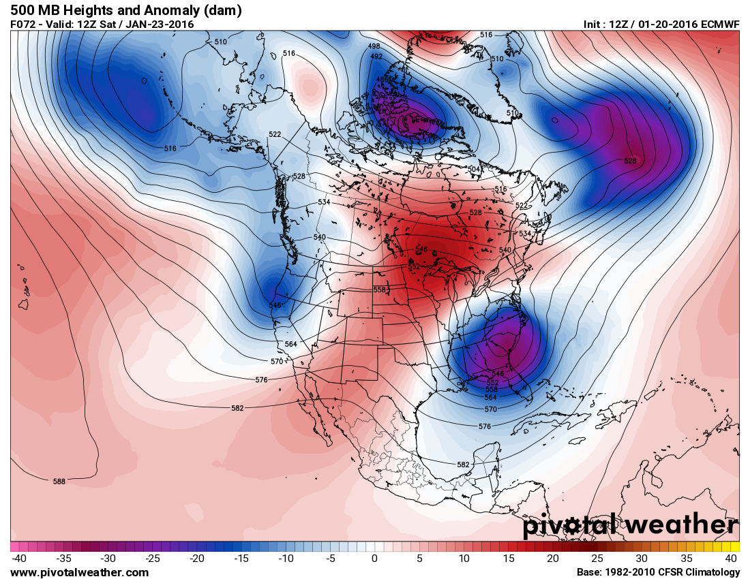

Sample Analysis for the map above. You are expected to do similar analyses of Maps

Analysis of features over and near the continental US. Parts 1 and 2 of each section.
There is a trough along the west coast. The strongest part of the trough dips into northern California and Oregon where 500 mb heights are near 100 meters below average. Precipitation is possible east (or ahead) of this feature in the northwestern United States. There is a broad ridge over the central US stretching from Arizona and Texas into Canada and western Great Lakes region with above average temperature expected over a large part of the central and northeastern United States. There is a closed low and trough in the southeastern US. 500 mb heights are as much as 250 meters below average from Northern Florida through Georgia and the Carolinas, so well below average temperature in those areas. Wrap-around precipitation may be happening near the closed low.

Read 500 mb height over Tucson. Forecast of Tucson weather. Part 3 each section.
The 500 mb height over Tucson is about 5770 meters. This is about 80 meters above the average of 5690 meters for Tucson in January. Expect well above average temperature. Tucson is not located in a position favorable for precipitation. Forecast is warm and dry.

General Instructions
The answers for this homework are divided into 4 main sections (3 map analysis sections and 1 summary section) as shown in the blank template. You need to fill in the answers using the answer template provided in a separate link below the assignment instructions. The map analysis sections have 5 parts each and should be numbered 1-5 as shown in the template. The summary section is just a paragraph. The next part of this document tells you what needs to be included in each section.

Specific Instructions
For part 1 of sections 1-3, you are expected analyze the GFS forecast maps by pointing out and locating significant features in the 500 mb height pattern for the continental United States and nearby coastal waters. You do not need to identify features that are not relevant to weather conditions for the continental US. You should identify and locate significant features like troughs, ridges, closed lows and closed highs, if they exist. If you are able, you can say something about the relative strength of the ridges and troughs. You can look at how much 500 mb heights are above or below average by using the color shading on the maps. Try to point out regions of significantly above or below average 500 mb heights (and therefore significantly above or below average temperatures). The shape of a trough can tell you something about its strength (as discussed in the reading notes). You may also want to use terms like “zonal pattern” or “amplified pattern” to describe the forecasted 500 mb height pattern. You can use state names or common geographical names, like great lakes region or pacific northwest or central plains, to locate features. You should not be writing about the 500 mb winds or obscure features in Northern Canada or way out in the Atlantic or Pacific Oceans. An example of what is expected is provided for the sample map shown above. At a minimum you must identify the significant features, such as those shown in bold in the example above. This need not be a long write-up. Make sure to point out large scale features.

For part 2 of sections 1-3, you are expected to compare the forecasted 500 mb height pattern of the ECMWF model with the GFS model forecast you analyzed in part 1. Basically repeat part 1 for ECMWF forecast, but this time emphasize similarities and differences between the forecasts. Look for the 500 mb features you pointed out in part 1. Sometimes differences are subtle, such as the slight differences location of a trough, while other times they are large, such as one forecasting a trough over a region, while the other forecasts a ridge.

For part 3 of sections 1-3, you need to read the 500 mb height that is forecasted for Tucson from both forecast maps and write both down both heights as part of your answer, i.e., one 500 mb height based on the GFS forecast and one 500 mb height based on the ECMWF forecast. You should then compare this value to the climatological average 500 mb height in Tucson of 5690 meters for this time of year. Based on this comparison, make general temperature forecasts of well below average, below average, near average, above average, well above average. (Note. When making a temperature estimate, within about 20 meters of average height, expect near average temperature, 30 to 60 meters above or below average height expect moderately above or below average temperature; more than 60 meters difference means well above or below average temperature.) You should also make precipitation forecasts for Tucson based on where Tucson sits in the 500 mb height pattern for both GFS and ECMWF. For precipitation, just state whether there is a chance for rain in Tucson or not based on its position within the 500 mb pattern. An example of what is expected for a single forecast is provided for the sample map above. You are expected to do this for both the GFS and ECMWF forecasts.

Parts 1-3 can be done immediately. All of the forecast maps are available on the maps page.

Parts 4 and 5 for each section cannot be completed until the verification (or true or actual) maps are available. These maps are based on measurements and thus become available several hours after the forecast time passes. These maps will be placed in the lower table on the maps page.

For part 4 of sections 1-3, you are expected to judge the accuracy of the forecasted 500 mb height patterns for both the GFS and ECMWF models. Here you are judging how good or bad the forecasts from each model actually turned out over the continental US and nearby coastal waters. Look at both the location and relative strength of features that were pointed out in parts 1 and 2. Do these features even show up in the verification maps? Are the features in the right position? Also, try to make a quick determination as to which forecast turned out better, GFS or ECMWF. You do not need to write more than a paragraph, so point out general differences without going into great detail.

For part 5 of sections 1-3, you are expected to read the 500 mb height over Tucson from one of the verification maps and write down this height as part of your answer. You should compare this true height over Tucson with the forecasts made by both models that you previously recorded in part 3. You should also evaluate the precipitation forecast by looking at the true 500 mb height pattern near Tucson and the possibility of rain. Which model, if either, made a better forecast for Tucson? Note. There is just one true height for Tucson. The number should be basically the same on both of the verification maps, other than slight uncertainty in the initial conditions. Just read a single true height and compare it to the values from part 3.

For Section 4, you are expected to write a summary paragraph based on the following questions: How accurately would a weather forecaster have been able to predict the weather across the United States 4, 7, and 10 days into the future based on the forecasted 500 mb height maps provided? How did the forecast accuracy change with the length of forecast period? Did one model make significantly better forecasts than the other at 4, 7 and 10 days?

Additional comments
I realize that most of you have never analyzed 500 mb height maps, so this assignment will not be graded harshly. However, you should be able to find the main features in the 500 mb pattern and be able to read and interpret 500 mb height values over Tucson. I encourage you to ask questions about the maps during class. I would like this assignment to be both instructive and “fun” in the sense that you get to look at the accuracy of computer forecasts of the large-scale weather pattern are for 4, 7, and 10 days into the future. At the outset of this assignment, I have no idea about how accurate the forecasts will turn out to be or which, if either model, will turn out to give the more accurate forecasts. You should analyze each map time individually. In other words do not try to connect the day 10 map to the day 7 map and the day 7 map to the day 4 map or try to describe what happened between day 4 and day 7 or 10.

Template
A blank template for completing your assignment is provided as a link under the homework section of the class web pages. You should use the template and fill in answers. Remember that you can immediately answer parts 1, 2, and 3 for sections 1 – 3 as the maps are available. However, you will not be able to complete the remaining parts of sections 1 – 3 or section 4 until after the true maps become available.

