ATMO 170 Name________Answers___________________
In-class Optional Assignment
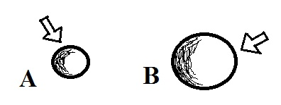
1. Object A in the picture at right has a smaller mass than Object B. When equal amounts of energy are added to each object, both objects experience the same temperature change, ΔT. This means that Object A must have a HIGHER, LOWER, the SAME specific heat as Object B ΔT = ______ΔE________
mass x specific heat
Maybe the hardest question on this assignment. Here's one way of looking at the problem:
Since each object experiences the same temperature change we write down the ΔT, ΔE equation for each object and set the two equations equal to each other
ΔT_{A} = ΔT_{B}

_________ΔE_____________ = ___ ΔE_____________
small mass x specific heat of A large mass x specific heat of B

A big specific heat for Object A can make up for its small mass, a small specific heat for B can compensate for its larger mass

___________ΔE_______________ = ___ ___ ΔE________________
small mass x big specific heat for A large mass x small specific heat for B

2. Energy transport by convection can take place in ___b____ and ___c____.
a. empty space b. gases c. liquids d. solids

3. If you place a cup of liquid nitrogen in a room it will slowly CONDENSE EVAPORATE FREEZE SUBLIMATE. Does this phase change TAKE energy from the surrounding air or RELEASE energy into the surrounding air?
The liquid nitrogen is turning from a liquid to a gas. That's evaporation. Energy will naturally flow from the warm surrounding air into the very cold liquid nitrogen. Energy is being "taken" from the surrounding air.

4. Rank the following temperatures in order from _100 C_
coldest (bottom step) to warmest (top step) _200 F_
0º C 0º F 0º K _300 K_
100º C 200º F 300º K ___0 C___
___0 F___
___0 K___
0 K is absolute zero, the coldest you can get. 0 F is below freezing (freezing is 32 F). 0 C is freezing (water freezes, ice melts). 300 K is the average temperature of the earth (about
60 F). 200 F is just below boiling (boiling point of water). 100 C is the boiling point of water.

5. Microwave radiation is a LONGER SHORTER wavelength and HIGHER LOWER energy form of electromagnetic radiation than ultraviolet light. Infrared light is a LONGER SHORTER wavelength and HIGHER LOWER energy form of EM radiation than visible light.

6. Room temperature is approximately 300º CELSIUS FAHRENHEIT KELVIN.

7. The formation of frost on a cold morning is an example of _deposition_. A bathroom mirror that fogs up during a hot shower illustrates _condensation_. A piece of dry ice left in a room will slowly disappear because of _sublimation_.
a. condensation b. deposition c. evaporation
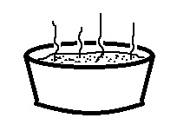
d. freezing e. melting f. sublimation

8. People often blow on a steaming hot bowl of soup to cool it
off so that they can eat it. What two energy transport processes
do you think cause the most cooling?
(Forced) convection - blowing on the hot soup.
Latent heat - the hot soup is evaporating. That takes energy from the hot soup and cools it.

