ATMO/ECE 489/589 Midterm Exam
March 11, 2015

Everyone should answer Question #1.
Then answer any 3 of the remaining 5 questions (please start each problem on a new sheet of paper)
Allow about 10-15 minutes per question

1. (15 pts) Answer any three of the following questions
(a) Benjamin Franklin was surprised to see that one of his lightning rods had been struck by lightning and that the tip was partially melted. What was the reason for his surprise?

(b) Why might you expect to find electrical charge on the top and bottom surfaces of a cloud layer during fair weather?

(c) Briefly explain the role of the R and C circuit components in the E field antennas systems shown below. Name two ways you could change the gain of either system, i.e. increase the value of the Vout for a given E field change.
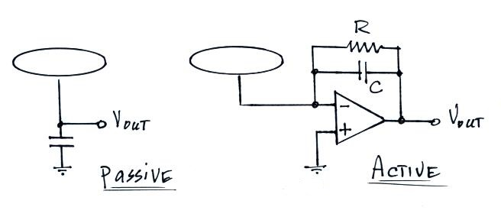

(d) What does the term electrical mobility refer to? Negatively charged small ions have slightly higher electrical mobility [1.25 x 10⁻⁴ (m/s)/(V/m) perhaps] than positively charged small ions [1.15 x 10⁻⁴ (m/s)/(V/m)]. Why is this?

(e) A mostly unlabeled plot of the "Carnegie curve" is shown below. What is being plotted (what label would you expect to find on the vertical axis)? Does the time axis show Local Time or Universal Time? What is the significance of the Carnegie curve?
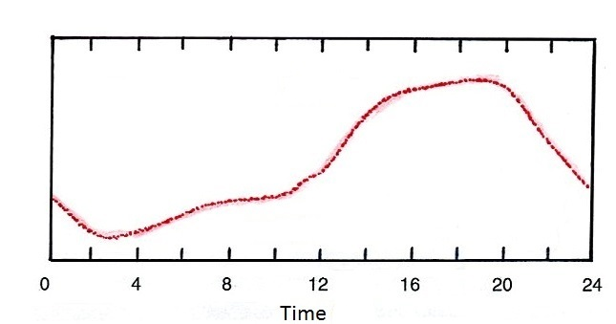

2. (15 pts) Attachment to particles becomes the dominant small ion loss mechanism when particulate concentrations exceed about 1000 cm⁻³ .

(a) Determine the small ion steady state concentration, n, given the following conditions:
ion production rate (q) = 2 ip/cm³ sec
Z = 5000 cm⁻³
small ion recombination coefficient (α) = 1.4 x 10⁻⁶ cm³/sec
small ion - particle attachment coefficient (β) = 2 x 10⁻⁶ cm³/sec

(b) Use the small ion concentration that you obtain to determine the conductivity of the air, λ. You may assume that the concentrations of positively and negatively charged small ions are equal and can use the electrical mobility values given in Problem 1d.

3. (15 pts) Show that the electric field a distance R from the pair of charges shown below varies as 1/R³ when R >> d.
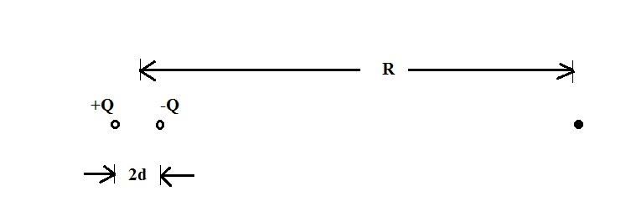

4. (15 pts) What resistance would you measure across the ends of a 1cm x 1cm x 10cm long piece of graphite assuming a resistivity of 7 x 10⁻⁶ ohm m.
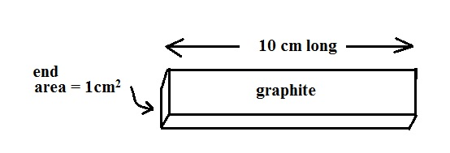

Would you measure the same resistance if you connected your ohmmeter across opposite sides of the piece of graphite?

5. (15 pts) Sketch the typical distribution of charge in a thunderstorm. Discuss the mechanism(s) that is (are) thought to be responsible for creation, separation, and arrangement of this charge.

6. (15 pts) Assume that the fair weather electric field decreases exponentially with increasing altitude and that the amplitude of the field is -200 V/m at the ground and -20 V/m at 1500 m altitude. Determine E_{o} and z_{o} in the equation below.
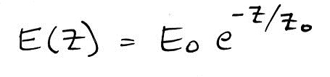

Use your expression for E(z) to determine the variation of the volume space charge density, ρ(z), between the ground and 1500 m altitude. What is the polarity of this space charge?

