ATMO/ECE 489/589 Midterm Exam Answers Spring 2013

1a. What is the basis for assuming that the current density J = J_{z} is constant with altitude?

We start with the continuity equation and assume steady state. We also assume the current density, J, has only a vertical component. The reason for this is that we are interested in only a few tens of kilometers between the earth's surface and the bottom of the ionosphere. This vertical distance is much less than the radius of the earth so we can consider this layer to be flat not curved. Also we generally assume the earth's surface is a conductor so that the fair weather E field (which drives J) will be perpendicular to the earth's surface.

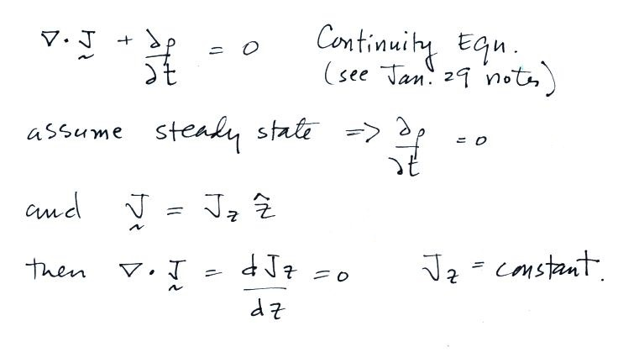

1b. Briefly define and give an example of the triboelectric effect.

Here's a quote from Wikipedia (which was included in the online notes).
"The triboelectric effect (also known as triboelectric charging) is a type of contact electrification in which certain materials become electrically charged after they come into contact with another different material through friction. Rubbing glass with fur, or a comb through the hair, can build up triboelectricity. Most everyday static electricity is triboelectric. The polarity and strength of the charges produced differ according to the materials, surface roughness, temperature, strain, and other properties.

We used this in class to try to understand the operation of the Van de Graaff generator. A rubber belt rubbing against a plexiglas roller would become negatively charged. The same belt rubbing against a polyethylene roller would become positively charged.

1c. Briefly describe and explain the significance of Franklin’s sentry box experiment.

A pointed metal rod extending out the roof of a sentry box would draw enough electrical charge from the atmosphere to spark over to a person on an insulating stand next to the rod (there is a small capacitance between the person and ground), to charge a Leyden jar, or to spark over to a grounded conductor placed near the rod.
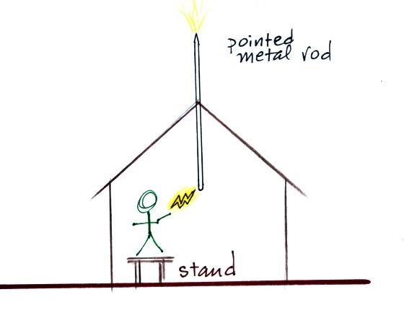

The experiment proved that electricity in the atmosphere was no different from the electrical charge that Franklin and others had been generating and studying in their laboratories. The experiment also makes use of the "power of points", i.e. the ability for pointed conductors to either draw off or throw off electrical fire (electrical charge).

1d. What is graupel? Where and how does it form?

Graupel is a type of frozen precipitation particle. It forms when snow crystals, which have diameters of 100 or 200 µm collide with smaller supercooled water droplets (diameters of 10 or 20 µm). The water droplets stick and freeze to the snow crystal. This process is called riming or accretion.

Graupel is commonly mistaken for hail and is sometimes called "soft hail" or "snow pellets" because of its frosty white appearance. You can see a couple of pretty good pictures at
http://blog.oregonlive.com/weather/2008/03/its_hail_its_snow_no_its_both.html

Graupel particles form in the mixed phase region of thunderstorms (-10º to -40º C). Collisions between riming graupel particles and smaller snow crystals are thought to be an important part of cloud electrification.

1e. The main negative charge layer in thunderstorms is always found between -10º and -30º C regardless of storm location and time of year. Why is that? Under what conditions can the main body of negative charge be found elsewhere in the thundercloud?

Laboratory experiments have shown that a non-inductive process involving collisions between riming graupel particles and ice crystals is best able to explain most of the charge generation that occurs in a thunderstorm. I.e. a cloud environment where graupel particles, ice crystals, and supercooled water droplets are present.

Ice particles aren't found at temperatures warmer than freezing (0º C). The supercooled water droplets will freeze homogeneously (without an ice crystal nucleus) at temperatures below about -40º C.

The figure below summarizes results from recent experiments and shows the charge acquired by the graupel particle in a graupel-ice crystal collision. It is able to account for a main negative charge center found between roughly -10º and -30º C, a main positive charge found higher up in the cloud at colder temperatures, and small volumes of positive charge found between freezing and the bottom of the main layer of negative charge. I.e. it is able to account for the charge distribution in seen in most thunderstorms.

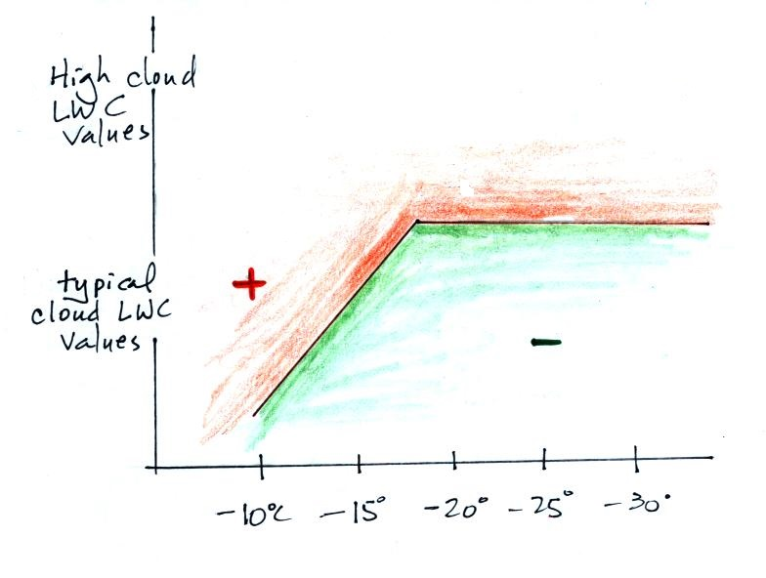

The distribution of charge in some thunderstorms is "flipped." I.e. positive charge is found in the -10º to -30º temperature range and negative charge is found higher up in the cloud. This is what the figure above would predict in clouds with unusually high LWC (liquid water content) values.

1f. Why might you expect to find electrical charge on the top and bottom surface of a cloud layer during fair weather?

The fair weather current is constant with altitude. Ohm's law states current density is just the product of conductivity and the fair weather electric field.
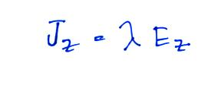

Conductivity will drop significantly inside a cloud because the small ions will attach to cloud droplets which will lower their mobility. In order for the current density to be constant both inside and outside the cloud, the strength of the electric field inside the cloud must increase to make up for the decrease in conductivity. Positive charge and negative charge will build up on the upper and lower surfaces of the cloud and enhance the field inside the cloud.
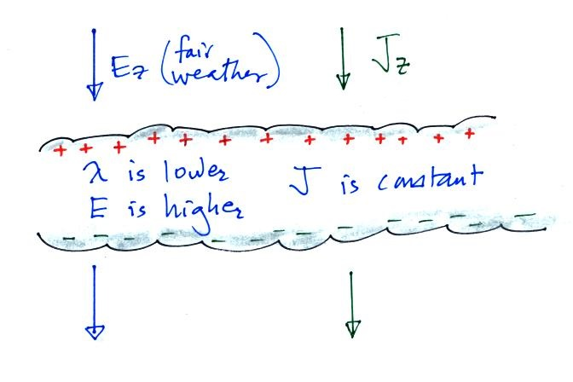

Note that if the amounts of charge on the upper and lower layers of the cloud are equal and if we assume that the cloud is of infinite horizontal extent, the charge layers will not change the existing field above or below the cloud. A Gaussian surface extending above and below the cloud will contain zero net charge. The charge layers will only affect the field inside the cloud. This latter point might be a little clearer after looking at the answer to Problem #4 on this exam.

1g. Estimate the power dissipated by the global fair weather electric current.

We'll use the following values from the first day of class:
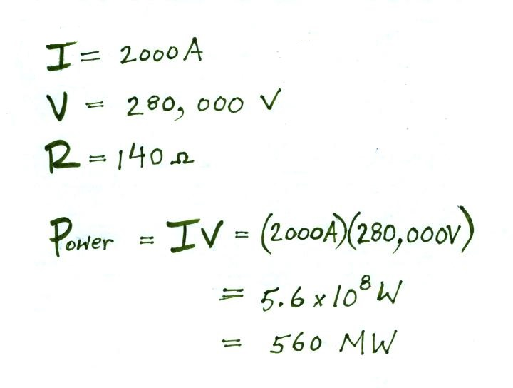

As a comparison the generation capacity of Tucson Electric Power Co. is currently 2267 MW (http://www.azcc.gov/Divisions/Utilities/Electric/summer%20preparedness/2013%20Summer%20Preparedness%20tep%20unse%20final.pdf).
1h. Why might it be advantageous to connect a flat plate “fast” or “slow” electric field antenna to an active integrator rather than a passive integrator?

With a passive integrator the decay time will be determined by the value of the integrating capacitor and the input impedance of the recording equipment and is often too short. For example with C = 100 pF and R = 1 MΩ, the decay time is 100 µs. If the passive integrator were connected to a long 50Ω cable (terminated with a 50Ω impedance) the decay time would be 5 ns.

With an active integrator the decay time constant will be determined by the values of R and C in the amplifier feedback circuit. With R = 10 MΩ and C = 100 pF, the decay time is 1 ms, suitable for a fast antenna system. There are ways of making the feedback resistance much larger in order to provide decay times on the order of 1 to 10 seconds for a slow antenna system. These decay times wouldn't change even if the amplifier were connected a terminated 50Ω cable (provided the amplifier is able to drive a 50Ω impedance).

2. Compute the field changes, ΔE, at 5 km range, produced by both a cloud-to-ground (CG) discharge and an intracloud (IC) discharge. You can assume the CG discharge neutralizes -25 C at an altitude of 6 km above ground level and the IC discharge neutralizes -25 C at 6 km altitude and +25 C of charge at 9 km altitude.

We make use of the expression for a point charge above a conducting plane:

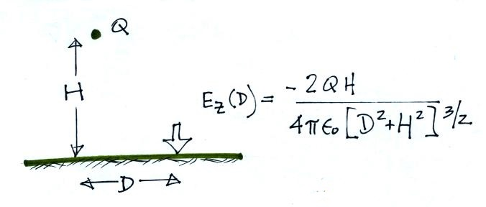

For the cloud-to-ground discharge
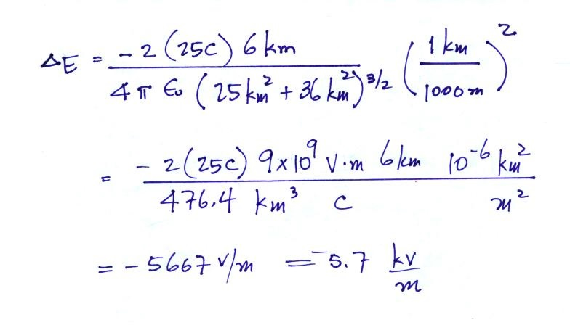

And for the intracloud discharge

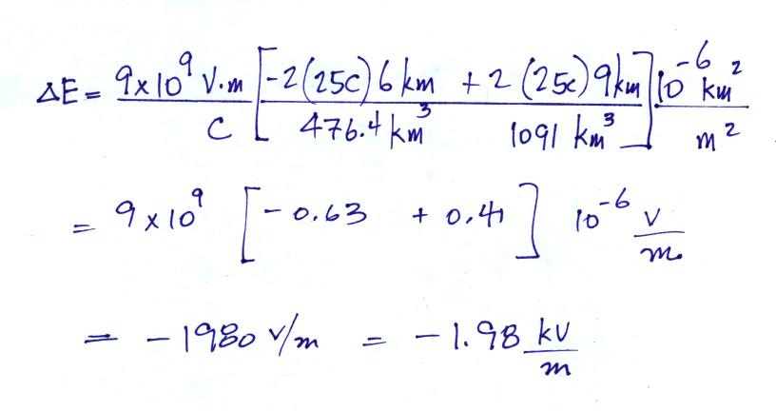

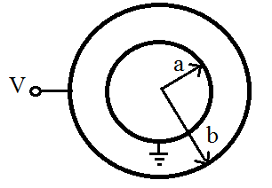
3. Show that the capacitance
of the spherical capacitor sketched at right is

C = 4πε_{o} (ab)/(b-a)

With negative charge on the inner electrode and positive charge on the outer electrode, the electric field, Er, will point inward as shown below
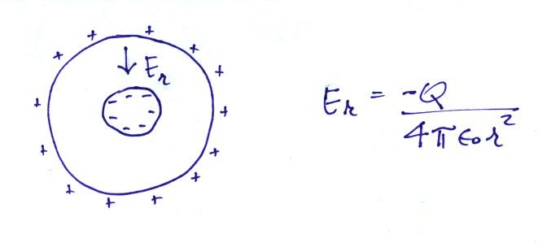

Next we compute the electrostatic potential, integrate the expression from a to b and set the result equal to
V.
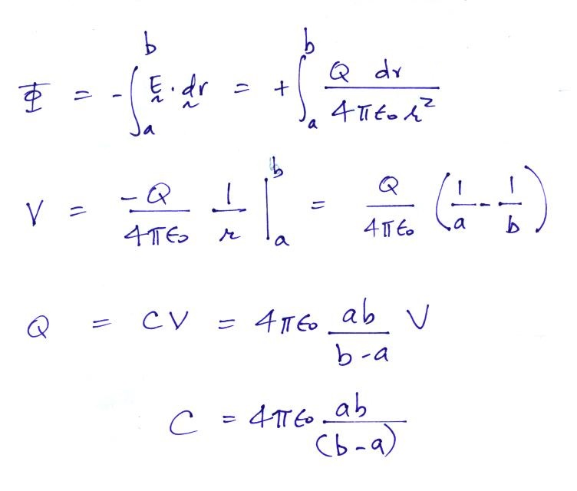

4. Compute the electric field, E, everywhere above, inside, and below a 500 m thick cloud of infinite horizontal extent. You can assume a uniform cloud volume space charge density of +1 nC/m³.
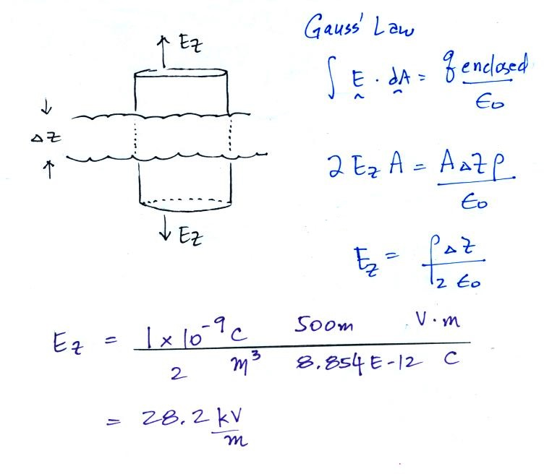

We have used the integral form of Gauss' Law to find the field above and below the layer. The field will have just a vertical component and won't vary with altitude.

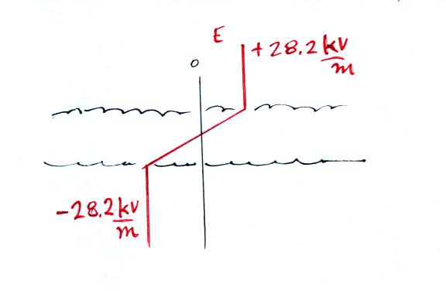

Below the cloud layer the field points downward. As you move upward through the cloud layer the field changes linearly from its value of -28.2 kV/m below the layer to its value of +28.2 kV/m above the cloud.

5. Determine the steady state small ion concentration, n, for “clean” air (Z = 500 particles/cm³) and “dirty” air (Z = 5000 particles/cm³). You can assume

a small ion recombination coefficient α = 1.4 x 10⁻⁶ cm³/sec
a small ion to particle attachment coefficient β = 2 x 10⁻⁶ cm³/sec
an ion pair production rate q = 10 ip/(cm³ sec)

We'll first write down the ion balance equation and recognize that it is a quadratic equation.

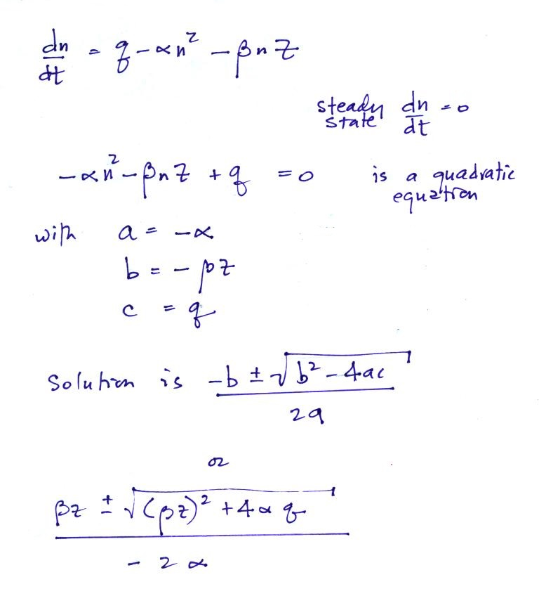

Next we'll substitute in the values for α, β, and Z for clean air.

Because the denominator is negative, we must take the negative square root in order for n to be positive.
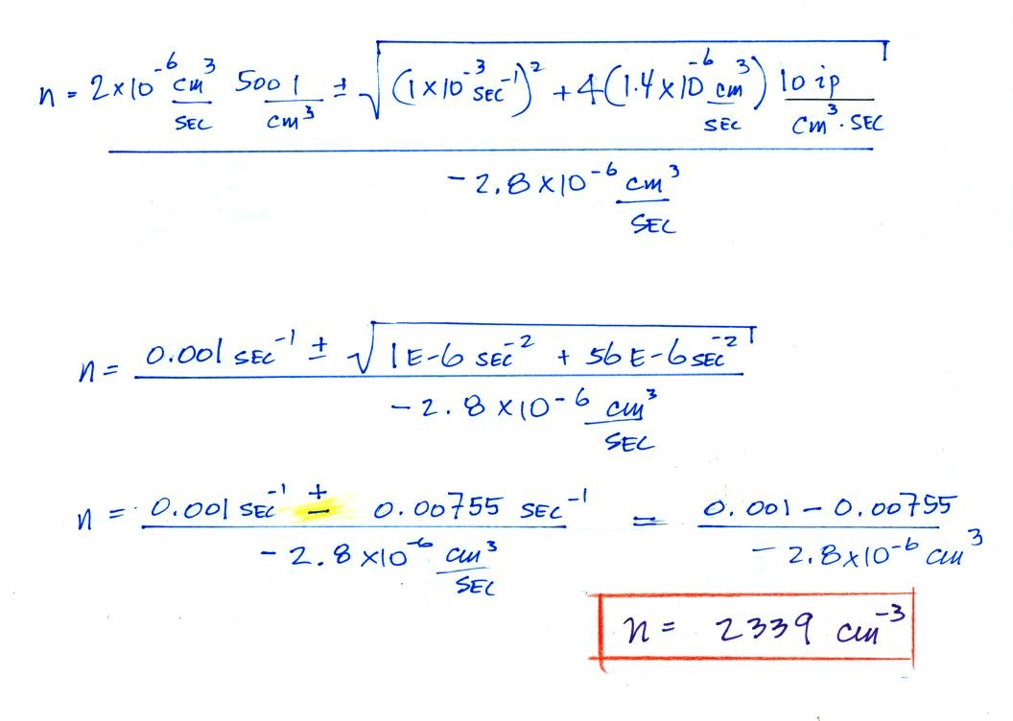

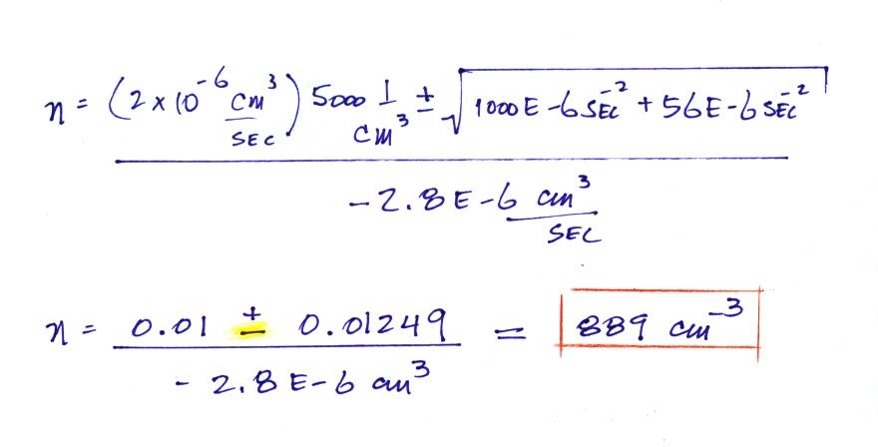
We'll leave out the first step or two when we solve for the small ion concentration in dirty air

Once again we took the negative square root in order to have a positive value for n.

6. Given a fair weather electrical field of 200 V/m and an atmospheric conductivity of 1.5 x 10⁻¹⁴ mhos/m, calculate the total resistance of the bottom 100 m of the earth’s atmosphere. You can assume that E and λ remain constant in the layer.

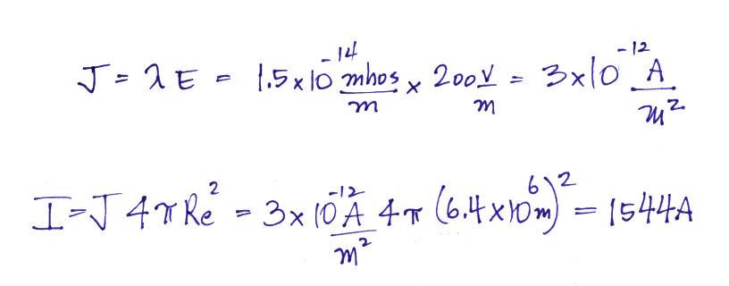
We'll first compute the current density and then multiply by the area of the earth's surface to determine the total current flowing between 100 m altitude and ground.

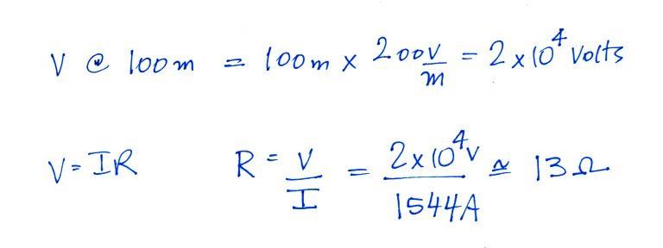
Because E is uniform throughout the layer it is very easy to compute the voltage difference across the 100 m thick layer. We then divide V by I to get the resistance R.

7. Two electric field antennas are shown in the figure below. One is a flat circular plate (radius = a) that is positioned flush with but electrically isolated from the surrounding ground. The other is a spherical antenna (radius = a) that is positioned above the ground. The upper and lower hemispheres of the sphere are insulated from each other.

Determine the effective gain or collection area of the spherical antenna. (hint: compare the total charge induced on the flat plate with that induced on the upper hemisphere of the spherical antenna when exposed to a downward-pointing electric field, E_{o}).
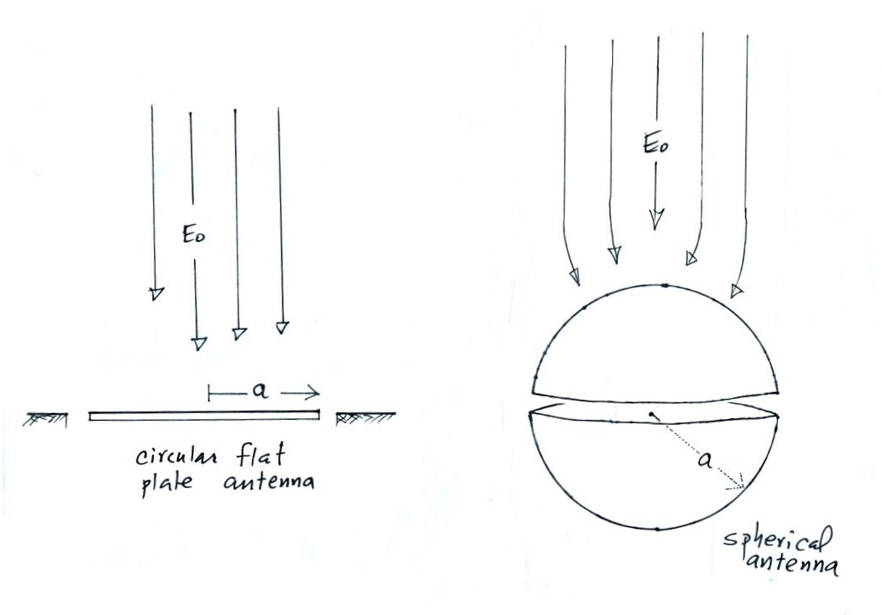

The charge induced on the flat plate antenna is
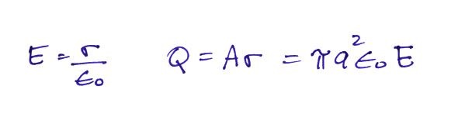

The surface charge density σ on the spherical antenna is a function of θ. We'll need to multiply σ by area and integrate over the upper half of the sphere.
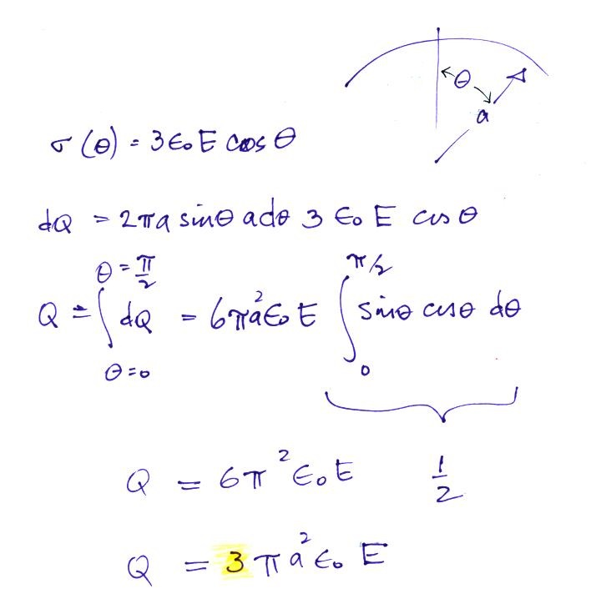

There is 3 times more charge induced on the spherical antenna than on the flat plate antenna. The spherical antenna has an effective gain of 3.

