from: UCAR Center for Science Education ( http://scied.ucar.edu/atmospheric-electricity )

From 1909 to 1929, Carnegie, a yacht that was nearly entirely non-magnetic and wood-hulled, sailed scientists around the world – nearly three-hundred thousand miles through its oceans – carefully locating and measuring then unknown magnetic influences in the atmosphere. The Carnegie's many voyages were part of the Carnegie Institution’s program that included an ambitious magnetic, electric, and oceanographic survey coupled with magnetic and electric surveys of land areas in many parts of the world. Eventually it carefully located and measured unknown magnetic influences in the atmosphere, and gave scientists something still used today called the Carnegie Curve, the characteristic universal variation of the atmospheric electric field.

http://centaur.reading.ac.uk/32889/1/10.1007_s10712-012-9210-2.pdf

O.W. Torreson, W.C. Parkinson, O.H. Gish, G.R. Wait, "Scientific Results of Cruise VII of the Carnegie during 1928-1929 under Command of Captain J.P. Ault, Oceanography - III, Ocean Atmospheric-Electric Results," Carnegie Institution of Washington Publication 568, 1946.
the entire publication is available at
http://ia902300.us.archive.org/0/items/scientificresult03sver/scientificresult03sver.pdf

from Wikipedia
http://en.wikipedia.org/wiki/Atmospheric_electricity
Experiments have shown that the intensity of this electric field is greater in the middle of the day than at morning or night and is also greater in winter than in summer. In 'fine weather', the potential, aka 'voltage', increases with altitude at about 30 volts per foot (100 V/m), when climbing against the gradient of the electric field.^{[3]} This electric field gradient continues up into the atmosphere to a point where the voltage reaches its maximum, in the neighborhood of 300,000 volts. This occurs at approximately 30–50 km above the Earth's surface.^{[4]} From that point in the atmosphere up to its outer limit, nearly 1,000 km, the electric field gradient produced in the lower atmosphere either ceases or has reversed.
Global daily cycles, with a minimum and a peak at roughly 16:00 hours later, were researched by the Carnegie Institution of Washington in the 20th century. This Carnegie curve^{[5]} variation has been described as "the fundamental electrical heartbeat of the planet".^{[6]}
The phenomena characterizing atmospheric electricity are of at least three kinds. There are thunderstorms, which create lightning bolts that 'instantaneously' discharge huge amounts of atmospheric charge to ground in a rapid release of energy stored in the electric field that built up to a particularly extreme degree in the storm clouds. There is a related phenomenon of continual electrification (re-charging) of the air in the lower atmosphere.^{[7]} A third phenomenon is that of the polar auroras.^{[8]}

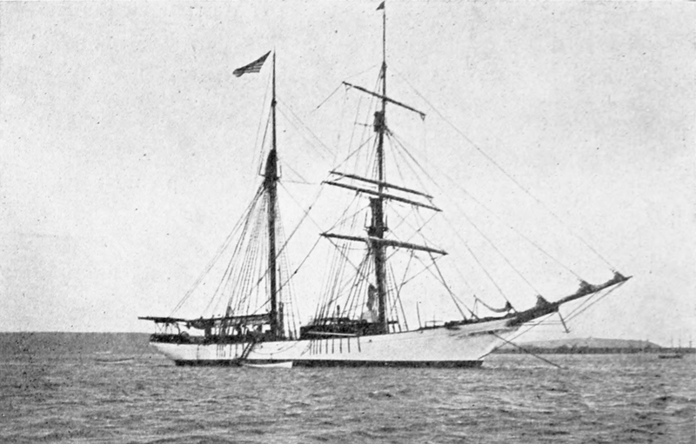

source of the image above
http://commons.wikimedia.org/wiki/File:PSM_V83_D112_The_non_magnetic_yacht_carnegie.png

