ATMO/ECE 489/589 Spring 2015
Homework #3 due Wed., Feb. 18
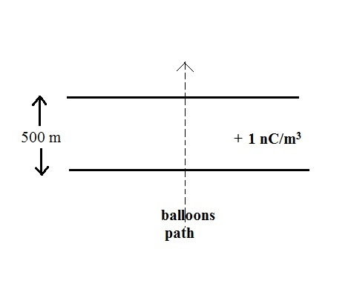
all students should work Questions 1 & 2. Only the 589 students need to do #3

1. (10 pts) Assume a balloon borne electric field sensor is approaching a 500 m thick layer of charge from below. Compute and plot the electric field, E(z), that would be measured by the sensor as it approaches the layer from below, passes through the layer, and then exits and moves away from the top of the layer. You can assume the layer has infinite horizontal extent and a uniform volume space charge density of + 1 nC/m³.
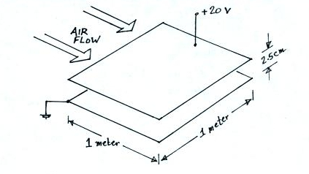
2. (10 pts) Bernard Vonnegut (the brother of author Kurt Vonnegut) proposed a conductivity meter that uses a parallel plate capacitor geometry. This is simpler than the cylindrical geometry examined in class (see the Feb. 06 notes). Assume that the area of each plate is one square meter, the plate separation is 2.5 cm, and the applied voltage is 20 volts. If air flows through the capacitor at 50 m/s (as might be the case if the conductivity meter were used on an airplane), what is the critical mobility of this device?

3. 589 students (extra credit sort of* for 489 students)
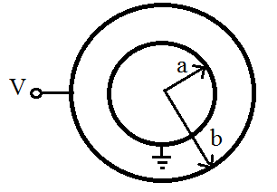
(10 pts) Show that the capacitance of the spherical capacitor sketched at right is

C = 4πε_{o} (ab)/(b-a)

(comment: we did a similar calculation in the Feb. 06 lecture about conductivity meters and ion counters)

* Extra credit earned on this problem can be used to make up for points missed on Questions 1 or 2.

