Carbon Cap and Trade Research Paper for ATMO 336, Spring 2015

Write a 2 to 3 page paper (with 12 point font and one inch margins this comes out to 500 to 1000 words), which includes the content described below. The focus of the paper is carbon cap and trade (CCT). CCT is basically a governmental system intended to reduce carbon emissions that may contribute to anthropogenic climate change. If you are unfamiliar with CCT, then you will need to do some background reading. The expected content is broken up into 4 parts, so you should have at least 4 paragraphs. You need to have a bibliography. Two or more citations to different references are required for part three. In addition you may need to include other citations to references if necessary.

- Introduction. This should at least include the following (in no specific order):
- Environmental reasons why many people around the world believe that humans need to limit or reduce emissions of carbon dioxide (no reference needed).
- Historical increase in CO₂ in the atmosphere and human activities that contribute most to the increase (reference needed if stating numbers or statistics, but not if discussed in general terms).
- Something about the increasing number of countries that are enacting policies to reduce carbon emissions (again reference will be needed if providing numbers, but not if discussed generally). Note that the US federal government has not enacted a national policy. You may want to mention that a carbon cap and trade bill passed the US House of Representatives in 2009. However, that bill was not voted on by the Senate and was not passed into law.
- Mention the two most common systems that have been implemented by governments to reduce emissions: carbon cap and trade and carbon tax. Do not go into much detail about the systems;
- Transition to body of paper, which will focus on carbon cap and trade.

- Describe the basics of how carbon cap and trade works in operation (probably will not need to reference material in this section, as it is common knowledge).
- How does carbon cap and trade accomplish emission reductions?
- What are emission permits or carbon credits?
- What is the cap? What is the trade part?
- Describe the differences between a grandfather system for issuing permits and an auction system for issuing permits, which are two varieties of a carbon cap and trade system.
- Some carbon cap and trade programs allow “carbon offsetting.” What does this mean?

- Choose a government entity that has already enacted a carbon cap and trade program. A world map showing countries and regions that have enacted carbon cap and trade or carbon tax is shown below. The government entity can be a group of countries (e.g., European Union), a single country, or a subnational area within a country (e.g., states or cities).
- Summarize the specific program and describe implementation, such as, when the system was put into operation? Who needs to comply? Is it an auction or grandfather system? Are carbon offsets allowed?
- Describe at least one thing that has worked well with the program and back it up with reference material. A citation to a reference will be necessary.
- Describe at least one thing that has not worked well with the program and back it up with reference material. A citation to a reference will be necessary.

- Briefly summarize your findings and give your opinion on whether or not you would support the enactment of a federal government carbon cap and trade policy for the US along with a brief reason for your opinion.
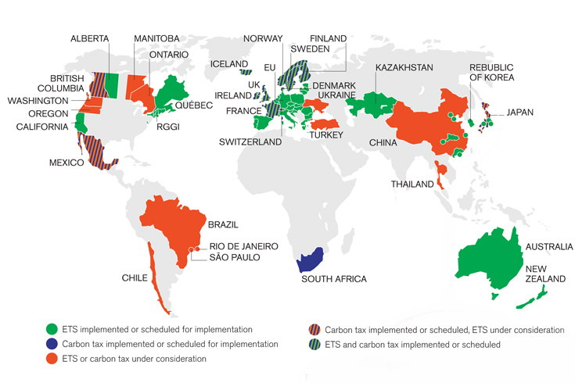
Source. World Bank <http://www.worldbank.org/en/news/feature/2014/05/28/state-trends-report-tracks-global-growth-carbon-pricing> (ETS stands for Emissions Trading Scheme, which is Carbon Cap and Trade.)

Finding Material
You can probably find the necessary reference material for this paper using specific web searches. The link to the World Bank web site given above has many links to articles and information to get you started. You should read material from several different sites before starting to write your paper.

Submitting your Paper
This paper is due on or before February 20. Your paper will be graded as described below and feedback provided within 3 weeks. You will then be given one chance to revise your paper based on the feedback and resubmit. If you do well on your first submission, then you do not need to worry about a revision.

Grading Rubric
The criteria in the table below will be used in grading your papers. There are seven grading items. For items 1 – 5, you will be awarded a percentage of the maximum points, where 100% is excellent; 90% is good; (70 – 80)% is passing, but consider revising your paper; and 60% or less is poor and revision is expected. Revised papers may receive up to 90% of the max points for items 1 – 5. Items 6 and 7 are not worth any points, but they are expected to be nearly perfect. Papers without a proper bibliography and citations and papers with grammar errors, spelling errors, poor sentences and improper use of words will have points deducted from the overall paper score, i. e., points earned for parts 1 - 5. The reduction can be large, so be sure to proofread your paper carefully. You can recover the lost points for items 6 and 7 by revising your paper.

Grading Rubric for Cap and Trade paper
Grade Item (Plus Points) | Max  Points | Section Score | Points
- Introduction.  Contains required content; Clarity; Smooth transition to rest of paper | 20 | (0 – 100) %
- Description of carbon cap and trade.  Contains required content; Clarity, correct description of components | 20 | (0 – 100) %
- Specific example of current system.  Clear, concise summary of program and implementation; Specific examples of something that has worked well and something that has not worked well with supporting references. | 25 | (0 – 100) %
- Conclusion.  Clear, concise summary; Statement of personal opinion on US implementation | 15 | (0 – 100) %
- Overall organization and layout | 20 | (0 – 100) %
Total Score Items 1 – 5 →
Grade Item (Negative Points)
- Bibliography.  Bibliography required; Missing or improper citations | 0 | 0 to -50 Points
- Grammar, Spelling, Proper use of words, Sentence structure | 0 | 0 to -50 Points
Final Grade →
(Sum of items 1-5 minus deductions for items 6 and 7)

Additional Notes
You should use word processing software (such as Microsoft WORD) in preparing your paper. It would be very helpful for grading purposes, if you could turn on line numbering. In WORD, you can go to the “Page Layout” lab, find “Line Numbers” and use the drop down menu to select “continuous.” Adding line numbers will allow graders to refer to line numbers when providing feedback.

Printed papers are due in class on or before February 20. Feedback will be provided as soon as possible, which should be no more than 3 weeks. If necessary, you will have at least 3 weeks to revise your paper and submit a revised paper, along with a copy of your original submission. Revised papers will be regraded. If you received less than 90% for any grade item 1 – 5 above, then you can revise that part and earn up to 90%. Points lost for grade items 6 and 7 can be recovered if properly revised. Only one revision is allowed.

