Name__________________________________

Atmospheric Stability Worksheet Instructions

Choose (circle) one of the following options
Option #1: 0.5 pts of extra credit provided you Option #2: Points that you earn by answering
make an honest effort to answer all the questions the following questions correctly will be added
and finish the assignment before coming to class to your 1S1P points total

1. (1 pt) Carefully plot the following "environmental" temperatures on the graph on the back of this page (you might also write these temperatures to the left of the altitude scale on the graph so that you can later compare them with the parcel temperatures). Connect the plotted points with straight lines.
0 km 25º C 4 km -6º C
1 km 18º C 5 km -13º C
2 km 10º C 6 km -20º C
3 km 2º C 7 km -28º C

2. (1 pt) Calculate the average environmental lapse rate between 0 and 7 km. (show your calculation below)

3. (2 pts) Determine the temperature of a rising parcel of air at 1 km intervals from 0 to 7 km altitude. Use these values to fill in the blanks on the right side of the graph on the back of this page. Plot these values on the graph and connect the points with straight lines.

You can assume that the air at the ground is moist but unsaturated and that the air will become saturated (relative humidity = 100%) when the air has cooled to 5º C. Assume that unsaturated air cools at a rate of 10º C/km and that saturated air cools 6º C/km.

4. (1.5 pts) Determine the condensation level of the rising parcel. Explain in a sentence or two how you determined it.

5. (1.5 pts) Determine the level of free convection. Explain in a sentence or two what that is and how you determined it.
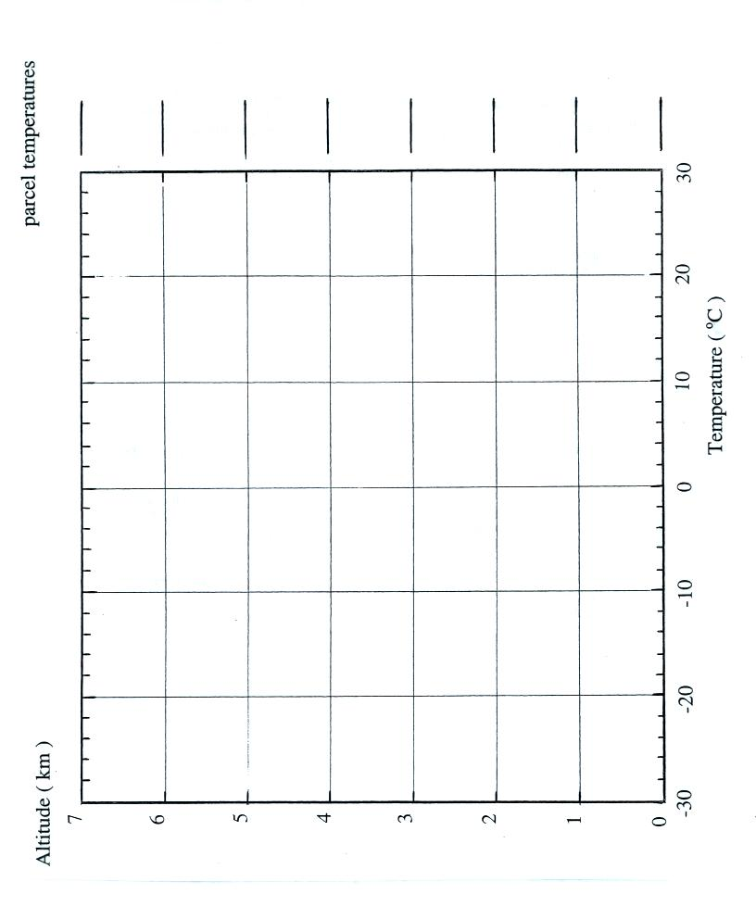
Name______________________________

