ATMO 170A1 Sect. 2 Name_________________________________________
Quiz #3 April 9, 2015 (please also write your name on the back)

1. (5 pts) Mixing ratio and _____ provide an idea of the actual amount of water vapor in the air.
a. relative humidity b. saturation mixing ratio c. dew point d. air temperature


2. (10 pts) The term rain shadow refers to the conditions on the DRY WET
side of the mountain in the picture at right. Winds blowing from the LEFT
RIGHT would produce the precipitation pattern shown at right.

3. (10 pts) Does the collision coalescence process work best when the water droplets in a cloud fall at the SAME or at DIFFERENT speeds? Are the largest raindrops produced by clouds with STRONG or WEAK updrafts?

4. (5 pts) Haloes and sundogs are formed by clouds that contain ICE crystals WATER droplets.

5. (10 pts) Which two of the following are true?
a. water droplets are only found in clouds at temperatures warmer than freezing
b. ice crystals and water droplets which have the same temperature evaporate at the same rates
c. snow crystals that break into pieces can increase the precipitation falling from a cloud
d. condensation nuclei are abundant but ice crystal nuclei are relatively scarce in the atmosphere

6. (5 pts) Warm air will always have a higher _______ than cool air.
a. mixing ratio b. saturation mixing ratio c. relative humidity d. dew point

7. (5 pts) When nimbo- or -nimbus is part of a cloud name, the cloud is
a. relatively thick b. dark grey c. precipitating d. composed of ice crystals

8. (5 pts) A combination of cold temperatures and wind make it feel colder than it really is. A combination of hot temperatures and ____________________ make it feel hotter than it really is.

9. (15 pts) During the cloud in a bottle demonstration, did the cloud form when the air was being COMPRESSED or when it EXPANDED. Did that cause the air to suddenly WARM or COOL? Was the cloud that formed in dirty air (lots of smoke particles) HARDER or EASIER to see.

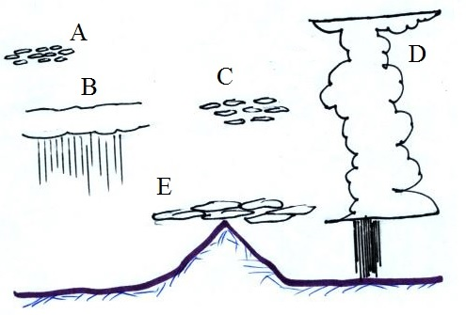
10. (5 pts) Determine the relative humidity on a day at 10 am when the air temperature is 80º F, the mixing ratio is 5 g/kg, the dew point temperature is 45º F, the saturation mixing ratio is 20 g/kg, and the air pressure is 1000 mb.

11. (10 pts) A stratocumulus cloud is drawn at Point _______
in the figure at right and a nimbostratus cloud is shown at
Point _______. (fill in the blanks)

Name_________________________________________

12. (10 pts) A falling snowflake that first melts then evaporates before reaching the ground would be called _______. An “ice storm” is caused by _______. (fill in the blanks)
a. sleet b. freezing rain c. virga d. hail e. snow

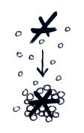
13. (5 pts) If you bring air indoors in the winter and heat it will the relative humidity INCREASE remain the SAME or DECREASE.

14. (5 pts) The precipitation particle that has been produced
by the process of riming shown at right is called _______.
a. graupel b. hail c. sleet d. snow e. virga

15. (10 pts Dew point and air temperatures at two locations are shown City A City B
at right. The air in City _______ could potentially hold the most Ta = 65º F Ta=85º F
water vapor. The air in City _______ has the highest relative humidity. Td = 55º F Td = 65º F

16. (5 pts) Which of the following has alternating layers of clear ice and rime ice?
a. hail b. sleet c. snow d. graupel e. freezing rain

17. (5 pts) The mixing ratio has units of
a. % b. grams/kilogram c. ºF d. millibars

18. (10 pts) _______ below tells you something about a cloud's altitude. A cloud with a lumpy, patchy appearance would have _______ in the name. (fill in the blanks)
a. cirro b. cumulo c. nimbo d. strato e. tropo

19. (5 pts) Foggy conditions mean the _______ is high
a. dew point b. mixing ratio c. relative humidity
d. saturation mixing ratio e. air temperature f. air pressure

20. (15 pts) Cirrostratus clouds are THICKER THINNER than altostratus clouds. Altocumulus clouds are HIGHER LOWER than stratocumulus clouds. Stratiform clouds form when the atmosphere is STABLE UNSTABLE.

21. (5 pts) Virga is rain that MELTS EVAPORATES CONDENSES FREEZES before reaching the ground.

Extra Credit (you can earn up to 10 pts)
1. (5 pts) A 200 μm diameter drop of drizzle would contain _____________ 20 μm cloud droplets.
( fill in the blank with 10 100 1000 10,000 100,000 or 1,000,000)

2. (5 pts) It stays warmer on a cloudy night than on a clear night because clouds are _______.
a. good reflectors of visible light b. good absorbers of visible light
c. good reflectors of infrared light d. good absorbers of infrared light

3. (5 pts) The flat top of a thunderstorm is called a(n)

