This is NOT an Optional Assignment (there's no place for your name). It's something to do while you're sitting in class today. Hang onto this sheet. You'll be able to check your answers with answers online.

1. Find the pattern in the column of numbers at left to estimate the relative humidities at right

Ta = 75 F, Td = 75 F, RH = 100% Ta = 55 F, Td = 35 F, RH is about__________%
Ta = 75 F, Td = 55 F, RH is about 50% Ta = 65 F, Td = 45 F, RH is about __________%
Ta = 75 F, Td = 35 F, RH is about 25% Ta = 95 F, Td = 35 F, RH is about __________%

2. Based on the information shown at right, does CITY A or City A City B
CITY B have the highest relative humidity. Does the air in CITY A Ta = 90 F Ta = 70 F
or CITY B contain the greatest actual amount of water vapor? Td = 60 F Td = 50 F

3. The air temperature is 85 F, the pressure is 1000 mb, the mixing ratio is 10 g/kg, the dew point is 60 F, the saturation mixing ratio is 25 g/kg, the wind is blowing from the south at 15 MPH, and the time is 20:00 UT (Universal Time). What is the relative humidity?

4. To really wring the water vapor out of moist air would it be best to COOL or WARM the air?

5. Assume that no moisture is added to or removed from the air during the day. The _______ will be highest in the morning, the _______ and _______ will be highest in the afternoon, and the _______
and _______ will stay constant during the day. (fill in blank with mixing ratio (r), saturation mixing ratio (r_{s}), air temperature (Ta), dew point temperature (Td) or relative humidity (RH); each answer should be used once).

6. Here's a solid question to test your understanding of the rain shadow effect.
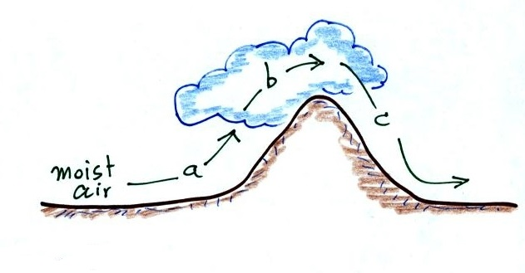
The mixing ratio, r, is increasing and RH is remaining constant _______
The RH is increasing & r is remaining constant _______
The mixing ratio is decreasing and RH is remaining constant _______
The RH is decreasing & r is remaining constant _______
(fill in each blank with a, b, or c corresponding to the paths shown in the figure or
use d for nowhere; each answer should be used once)

