ATMO 336 - Weather, Climate, and Society, Spring 2014 - Homework #3
Make sure you read and answer all the parts to each question! If you need to calculate an answer, you must show your work to receive full credit. We prefer that you type your answers, however, neatly written solutions will be accepted.
You must complete all 12 questions on this homework!
The material for questions 11 and 12 will have been covered in class on Friday, February 14
- Suppose you are about to begin a rafting trip through the Grand Canyon. A guide unrolls your inflatable raft on the grass next to the river and pumps air into the raft until it becomes nice and firm. The raft is then placed onto the cold water of the Colorado River and is anchored to a tree by a rope. A short time later you notice that the raft has lost its firmness and has become “baggy”. A whiner in your group cries “Oh no! There is a hole in our raft. I’m not going!” But you say “Don’t worry the raft lost its firmness because it was put in the cold water.” Explain why the raft would lose its firmness. In your answer you should describe what happens to the temperature and number density of the air in the raft after being placed in the cold water. (Hint. Think about the Kinetic Model for gases. You can assume that the air pressure inside the raft changes little as it loses its firmness, since basically the raft loses volume to keep the air pressure inside the raft nearly the same as the air pressure outside the raft, so if you want to use the gas law to answer this question, consider pressure is held constant.) How can this “problem” be fixed?
- In this class we have used the height of the 500 mb pressure surface to indicate something about the air temperature. How is the air temperature related to the 500 mb height? Briefly explain or describe the reason for this relationship. Give at least one possible reason why (or describe a situation wherein) the 500 mb height may not provide an accurate estimation of the air temperature just above the ground level where we live.

- Suppose you were going to walk from the ocean near Calcutta, India up to the top of Mount Everest at 8846 meters above sea level. I round the elevation to 9000 meters. We will look at how air temperature, pressure, and density change on your way up.
Elevation (meters) | Fraction of way up by altitude | Air Temperature | Air Pressure | Percentage of the atmosphere below you by weight
0 | At bottom | 31° C | 1000 mb | 0 %
3000 | 1/3 | ? | 700 mb | ?
6000 | 2/3 | ? | 500 mb | ?
9000 | At top | ? | 330 mb | ?

- Estimate the air temperature at 3000, 6000, and 9000 meters. To do this use the average rate at which air temperature falls with increasing altitude in the troposphere, which is -6.5° C for every 1000 meter gain in elevation.
- Compute the percentage of the atmosphere below 3000, 6000, and 9000 meters (based on weight). You will need to use the equation for the fraction of the atmosphere above you by weight provided in the reading page “Temperature, Pressure, and Density of the Atmosphere” and during lecture.
- Explain why the rate of decrease of air pressure is not constant with increasing altitude, i.e., it drops by 300 mb over the first 3000 meters of the climb (from 0 m to 3000 m), 200 mb over the next 3000 meters of the climb (from 3000 m to 6000 m), and 170 mb over the last 3000 meters of the climb (from 6000 m to 9000 m). Hint: the answer has to do with how air density changes with increasing altitude.

- Suppose you are driving from sea level up to the top of Mauna Kea in Hawaii, which is at 4,200 meters or 14,800 feet above sea level. In your car you have a sealed, unopened bad of potato chips. Which may happen to your bag of chips on the drive up and why (a) the bag could explode outward or (b) the bag could implode or burst by being crushed inward?

- Provided below are two skew-T diagrams for Tucson and two 500 mb maps for North America. One skew-T was observed at 00Z on Tuesday, January 15, 2013, and the other was observed at 12Z on Tuesday, January 15, 2013. One 500 mb map is valid for the time 00Z on Tuesday, January 15, and the other is valid for the time 12Z on Tuesday, January 15, 2013. The time stamps have been removed from the diagrams and maps. The labels on top of the diagrams are "skew-T #1" and "skew-T #2" and on the maps "500 mb map #1" and "500 mb map #2." In the first part of this question, I want you to determine which skew-T diagram and which 500 mb map correspond with 00Z, January 15 and which skew-T diagram and 500 mb map correspond with 12Z, January 15. You must fully explain how you arrived at your answer. There are at least four pieces of information that can be used to match the skew-T diagrams and 500 mb maps, can you identify them all? There are also links to the skew-T diagrams and 500 mb maps under the homework section on the class web pages, in case you are having trouble reading the embedded images clearly.

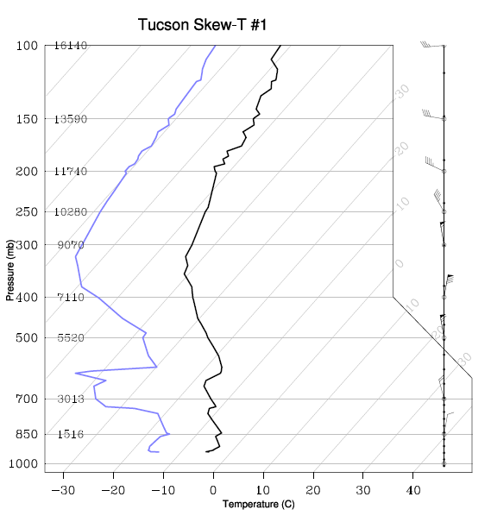
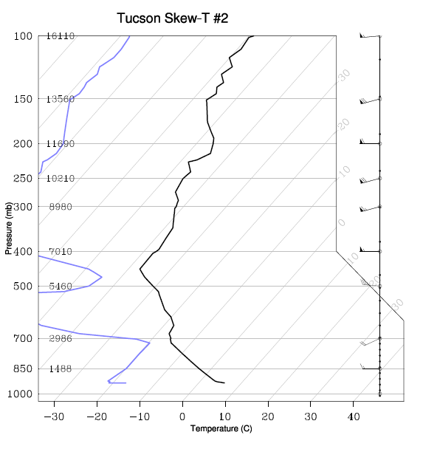

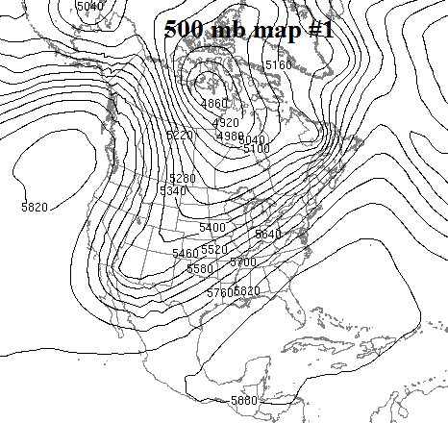
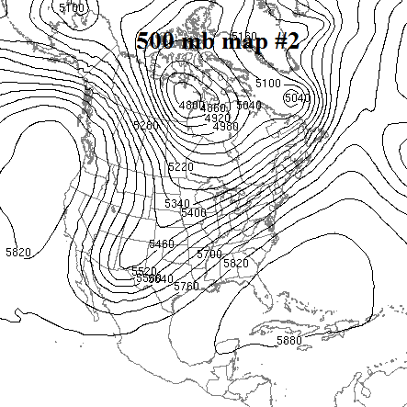
The remaining questions are based on the skew-T diagram labeled "Tucson skew-T #2." Fill in the missing values in the table below. Do you see any evidence of clouds in this sounding? If so, what is the approximate altitude of any cloudy layers.
Pressure (mb) | Altitude Above Sea Level (m) | Air Temperature (°C) | Dew Point Temperature (°C) | Wind Direction | Wind Speed  (knots)
200 | 11690 | -46 | -81 | West | 60
250 |  |  | <-80
500
700
850

- Considering the continental United States, starting with the fact that the average air temperature in the lower troposphere decreases as you go from south to north, explain why the winds at 500 mb generally blow from west toward east. You are expected to identify the important forces that act on the air.

- The image below shows a portion of a sea level (or surface) weather map. Based on the pattern of isobars, determine the wind direction at the dots labeled A and B. Note that the wind direction will be the same at all three A dots and the wind direction will be the same at all three B dots. I am looking for a direction (like southeast) for eachj set of dots, A and B. Assume that north is straight up. Remember wind direction is defined as the direction from which the wind is blowing. Does the wind pattern at the two sets of dots result in divergence, convergence, or neither for the air located between the dots? Is this wind pattern favorable, unfavorable, or neutral in regard to the possibility of rain between the two dots? Explain your answer.

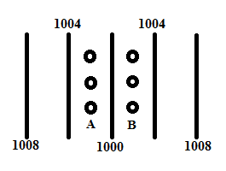

- Consider a beaker that is half full of liquid water and is sealed at the top so that no air can enter or leave the beaker. This is the “closed system” described in the lecture notes. Initially, the temperature of the liquid water and air inside is held at 20° C. After a short time, the water vapor content of the air in the beaker reaches a “dynamic equilibrium” or a state of “saturation”. Explain what is meant by “saturation” or a “dynamic equilibrium”. Now assume that the temperature of the water and air inside the beaker is warmed up to 35° C. This temporarily causes the system to no longer be in dynamic equilibrium or a state of saturation with respect to water vapor. If the temperature is now held at 35° C, explain how the system will return to a new dynamic equilibrium or state of saturation.

* You will need to refer to the table of saturation mixing ratios using Fahrenheit temperature to complete questions 9 and 11. The table is available as a link under the homework section of the class web pages. It is also provided after the last question. *

- On a day in winter 2008, the following conditions were measured on the UA campus
    - At 8 AM: air temperature, T = 45° F; dewpoint temperature, T_{d} = 25° F.
    - At 10 AM: air temperature, T = 60° F; dewpoint temperature, T_{d} = 25° F.
    - At 2 PM: air temperature, T = 70° F; dewpoint temperature, T_{d} = 25° F.
- Using the table of saturation mixing ratios, compute the relative humidity for each of the times and conditions specified above.

- How did the water vapor content in the air change between 8 AM and 2 PM? Explain why the relative humidity changed the way it did from 8 AM through 2 PM.

- Here in Tucson when it is hot outside, restaurants with outdoor seating often use misters to make conditions more comfortable for their customers. Misters work by spraying a fine mist of tiny liquid water droplets into the air. How do misters cool the air? (Hint. Think about what would happen to liquid water drops surrounded by desert air in summer.) What happens to the relative humidity of the air that is being cooled? Give two reasons why the relative humidity changes the way that it does.

- On a summer day, the conditions measured at Tucson, Arizona and New Orleans, Louisiana are given below

Tucson, Arizona
Air Temperature | 105° F
Relative Humidity | 15 %

New Orleans, Louisiana
Air Temperature | 90° F
Relative Humidity | 65 %

- Using the heat index chart provided with the course lecture notes (reading page titled “Temperature, humidity, wind, and human comfort”), find the heat index for the two cities. How do the rates of heat loss from the body compare at these two locations? Which location is most stressful to the human body?

- Compute the dew point temperatures for the two cities (you may need to interpolate between the closest values in the saturation mixing ratio table). Which city has the higher concentration of water vapor in the air? How do you know?

- On a winter day, conditions measured at Fairbanks, Alaska and West Yellowstone, Montana are given

Fairbanks, Alaska
Air Temperature | -10° F
Wind Speed | 15 MPH

West Yellowstone, Montana
Air Temperature | 0° F
Wind Speed | 30 MPH

- Using the wind chill chart provided with the course lecture notes (reading page titled “Temperature, humidity, wind, and human comfort”), find the wind chill equivalent temperature for the two cities. How do the rates of heat loss from the body compare at these two locations? Which location is most stressful to the human body?

- The wind chill equivalent temperature accounts only for heat losses related to air temperature and wind speed. Explain why cold and windy conditions could be even more dangerous for a person wearing wet clothing (perhaps for example someone who has fallen into water, climbs out, but remains wet).

Table of Saturation Mixing Ratios for Fahrenheit Temperature
Temperature  (ºF) | Saturation Mixing Ratio (g/kg) | Temperature  (ºF) | Saturation Mixing Ratio (g/kg)
5 | 1.21 | 55 | 9.32
10 | 1.52 | 60 | 11.19
15 | 1.89 | 65 | 13.38
20 | 2.34 | 70 | 15.95
25 | 2.88 | 75 | 18.94
30 | 3.54 | 80 | 22.43
35 | 4.33 | 85 | 26.48
40 | 5.28 | 90 | 31.16
45 | 6.40 | 95 | 36.56
50 | 7.74 | 100 | 42.78

