ATMO/ECE 489/589 Midterm Exam
March 8, 2011

A charge Q is located a distance H above the ground which is assumed to be a flat perfectly conducting surface. You’re standing a distance D away as shown in the figure below.
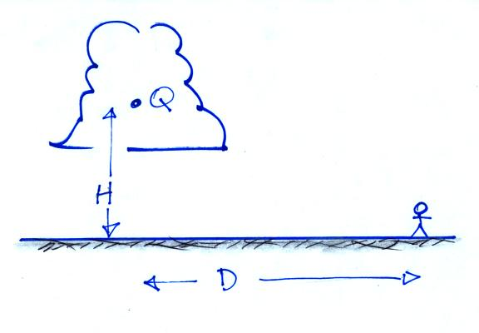

(a) Write down an expression for the electric field at your position.

(b) Assume that the charge Q is allowed to move up or down (i.e. H can vary, but D remains constant). Show that the electric field observed at D is a maximum when

