ATMO 170A1 Sect. 1 Name_______________________________
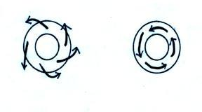
In-Class Optional Assignment

1. Does the RIGHT figure or the LEFT
figure show surface winds? Are the surface
winds shown in the figure NORTHERN or
SOUTHERN hemisphere winds? Are the
surface winds in the figure blowing around
a center of HIGH or LOW pressure?
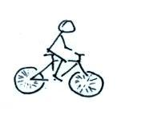
2. What happens if, when you’re riding your
bicycle along a flat level road you stop pedaling?
Would you continue to move in a straight line
at constant speed? If not, draw an arrow to show
the direction of the net force that would be
exerted on the bicycle. What is the name or
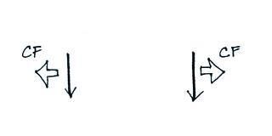
cause of this force?

3. Circle the figure that shows winds blowing in the
southern hemisphere. CF stands for Coriolis force.

4. Does a hurricane’s direction of SPIN or direction of TRAVEL change when you move
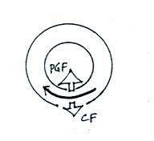
from the northern to the southern hemisphere?

5. Does the figure at right show winds spinning around a
center of HIGH or LOW pressure? Is this a
NORTHERN or SOUTHERN hemisphere map?

6. Isaac Newton
a. invented calculus
b. discovered that white light is a mixture of different colors of light
c. formulated a law of gravitation d. formulated laws of motion
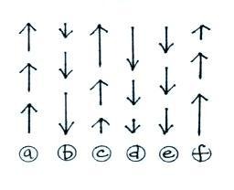
e. all of the above

7. The net force on _______ and _______
at right points upward. The net force on
_______ and _______ is zero. The net
force on _______ and _______ points
downward. (the arrows show the direction
of motion, the length gives you an idea of
the speed)

8. The direction of the _______ force changes direction when you move from the northern to the
southern hemisphere.
a. Coriolis b. frictional c. gravitational d. pressure gradient

9. Have you ever been to the southern hemisphere? If so, where?

10. The net force exerted on an object moving in a circular path at constant speed
a. points in the direction of motion
b. is zero
c. points inward toward the center of rotation
d. points outward away from the center of rotation

11. Hurricanes don’t form at the equator because there isn’t any CORIOLIS GRAVITATIONAL PRESSURE GRADIENT force there.

12. The strength of the Coriolis force depends on wind speed and also on ____________________.

13. Working together the _______ and the _______ determine the direction and speed of upper level winds.
a. Coriolis force b. frictional force c. gravitational force d. pressure gradient force
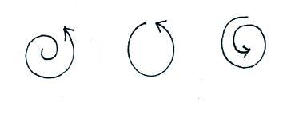

14. For each figure at right indicate
whether the net force is INward
OUTward or ZERO.

15. Does the figure below show a NORTHERN or SOUTHERN hemisphere middle latitude storm
