Friday Mar. 1, 2013
"House of the Rising Sun" from The Animals before class today.
The Experiment #3 materials were handed out in class today. I have lots of extra materials available and will bring a bunch more to class next Monday. Perfect weather for Expt. #3 forecast for the next several days.
I am starting to get a lot of emails about grades. At this point you have one quiz score, some 1S1P pts (hopefully) and should have completed or be working on an experiment. Once Quiz #2 is graded (that should be done in time to return the quizzes next Friday) I'll enter everything into one of my computers and print out a grade summary. Those probably won't be ready until the Monday after Spring Break. So please be patient and concentrate on next week's quiz.

Here's another example of warm white and cool white: automobile headlights.
Clouds are normally white. Around sunrise and sunset clouds often become yellow, orange, and red. The reason for this is that the color of the sunlight that is shining on and being reflected by the clouds changes.

When the sun is low in the sky the rays of sunlight take a much longer path through the atmosphere and there is more opportunity for light to be scattered (and absorbed).
At Point 1 in the figure below we assume the incoming sunlight is white because it is a mixture of equal amounts of all the colors. After this sunlight travels a short way through the atmosphere some of the shorter wavelengths get scattered and removed from the incoming beam of light.
The scattered light, Point 3, is what you see when you look at the sky. It's is not nearly as intense as the original beam of sunlight and is colored blue.
The unscattered light is the original mix of colors with a little bit of some of the shorter wavelengths removed. This can change the color slightly form white to a warmer shade of white.

When the rays of sunlight take a longer path through the atmosphere much more scattering can occur. Almost all of the shorter wavelengths can be removed from the incoming beam of light. This turns the unscattered light orange or red and is shown at Point 4 above. Here's a pretty impressive photograph of the changing color of the setting sun.
Notice that the unscattered light becomes less intense (even so you shouldn't look directly at the sun)

Because the sunlight that is reflected by clouds at sunset (or sunrise) is orange or red, the clouds themselves will appear orange or red.

We rushed through the simplified explanation of the greenhouse effect in the last 10 minutes of class on Wednesday. So we started with that again today.
You should be able to take a blank sheet of paper and reproduce the figure below. Not only that you should be explain to add some commentary as you draw in the various arrows.

Draw in the ground and the top of the atmosphere. Then add a couple of green arrows of incoming sunlight. We assume it all passes through the atmosphere and gets absorbed by the ground. Then draw three arrows of IR radiation emitted by the earth. One of these passes through the atmosphere and goes into space. The other two don't, they get absorbed by the atmosphere. The atmosphere then emits two arrows of IR radiation itself. One goes up and into space, the other downward where it gets absorbed by the ground.
One thing we didn't do in class last Wednesday was check to see that every part of the picture is in energy balance. We did that today.

The ground is absorbing 3 units of energy (2 green arrows of sunlight and one bluish arrow coming from the atmosphere) and emitting 3 units of energy (one pink and two red arrows). So the ground is in energy balance.

The atmosphere is absorbing 2 units of energy (the 2 red arrows coming from the ground) and emitting 2 units of energy (the 2 blue arrows). One goes upward into space. The downward arrow goes all the way to the ground where it gets absorbed (it leaves the atmosphere and gets absorbed by the ground). The atmosphere is in energy balance.

And we should check to be sure equal amounts of energy are arriving at and leaving the earth. 2 units of energy arrive at the top of the atmosphere (green) from the sun after traveling through space, 2 units of energy (pink and orange) leave the earth and head back out into space. Energy balance here too.

In our simplified explanation of the greenhouse effect we assumed that 100% of the sunlight arriving at the earth passed through the atmosphere and got absorbed at the ground. We will now look at how realistic that assumption is.

The bottom figure above shows that on average (over the year and over the globe) only about 50% of the incoming sunlight makes it through the atmosphere and gets absorbed at the ground. This is the only number in the figure you should try to remember.
About 20% of the incoming sunlight is absorbed by gases in the atmosphere. Sunlight is a mixture of UV, VIS, and IR light. Ozone and oxygen will absorb a lot of the UV (UV makes up only 7% of sunlight). Roughly half (49%) of sunlight is IR light and greenhouse gases will absorb some of that.
The remaining 30% of the incoming sunlight is reflected or scattered back into space (by the ground, clouds, even air molecules).

Now that we know a little bit more about the fate of incoming sunlight we'll improve our simplified illustration of the greenhouse effect somewhat. We'll make it a little more realistic.

In this case we'll assume that 1 of the 2 incoming arrows of sunlight is absorbed in the atmosphere instead of passing through the atmosphere and being absorbed at the ground. The ground is still emitting 3 arrows of IR light. What would you need to add to this picture to bring it into energy balance?
Start with the atmosphere. How many units does it need to emit. It's absorbing 3 units or energy and must, therefore, emit 3 arrows of radiation. How many should we draw going upward, how many go downward?
We'll next look at the ground. It is absorbing 1 unit of sunlight energy but emitting 3; it needs two more units of energy. Thus we should send 2 of the 3 arrows of radiation emitted by the atmosphere downward toward the ground.
We'll send the remaining arrow of energy emitted by the atmosphere upward and into space.

The atmosphere is emitting 3 arrows of IR light. 1 goes upward and into space, the other two go downward and get absorbed by the ground.
Students performing Experiment #3 will be measuring the amount of sunlight energy arriving at the ground. About 2 calories pass through a square centimeter per minute at the top of the atmosphere. Since about half of this arrives at the ground on average, students should expect to get an answer of about 1 calorie/cm2 min.
And if you weren't in class you missed a couple of Expt. #3 videos, potential Academy Award winners in the short documentary film category.

Next we will look at pretty realistic picture of energy balance on the earth (the bottom figure below). The simplified version that we just worked out earlier in the class is also shown for comparison (top figure). This figure (handed out in class) is a replacement for p. 72 in the ClassNotes.
In the top figure (the simplified representation of energy balance) you should recognize the incoming sunlight (green), IR emitted by the ground that passes through the atmosphere (pink or purple), IR radiation emitted by the ground that is absorbed by greenhouse gases in the atmosphere (orange) and IR radiation emitted by the atmosphere (blue).
The lower part of the figure is pretty complicated. It would be difficult to start with this figure and find the greenhouse effect in it. That's why we used a simplified version. Once you understand the upper figure, you should be able to find and understand the corresponding parts in the lower figure (especially since I've tried to use the same colors for each of the corresponding parts).
Some of the incoming sunlight (51 units in green) reaches the ground and is absorbed. 19 units of sunlight are absorbed by gases in the atmosphere. The 30 units of reflected sunlight weren't included in the figure.
The ground emits a total of 117 units of IR light. Only 6 shine through the atmosphere and go into space. The remaining 111 units are absorbed by greenhouse gases. The atmosphere in turn emits energy upward into space (64 units) and downward toward the ground (96 units). Why are the amounts different? One reason might be that the lower atmosphere is warmer than the upper atmosphere (warm objects emit more energy than cold objects). Part of the explanation is probably also that there is more air in the bottom of the atmosphere (the air is denser) than near the top of the atmosphere.
Notice that conduction, convection, and latent heat energy transport (the 7 and 23 units on the left side of the figure) are needed to bring the overall energy budget into balance (and you should check to see if every part of the figure is in energy balance). The amount of energy transported by conduction, convection, and latent heat is small compared to what is transported in the form of EM radiation.
A couple more things to notice in the bottom figure.
(i) The ground emits more energy (117 units) than it gets from the sun (51 units). It is able to achieve energy balance because it also gets energy from the atmosphere (96 units).
(ii) The ground is actually receiving more energy from the atmosphere (96 units) than it gets from the sun (51 units)! Part of the reason for this is that the sun just shines for part of the day. We receive energy from the atmosphere 24 hours per day.

There's a very little bit left in this section but with only a few minutes left in the period at this point, we'll have to do that next Monday.
Here's another picture that wasn't shown in class, to test your understanding.

One unit of sunlight energy arrives at the earth and gets absorbed by the atmosphere. It doesn't make it to the ground. The ground is emitting one unit of energy that gets absorbed by the atmosphere. You need to figure out what the atmosphere is doing to bring this picture into energy balance. You'll find the answer on the next page.

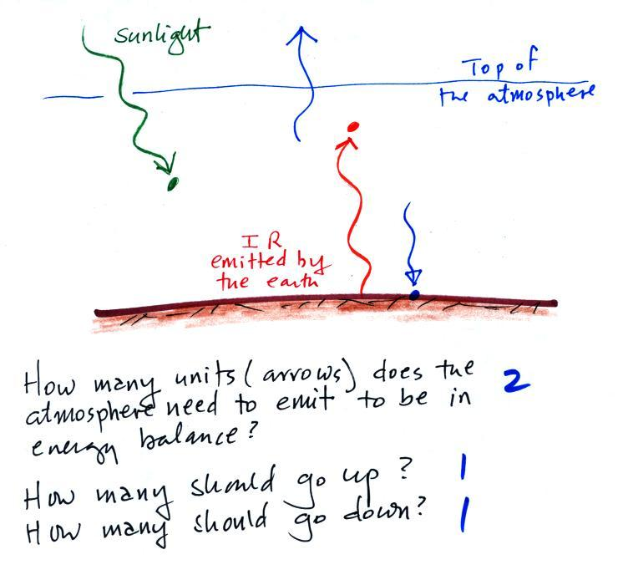

The atmosphere is absorbing two units of energy so it must emit two. One is sent downward to the ground to balance the one unit of IR radiation being emitted by the ground. The other is sent upward into space. One unit arrives at the earth and one unit leaves the earth and goes back out into space.

