ATMO 336 - Weather, Climate, and Society

Spring 2012 Homework #4 Cloud and Stability Problems

Make sure you read and answer all the parts to all questions! You must show work where requested for full credit. Please only turn in the answers, labeled by question number. Do not include the questions. There are 7 questions. Not all questions will be weighted equally

- “Advection fog” is common along the northern California coast in summer. In this region, the temperature of the ocean surface water near the coast is much colder than the temperature of the ocean surface water farther offshore. The fog forms over the cold water near the coast when westerly surface winds (blowing from west toward east) move (or “advect”) air from well offshore (where the ocean surface water is warm) to a position above the colder water near the coast. This fog is often carried inland by the westerly winds (e.g., San Francisco fog).
  - Explain why this fog forms. Hint: Fog is nothing more than a cloud that forms just above the ground. All clouds form by condensation whenever air is cooled to its saturation point. Most clouds form where air is rising, since the rising air cools by expansion. You need to identify what leads to condensation in this situation.
  - Over land, this fog often persists through the morning hours, but “burns off” as the afternoon wears on. This occurs because some sunlight is able to penetrate through the fog and warm the ground and this subsequently leads to warming of the air. Explain how this would act to dissipate the fog (of course, the fog doesn’t actually “burn”). Would you expect the fog to dissipate from the bottom up or from the top down? Explain

- This question has to do with the formation of condensation funnels in tornadoes. When air parcels are drawn into a tornado’s circulation they experience a pressure drop as they approach the low pressure at the tornado’s center. The pressure drop can be as much as 20%, for example, from 1000 mb outside the tornado to 800 mb near the tornado’s center. Explain why this sometimes results in the formation of a visible condensation funnel. In other tornadoes with the same pressure drops, condensation funnels do not form. What is the most likely reason why visible condensation funnels do not always form even when inward moving air parcels experience a significant pressure drop? Even though these tornadoes do not produce visible condensation funnels, evidence of the tornado’s circulating winds can often still be seen. What else causes these tornadoes to often be “visible”?

- In lecture it was stated that the tropopause acts as a “lid on rising air motion.” In other words, rising (and unstable) parcels of air, usually stop rising soon after they encounter the tropopause. We find evidence for this with strong thunderstorms. The highest clouds in the thunderstorm, often called the anvil, top out at the troposphere-tropopause boundary. Explain why the tropopause acts as a lid on rising air motion. Hint. You need to consider how the vertical atmospheric temperature profile [or the environmental temperature profile] changes in the transition from the troposphere to the tropopause, i.e., the atmospheric temperature surrounding air parcels will stop decreasing with increasing altitude and become steady, and how this will affect the stability of a rising parcel. Keep in mind that rising parcels of air always cools due to expansion regardless of how the temperature changes in the air surrounding the parcel.
- Answer the following questions and fill in tables for each part below. Create your own tables (perhaps copy and paste in WORD) or re-write tables on your own paper. DO NOT print this page and squeeze answers into the tables below. You are going to follow a parcel of air that is forced to rise up a mountain, then back down the other side.

  - Fill in the table below for an air parcel forced to rise from 0 meters up to the top of a 5,000 m mountain. At what altitude will a cloud start to form? Once a cloud starts to form, what happens to the rate at which air temperature in the parcel changes with increasing altitude? Explain why.

Altitude | Parcel Temperature | Parcel Dew point Temperature
5,000 m
4,000 m
3,000 m
2,000 m
1,000 m
0m | 23º C | 3º C

  - Bring the parcel back down the other side of the mountain. To begin, copy the values for the parcel temperature and dew point temperature at 5000 m from part (a) into the table below. For this part assume that the cloud of liquid water droplets that formed in the parcel on the way up remains inside the parcel as it starts to descend. What happens to the cloud as the parcel is lowered? How does the presence of a cloud in the parcel affect the rate at which the air temperature in the parcel changes with decreasing altitude compared with a parcel that does not contain a cloud? Explain why. Hint: since no water enters or leaves the parcel in this part, the dew point temperature of the sinking parcel cannot become greater than 3° C.

Altitude | Parcel Temperature | Parcel Dew point Temperature
5,000 m | * (from part a) | * (from part a)
4,000 m
3,000 m
2,000 m
1,000 m
0 m
* to get started you need to copy the values you computed at 5000 m from the table in Part (a)

  - Repeat part (b), but this time assume that 46% and all liquid or ice that condensed into a cloud as the parcel went up the mountain fell out of the parcel as precipitation. Fill out the same table as for part (b).

Altitude | Parcel Temperature | Parcel Dew point Temperature
5,000 m | * (from part a) | * (from part a)
4,000 m
3,000 m
2,000 m
1,000 m
0 m
* to get started you need to copy the values you computed at 5000 m from the table in Part (a)

In order to fill in the table correctly, you will have to compute the answers to these questions. You will need to use the table of saturation mixing ratio in Celsius. One was given to you as an in-class handout. I have also placed one under the homework link on the class web page. (For full credit you must show work)
- How much water vapor condensed into liquid in moving the parcel from 0 m up to 5000 m?
- After removing 46% of the condensed water due to precipitation (54% remains in the parcel), how much total water (liquid water plus water vapor) remains in the parcel?
- What is the corresponding dew point temperature for this amount of water if it were all water vapor? Hint: the dew point temperature in the sinking parcel cannot become higher than this value.

  - Explain why the parcel in part (c) arrives back at sea level (0 m) warmer than it was before it went up and over the mountain.

- Answer the following questions and fill in tables for each part below.

The lifted index (LI) is defined as the difference between the environmental air temperature at 500 mb, i.e., the temperature of the atmosphere where the air pressure is 500 mb (this is labeled as T₅₀₀ below) and the air temperature inside an air parcel after it has been lifted from the surface up to 500 mb, i.e., you need to determine the temperature of a parcel that moves up from the surface to where the air pressure is 500 mb (this is labeled as T_{Parcel} below). Meteorologists use the lifted index to access the stability of the atmosphere. Note the lifted index was not covered in the reading material or during lecture. Use the simple definition of lifted index given below.

LI = T₅₀₀ - T_{Parcel}

- Explain why the atmosphere is said to be stable when the lifted index is positive and unstable when the lifted index is negative.

- The following information is available for Asheville, NC (elevation ~500 m above sea level) at 8:00 AM. Fill in the table by lifting an air parcel from the surface up to 5500 m, where air pressure is 500 mb. At what altitude does a cloud start to form? What is the lifted index at 8:00 AM? Is the atmosphere unstable for parcels lifted to 500 mb?

Air Pressure | Altitude (m) | Atmospheric Temperature (°C) | Parcel Temperature (°C) | Parcel Dew Point (°C)
500 mb | 5500 | -20  (this is T₅₀₀ in LI above) | (this will be T_{Parcel} in LI)
---------- | 4500 | -13
---------- | 3500 | -6
---------- | 2500 | 1
---------- | 1500 | 8
---------- | 500 | 10 | 10 | 0

- Later that day at 3:00 PM, the following conditions were measured in Asheville, NC. Fill in the table below by lifting an air parcel from the surface up to 5500 m, where air pressure is 500 mb. At what altitude does a cloud start to form? What is the lifted index at 3:00 PM? Is the atmosphere unstable for parcels lifted to 500 mb?

Air Pressure | Altitude (m) | Atmospheric Temperature (°C) | Parcel Temperature (°C) | Parcel Dew Point (°C)
500 mb | 5500 | -20
---------- | 4500 | -13
---------- | 3500 | -5
---------- | 2500 | 3
---------- | 1500 | 11
---------- | 500 | 20 | 20 | 0

- What change took place in the atmosphere between 8:00 AM and 3:00 PM that caused the stability of the atmosphere to change? Explain why this change tends to make the atmosphere more unstable.

- In lecture we discussed the concept of atmospheric stability with regard to the potential for thunderstorms. The stability of the atmosphere can also be important in some situations where clouds and thunderstorms are not expected to form. The table below shows how the atmospheric (or environmental) temperature changes with height above the ground surface at three different times of day for a large city.

Altitude (meters) | Atmospheric Temperature  at sunrise (°C) | Atmospheric Temperature  in late morning (°C) | Atmospheric Temperature  in late afternoon (°C)
1000 m | 10° C | 10° C | 10° C
900 m | 9.5° C | 9.5° C | 11° C
800 m | 9° C | 9° C | 12° C
700 m | 8.5° C | 8.5° C | 13° C
600 m | 8° C | 8° C | 14° C
500 m | 7.5° C | 7.5° C | 15° C
400 m | 7° C | 7° C | 16° C
300 m | 6.5° C | 8° C | 17° C
200 m | 6° C | 9° C | 18° C
100 m | 5.5° C | 10° C | 19° C
0 m | 5° C | 11° C | 20° C

- Identify any temperature inversion layers that are present for each of the three times of day. For example, a temperature inversion layer exists between 400 meters and 1000 meters for the late morning time, i.e., temperature increasing with increasing altitude.

- For each of the three times of day specified above, assume that a parcel of air in contact with the ground becomes one degree Celsius warmer than the surrounding environmental air at the ground. This commonly happens above “hot spots” on the ground (areas of the ground surface which are better absorbers of radiation from the Sun). Move this parcel of air from the ground (0 meters) upward to 1000 meters in steps of 100 meters. (NOTE: Unsaturated rising parcels of air cool at a rate of 10° C per 1000 meters, which is 1° C per 100 meters). How high up would the warmed parcel rise simply because it is warmer than the surrounding atmospheric temperature? The answer will be different for each of the three times of day. To avoid confusion I show how to arrive at the answer for the late morning time using the table below. You do not need to include tables like this in your written answers to the homework, but you must use them to arrive at your answer. Based on the table below, a parcel of air in contact with the ground, which is 1° C warmer than the atmospheric temperature in the late morning, will rise upward to somewhere between 400 and 500 meters above the ground surface, since it remains warmer than the surrounding air up to that altitude. You must do a similar analysis for sunrise and late afternoon. You do not need to turn in filled-in tables for this part, but you may want to use them to determine your answer.
Altitude (meters) | Atmospheric Temperature  in late morning (°C) | Temperature of lifted parcel  (°C)
1000 m | 10° C | 2° C
900 m | 9.5° C | 3° C
800 m | 9° C | 4° C
700 m | 8.5° C | 5° C
600 m | 8° C | 6° C
500 m | 7.5° C | 7° C
400 m | 7° C | 8° C
300 m | 8° C | 9° C
200 m | 9° C | 10° C
100 m | 10° C | 11° C
0 m | 11° C | 12° C

- In large urban cities, vehicle exhaust and industry emit pollutants into the air at ground level. Based on the tables you filled out, at what time of day would there be a potentially dangerous problem where pollution will get trapped and accumulate in the air near the ground? At what time of day will pollution be the least problematic in that the polluted air will be able to rise upward and become diluted by mixing with cleaner (less polluted) air above.

- Describe as best you can why (or how) the environmental temperature transitions from sunrise to late morning to late afternoon on a day when the sun is shining and no clouds form. Hint: This is described in a class handout.
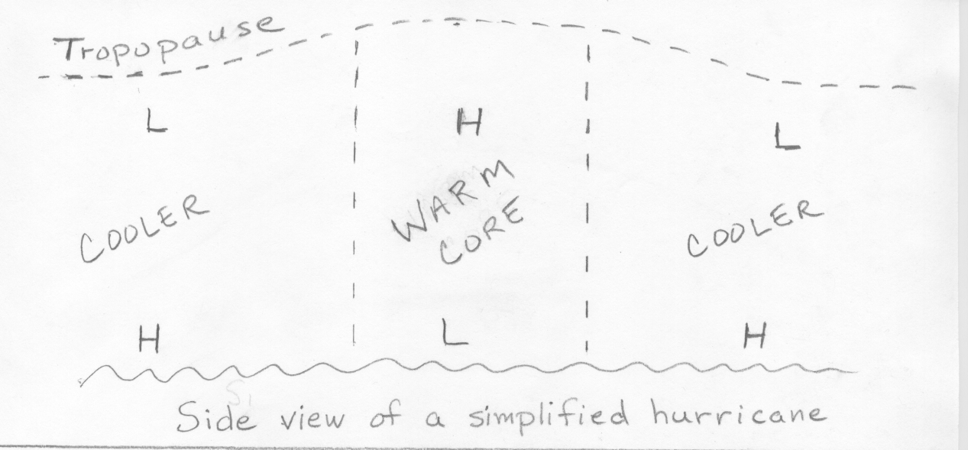
- Hurricanes are called “warm core” systems or warm core lows because the column of air above the surface low pressure area is warmer than the air surrounding the column. See figure above. The H’s and L’s in the figures indicate the positions of relatively high and low pressure respectively.
  - Explain how the warm core develops.
  - The pressure gradient across the ocean surface from high pressure outside the storm to low pressure at the storm center results in surface winds that blow counterclockwise and spiral inward around the center of low pressure. Explain why the strength of the pressure gradient (basically the change in pressure between the center of the storm and outside the storm) and thus the winds will get weaker as one moves upward above the ocean surface. (Note. If you continue to move upward, the pressure gradient will become zero, then reverse direction and get stronger in the reverse direction.)
  - Wintertime middle latitude low pressure areas are called “cold core” lows because the column of air above the surface low is colder than the surrounding air (see figure below). Most often cold core lows are not vertically stacked as shown, but are tilted with respect to the vertical; however, that would not change the answer for the question that follows. As with the warm core low, the pressure gradient across the ground surface from high pressure outside the storm to low pressure at the storm center results in surface winds that blow counterclockwise and spiral inward around the center of low pressure. For the cold core low, explain why the strength of the pressure gradient and thus the winds will get stronger as one moves upward above the ground surface. (Note. For the cold core low, the pressure gradient remains in the same direction and gets stronger as one moves from the ground surface to the top of the troposphere. This is why we generally see the strongest winds near the jet stream in association with winter storm systems.)
