Thursday Feb. 2, 2012
Some music from Calexico, a local group. You heard Along Again Or (3:31), World Drifts In (4:40), Ballad of Cable Hogue (3:30). Calexico was joined in the last two songs by a local mariachi band, Mariachi Luz de Luna.
The Experiment #1 reports are due next Tuesday. There is still time to bring your materials to my office and pick up the supplementary information handout. The Experiment #2 materials should become available Thursday next week.
Ordinarily you will be given the full class period for a quiz. But because today's quiz is a practice quiz we'll cover a little new material first.

We had time to learn about the ideal gas law this morning. That is the first step in really understanding why warm air rises and cold air sinks.

Hot air balloons rise (they also sink), so does the relatively warm air in a thunderstorm updraft (it's warmer than the air around it). Conversely cold air sinks. The surface winds caused by a thunderstorm downdraft (as shown above) can reach speeds of 100 MPH (stronger than many tornadoes) and are a serious weather hazard.
A full understanding of these rising and sinking motions is a 3-step process (the following is from the bottom part of p. 49 in the photocopied ClassNotes).

We will first learn about the ideal gas law (today). That is an equation that tells you which properties of the air inside a balloon work to determine the air's pressure. Then, next Tuesday, we will look at Charles' Law, a special situation involving the ideal gas law (air temperature and density change together in a way that keeps the pressure inside a balloon constant). We'll learn about the vertical forces that act on air (an upward and a downward force).
Students working on Experiment #1 will need to understand the ideal gas law to be able to explain why/how their experiment works.
The figure above makes an important point: the air molecules in a balloon "filled with air" really take up very little space. A balloon filled with air is mostly empty space. It is the collisions of air molecules traveling at 100s of miles per hour with the inside walls of the balloon that keep it inflated.

Up to this point in the semester we have been thinking of pressure as being determined by the weight of the air overhead. Air pressure pushes down against the ground at sea level with 14.7 pounds of force per square inch. If you imagine the weight of the atmosphere pushing down on a balloon sitting on the ground you realize that the air in the balloon pushes back with the same force. Air everywhere in the atmosphere pushes upwards, downwards, and sideways.
The ideal gas law equation is another way of thinking about air pressure, sort of a microscopic scale version. We ignore the atmosphere and concentrate on just the air inside the balloon. Pressure (P) will be on the left hand side of the equation. Relevant properties of the air inside the balloon will be found on the right hand side.

In A
the pressure produced by the air molecules inside a balloon will first depend on how many air molecules are there, N. If there weren't any air molecules at all there wouldn't be any pressure. As you add more and more add to something like a bicycle tire, the pressure increases. Pressure is directly proportional to N; an increase in N causes an increase in P. If N doubles, P also doubles (as long as the other variables in the equation don't change).
In B
air pressure inside a balloon also depends on the size of the balloon. Pressure is inversely proportional to volume, V . If V were to double, P would drop to 1/2 its original value.
Note
it is possible to keep pressure constant by changing N and V together in just the right kind of way. This is what happens in Experiment #1 that some students are working on. Here's a little more detailed look at that experiment.
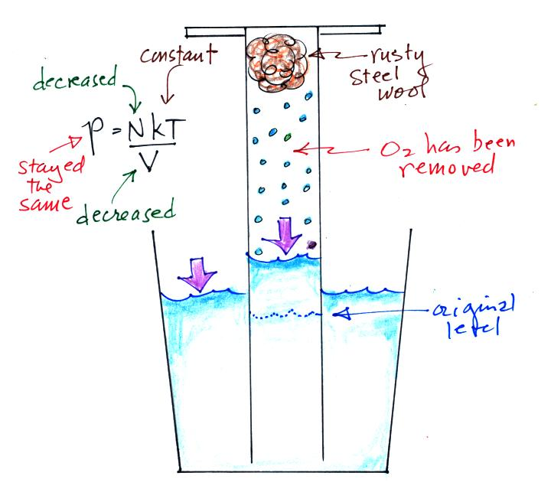
An air sample is trapped together with some steel wool inside a graduated cylinder. The cylinder is turned upside down and the open end is stuck into a glass of water. This is shown at left above. Water will move into or out of the cylinder to keep P_{out} equal to P_{in}.
Oxygen in the cylinder reacts with steel wool to form rust. Oxygen is removed from the air sample which causes N (the total number of air molecules) to decrease. Removal of oxygen would ordinarily cause a drop in P_{in}. But, as oxygen is removed, water rises up into the cylinder decreasing the air sample volume. N and V both decrease in the same relative amounts and the air sample pressure remains constant. If you were to remove 20% of the air molecules, V would decrease to 20% of its original value and pressure would stay constant.

Part C: Increasing the temperature of the gas in a balloon will cause the gas molecules to move more quickly. They'll collide with the walls of the balloon more frequently and rebound with greater force. Both will increase the pressure. You shouldn't throw a can of spray paint into a fire because the temperature will cause the pressure inside the can to increase and the can could explode.
Surprisingly, as explained in Part D, the pressure does not depend on the mass of the molecules. Pressure doesn't depend on the composition of the gas. Gas molecules with a lot of mass will move slowly, the less massive molecules will move more quickly. They both will collide with the walls of the container with the same force.
The figure below (which replaces the bottom of p. 51 in the photocopied ClassNotes) shows two forms of the ideal gas law. The top equation is the one we just derived and the bottom is a second slightly different version. You can ignore the constants k and R if you are just trying to understand how a change in one of the variables would affect the pressure. You only need the constants when you are doing a calculation involving numbers (which we won't be doing).

We'll come back to this topic next week.

Next we watched a 10 minute video from a PBS program called "The Adventurers." It documented Auguste Piccard's first trip into the stratosphere by balloon.

The remainder of the period was devoted to the Practice Quiz. If you missed the quiz I'd suggest you download it so you can at least become familiar with the format. You can also download answers to the quiz questions.
Quiz #1 coming up in 2 weeks (Feb. 16) will cover the same material that was on the Practice Quiz plus newer material that we cover between now and then (such as the ideal gas law).

