NATS 101 Optional Assignment Name___________Answers_____________
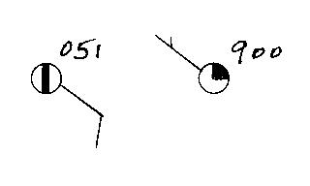
1. What are the actual sea level pressure values
plotted at right using the station model notation?

1005.1 mb and 990.0 mb
You must add either a 9 or a 10 and a decimal point
in front of the plotted data. So the first example would be either 905.1 or 1005.1 mb. Then you pick the value that falls between 950 and 1050 mb, so the answer is 1005.1 mb. The second example would be either 990.0 or 1090.0 mb
990.0 falls between 950 and 1050, 1090.0 is too big.

2. The atmosphere is split into layers (troposphere, stratosphere, mesosphere, etc.) according to how ___d___ changes with altitude.
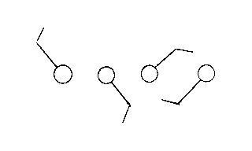
a. composition b. density c. pressure d. temperature

3. Which of the figures at right
shows winds blowing from the southwest?
from left to right these winds are blowing from the
NW, SE, NE, and SW.

4. The ideal gas law equation gives the relationship between the number (N), temperature (T), and pressure (P) of the air in a volume (V):
P = (N k T) / V
If N, V, and T were each to increase by a factor of 2, the pressure would
a. increase by 2 b. increase by 4 c. decrease by 2 d. decrease by 4

Increasing N and T each by a factor of 2 will increase the value of the numerator by 4
Increasing V by 2 will increase the denominator by 2.
The overall change (numerator/denominator) is a factor of 2 increase
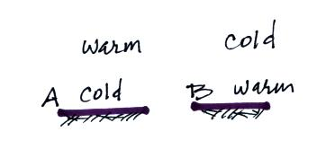
5. Would stable atmospheric conditions
be found in FIG. A or FIG. B in the
picture at right?
Temperature is increasing with increasing altitude in
Figure A. That is a temperature inversion and produces stable atmospheric conditions

6. Which of the following does not cause rising air motions?
a. cold front b. surface high pressure c. warm front d. surface low pressure
sinking air motions are found with surface high pressure
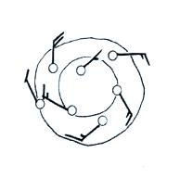

7. Are the winds spinning in a CLOCKWISE or
COUNTERCLOCKWISE direction in the figure
at right. Are the winds CONVERGING or
DIVERGING. Does the figure show a surface
HIGH or LOW pressure center.

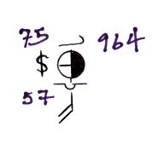
8. Show at right how the following weather observations would be plotted using the station model notation. (the data is plotted at right)
Temperature = 75º F cloud cover = 5/8
Pressure = 996.4 mb dew point = 57º F
Wind direction & speed = south at 20 knots
Low clouds = stratocumulus clouds
High altitude clouds = filaments of cirrus clouds
Dust or sand raised by the wind at the time
of observation.

9. Before being plotted on a surface weather map,
the station pressure measurement must be corrected for __a___.
a. altitude b. latitude c. temperature d. time

10. Use the altitude and pressure data in the figure below to
a. determine the station pressure at Point A
b. determine the sea level pressure for Station B
c. determine the altitude of Point C
(you can assume that pressure decreases at a rate of 1 mb per 10 meters of altitude gain)
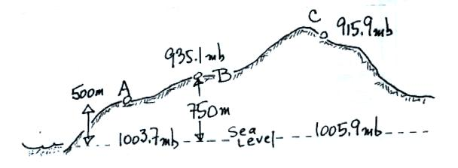

a. Pressure will decrease 500 m x (1 mb/10 m) = 50 mb when going from sea level to Pt. A
Thus the station pressure at Pt. A will be 1003.7 mb – 50 mb = 953.7 mb.
b. Pressure will increase 750 m x (1 mb/10 m) = 75 mb when going from Pt. B to sea level
Thus the sea level pressure for Pt. B will be 935.1 mb + 75 mb = 1010.1 mb
c. There is a 1005.9 mb – 915.9 mb = 90 mb pressure difference between Pt. c and sea level
In this case we divide 90 mb by the (1 mb/10 m) rate of pressure change and get 900 m
Pt. C is 900 meters above sea level

11. ___d___ below is the symbol for a northern hemisphere hurricane. ___c___ is the symbol for a southern hemisphere tropical storm.
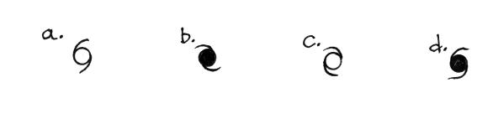

Hurricanes have low pressure centers (in both the northern and southern hemispheres). Surface winds will spin in a counterclockwise direction around hurricanes and tropical storms in the northern hemisphere. The winds spin clockwise in the southern hemisphere.

