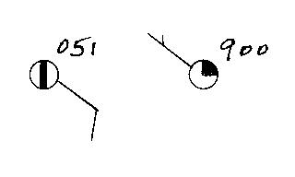
NATS 101 Optional Assignment Name__________________________________

1. What are the actual sea level pressure values
plotted at right using the station model notation?

2. The atmosphere is split into layers (troposphere, stratosphere, mesosphere, etc.) according to how _______ changes with altitude.
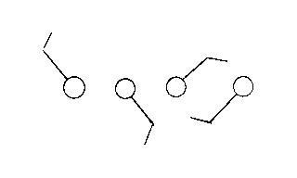
a. composition b. density c. pressure d. temperature

3. Which of the figures at right
shows winds blowing from the southwest?

4. The ideal gas law equation gives the relationship between the number (N), temperature (T), and pressure (P) of the air in a volume (V):
P = (N k T) / V
If N, V, and T were each to increase by a factor of 2, the pressure would
a. increase by 2 b. increase by 4 c. decrease by 2 d. decrease by 4

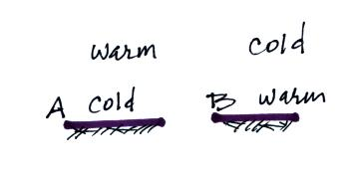
5. Would stable atmospheric conditions
be found in FIG. A or FIG. B in the
picture at right?

6. Which of the following does not cause rising air motions?
a. cold front b. surface high pressure c. warm front d. surface low pressure
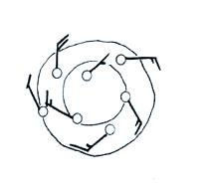

7. Are the winds spinning in a CLOCKWISE or
COUNTERCLOCKWISE direction in the figure
at right. Are the winds CONVERGING or
DIVERGING. Does the figure show a surface
HIGH or LOW pressure center.

8. Show at right how the following weather observations would be plotted using the station model notation.
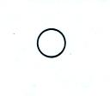
Temperature = 75º F cloud cover = 5/8
Pressure = 996.4 mb dew point = 57º F
Wind direction & speed = south at 20 knots
Low clouds = stratocumulus clouds
High altitude clouds = filaments of cirrus clouds
Dust or sand raised by the wind at the time
of observation.

9. Before being plotted on a surface weather map,
the station pressure measurement must be corrected for ______.
a. altitude b. latitude c. temperature d. time

10. Use the altitude and pressure data in the figure below to
a. determine the station pressure at Point A
b. determine the sea level pressure for Station B
c. determine the altitude of Point C
(you can assume that pressure decreases at a rate of 1 mb per 10 meters of altitude gain)
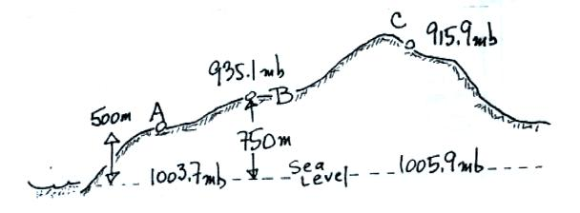

11. _______ below is the symbol for a northern hemisphere hurricane. _______ is the symbol for a southern hemisphere tropical storm.
