ATMO/ECE 489/589 Spring 2011
Homework #1 due Tue., Feb. 1

1. (8 pts) The fair-weather electric field at the earth's surface is approximately 200 V/m and points downward. At an altitude of 1500 m, the field still points downward but is only 20 V/m. What is the average volume charge density in the atmosphere between the ground and 1500 m? What polarity does this space charge have?

2. (10 pts) A lightning leader is often modeled as having a narrow diameter conducting core surrounded by a cylindrical envelope of space charge. Assuming that the channel is infinitely long and straight, and that the total charge per unit length on the leader is ρ_{o} (C/m), derive an expression for the electric field, E(r), everywhere inside and outside the space charge radius. You can assume that the volume charge density within R is uniform, and you can ignore the conducting core.

In practice R will be controlled by the local breakdown electric field, E_{B}, Estimate the minimum R when ρ_{o} = 10⁻³ C/m and E_{B} = 3 x 10⁶ V/m.

3. (12 pts) A point charge, Q, is located at an altitude, H, above a grounded conducting plane of infinite extent.

(a) Is there an attractive or repulsive force between Q and the conducting plane?
(b) Derive an expression for the electric field at the ground as a function of horizontal distance, D (you can assume the ground is flat; it’s not drawn very well below).
(c) Determine the surface charge density as a function of D, σ(D).
(d) Integrate the surface charge density over the entire conducting plane.

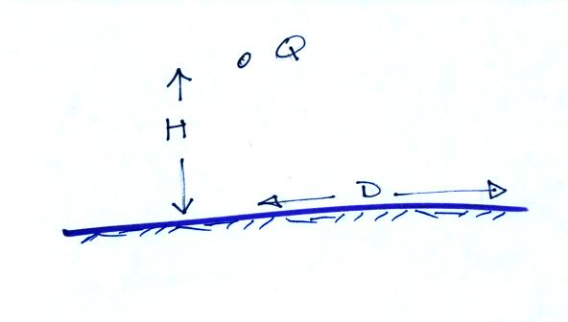
4. (EC*) Verify the following
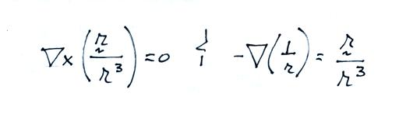

*EC means extra credit (sort of). Any points earned on this extra credit question can be used to make up for points missed on Questions 1 – 3. You can earn up to a maximum of 30 pts on this assignment

