yet another NATS 101 Name________Answers____________________
In-class Optional Assignment

1.
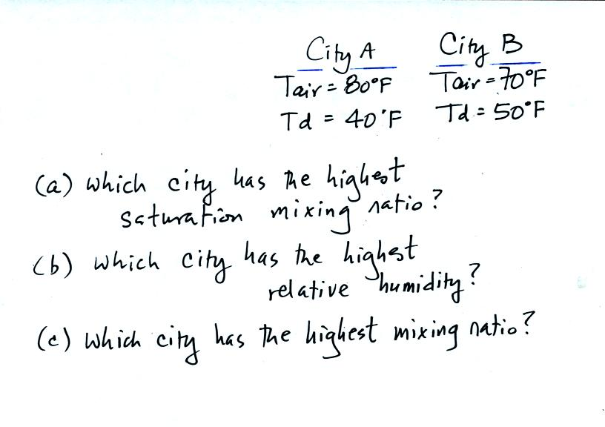
(a) City A. Saturation mixing ratio depends on temperature. The city with the highest air temperature will have the highest saturation mixing ratio.
(b) City B. The difference between the air temperature and the dew point temperature gives you an idea of the relative humidity. A small difference means high relative humidity (zero difference means RH=100%)
(c) City B. The mixing ratio and the dew point temperature both provide a measure of the actual amount of water vapor in the air. The city with the highest dew point temperature will also have the highest mixing ratio.

2. Which two of the following instruments do you think might be used to measure moisture in the air?
a. anemometer b. barometer c. hygrometer d. psychrometer

3.
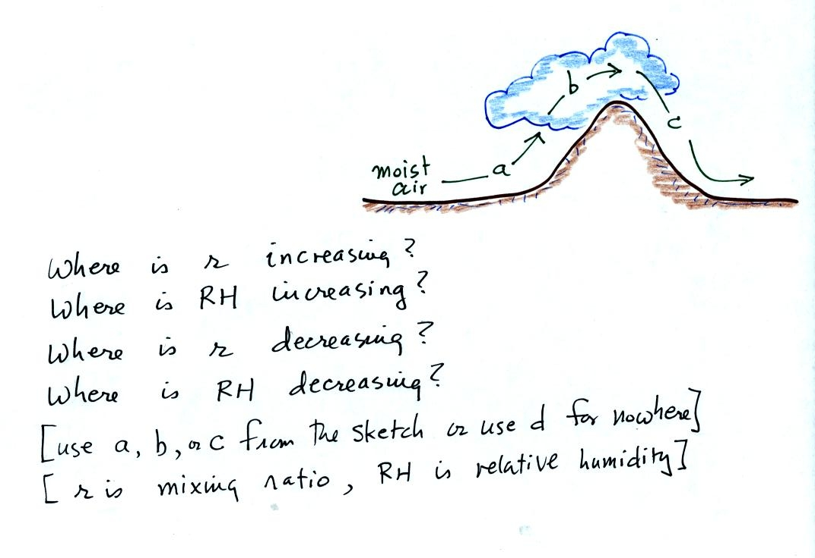
The moist air is rising, expanding, and cooling along Path a. Cooling moist air will increases the relative humidity. The cloud base indicates the rising air has cooled to the dew point and the RH has reached 100%.

The air continues to cool along Path b. Cooling moist air below its depend will cause water vapor to condense. Water vapor is being removed from the air along Path B and the mixing ratio will decrease.

The descending air along Path c will warm. This lowers the relative humidity (that’s why the cloud disappears).

The mixing ratio doesn’t increase anywhere in the picture.

4. Warming moist air will cause the mixing ratio to __same___, the saturation mixing ratio to __incr___, the relative humidity to ___decr___, and the dew point temperature to ___same___. (fill in each blank with INCRease, DECRease, or remain the SAME)

