yet another NATS 101 Name_____________________________________
In-class Optional Assignment

1.
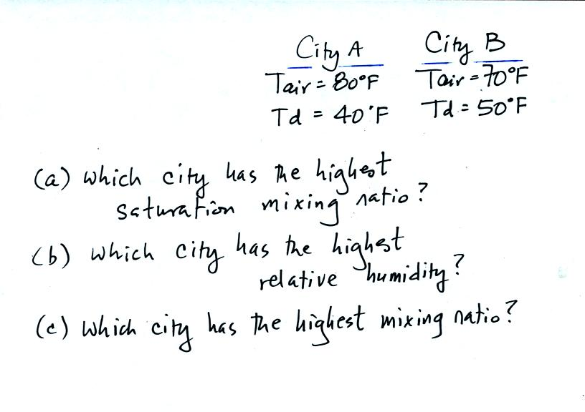

2. Which two of the following instruments do you think might be used to measure moisture in the air?
a. anemometer b. barometer c. hygrometer d. psychrometer

3.
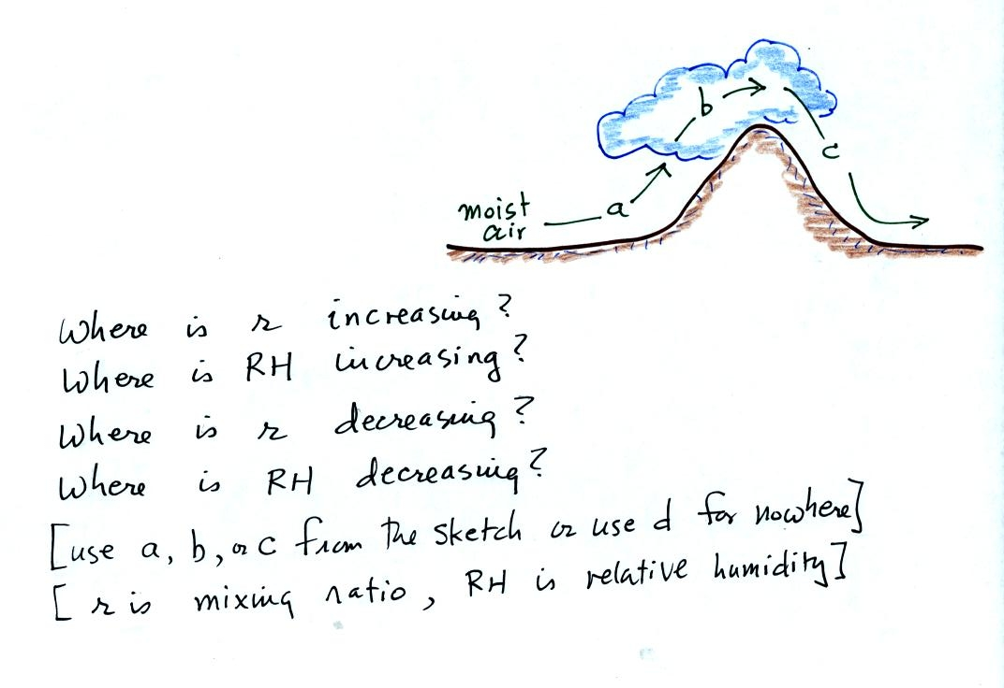
4. Warming moist air will cause the mixing ratio to __________, the saturation mixing ratio to __________, the relative humidity to __________, and the dew point temperature to __________. (fill in each blank with INCRease, DECRease, or remain the SAME)

