NATS 101 Name_______________________________
In-class Optional Assignment
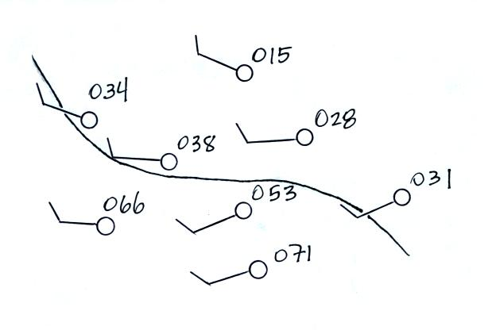
1.

Is this the 996 1000 1004 or 1008 millibar isobar?

2. Does the figure below show a center of HIGH or LOW pressure
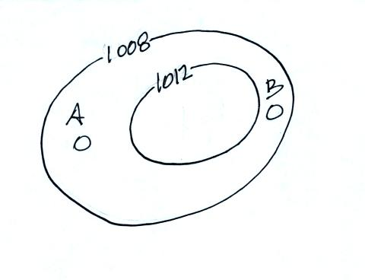

You would expect to find _______ winds blowing at _______ at Point A
You would expect _______ winds blowing at _______ at Point B
a. NW, 10 knots b. NE, 10 knots c. SE, 10 knots d. SW, 10 knots
e. NW, 20 knots f. NE, 20 knots g. SE, 20 knots h. SW, 20 knots

3. Would winds blowing around a center of HIGH LOW pressure at Point B produce the temperature pattern below?
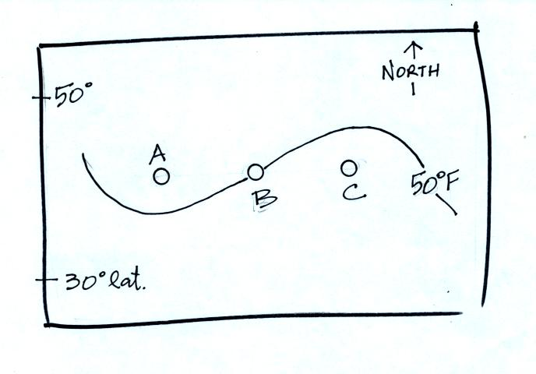

Points A and C are located at the same latitude. Would the air temperature at Point A most likely be WARMER, EQUAL, or COLDER than(to) the air at Point C?

4. See if you can draw in the cold front in the figure below (look for a change in air temperature and wind direction on opposite sides of the front)
