NATS 101 Name_______________________________
In-class Optional Assignment

1. The top of a thunderstorm is normally POSITIVELY NEGATIVELY charged.

2. Is the following statement TRUE or FALSE? A lightning rod is designed to be struck by lightning and then safely conduct the lightning current around the structure it protects.

3. Early in the summer thunderstorm season, “dry lightning” is the cause of many forest fires in Arizona. What is dry lightning?

4. Lance Armstrong won the Tour de France _______ times.
a. 1 b. 3 c. 5 d. 7 e. 9

5. An air mass thunderstorm last about _______ hour(s). Most tornadoes have winds of _______ MPH or less. About _______ people are killed by lightning every year. An air mass thunderstorm will grow to a height of about _______ kilometer(s). There are about _______ tornadoes in the US every year. (fill in each blank with 1, 10, 100, or 1000)

6. _______ below is the most common type of lightning, _______ is the least common type.
a. negative cloud-to-ground lightning b. intracloud lightning
c. positive cloud-to-ground lightning d. upward lightning

7. What is the name given to the weak electrical discharge that is sometimes seen at the tops of tall pointed objects on the ground underneath a thunderstorm?

8. The _______ is the first process in a normal negative cloud-to-ground lightning discharge.
a. return stroke b. stepped leader c. dart leader d. upward discharge

9. _______ produce(s) the positive and negative electrical charge in a thunderstorm that causes lightning
a. Cosmic rays b. Freezing and melting of precipitation particles
c. Ultraviolet light d. Collisions between different types of precipitation particles
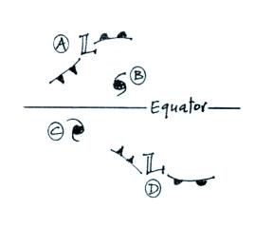
10. You would find counterclockwise spinning
winds around storms _______ and _______
in the figure at right. Storms _______ and
_______ would slowly move from east to west.

