NATS 101 Name_______________________________
Optional Assignment

1. Show at right how the following weather
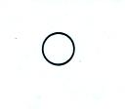
observations would be plotted using the
station model notation.
Temperature = 85º F cloud cover = 1/8
Pressure = 996.4 mb dew point = 37º F
Wind direction & speed = south & 15 knots
Low clouds = fair weather cumulus clouds
High altitude clouds = filaments of cirrus clouds
Dust or sand raised by the wind at the time
of observation.

2. The air temperature is always GREATER LESS than or equal to the dew point temperature.
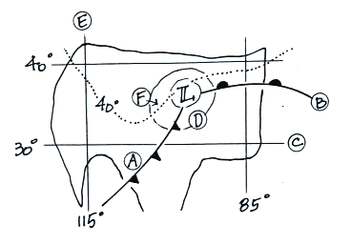
3. Find an example of each of the following on
the surface weather map at right.

line of constant latitude_______

isobar_______ warm front_______

cold front_______ isotherm_______

line of constant longitude_______

4. The large L symbol that you see on a surface weather map indicates a region of low _______.
a. altitude b. air density c. air pressure d. air temperature

5. Use the figure at right to fill in the values of the following weather variables.
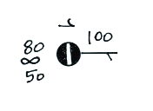
Temperature_________ cloud cover_________

Pressure____________ dew point_________

Wind direction__________ Wind speed__________

Present weather conditions__________

6. Before being plotted on a surface weather map,
the station pressure measurement must be corrected for ______.
a. altitude b. latitude c. temperature d. time

7. Which of the following does not produce rising air motions?
a. cold front b. surface high pressure c. surface low pressure d. warm front
8. Upper air weather data are collected (using radiosondes) twice each day, at 00Z and 12Z.
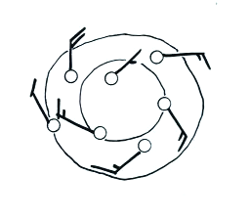
00Z is __________ MST and 12Z is __________MST.

9. Are the winds spinning in a CLOCKWISE or
COUNTERCLOCKWISE direction in the figure
at right. Are the winds CONVERGING or
DIVERGING. Does the figure show a surface
LOW or HIGH pressure center?

10. City A in the figure below is 250 m above sea level. The sea level pressure for City A is 1008.4 mb, what would the station pressure for City A be? The station pressure for City B is 949.1 mb, what would the sea level pressure for that city be (City B is 600 m above sea level). Use the station and sea level pressure values given for City C to determine the altitude of City C.
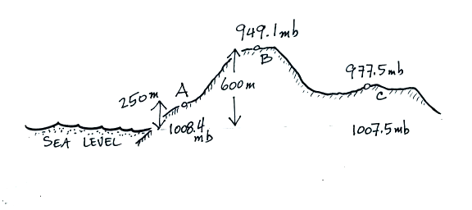

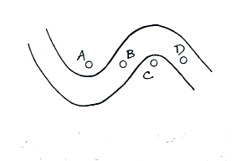

11. Point_______on the upper level chart at right is in a
trough. The warmest air would probably be found
below Point _______.

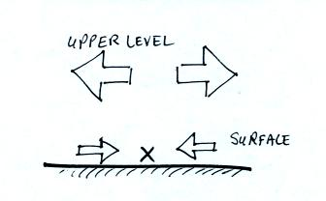

12. Surface winds are converging and the upper level winds
are diverging in the crossectional figure at right. Would
you expect to find surface LOW or HIGH pressure at
Point X in the figure? Based on the relative amounts of
convergence and divergence would you expect the pressure
at Point X to INCREASE or DECREASE?

