NATS 101 Name_______________________________
In-class Optional Assignment

1. If the force of gravity on the earth were to increase but the amount (mass) of air in the atmosphere stayed the same, would the atmospheric pressure at sea level INCREASE, DECREASE, or remain CONSTANT?

2. If you traveled from the Tucson valley (2500’ alt.) to the top of Mt. Lemmon (9000’ alt) you would expect to see a __________ in air temperature, a __________ in air density, and a __________ in air pressure. (fill in each blank with DROP or RISE)

3. To determine the upward buoyant force exerted on an object held underwater, you would need to know the object’s
a. density b. mass c. volume d. weight

4. The ideal gas law equation gives the relationship between the number (N), temperature (T), and pressure (P) of the air in a volume (V):

P = (N k T) / V

If N, V, and T were each to increase by a factor of 2, the pressure would
a. increase by 2 b. increase by 4 c. decrease by 2 d. decrease by 4
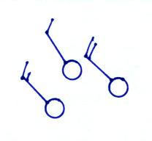

5. Are the winds at right blowing from
the NE NW SE or SW?

6. Absorption of ultraviolet light by ozone in the STRATOSPHERE TROPOSPHERE is the reason why temperature there INCREASES DECREASES with increasing altitude.
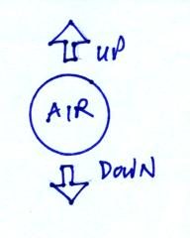

7. The strength of the UPWARD DOWNWARD force
exerted on an air parcel is determined by the mass of
the air inside the parcel.

8. A gallon of water weighs about 8 pounds. Underwater, would the gallon of water weigh MORE than 8 lbs, LESS than 8 lbs, or would the bottle weigh practically NOTHING?

9. This is a big week for the instructor of this class – has 2 favorite TV shows begin new seasons. What do you think those two shows are?
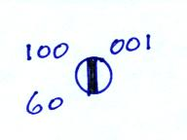

10. Four distinct pieces of weather data are plotted at right.
Identify any two of them.

