Friday Mar. 13! again (the second time this semester)
About a song and a half this afternoon from Missy Higgins. She'll be appearing at the Rialto Theatre in Tucson on the Spring Equinox (Fri., Mar. 20)
The quizzes have been graded. Check the grading carefully.
I hope to grade all the 1S1P reports over Spring Break together with the Expt. #1 revised reports and the Controls of Temperature Optional Assignments.
If that happens (and it may not because remember St. Patrick's day and the Spring Equinox are next week, March Madness starts next week, the weather forecast is for above average temperatures, ...) I will try to put together somekind of a midterm grade summary.
We're going to cover 2, maybe 3, topics today.

Topic #1
On the equinoxes, the sun rises exactly in the east and sets exactly in the west. The picture below shows the position of the sun at sunrise (around 6:30 am on the spring and fall equinox in Tucson).
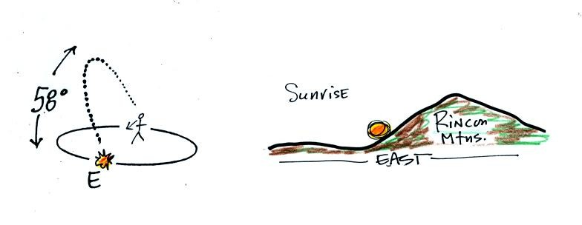
At noon you need to look about 60 degrees above the southern horizon to see the sun
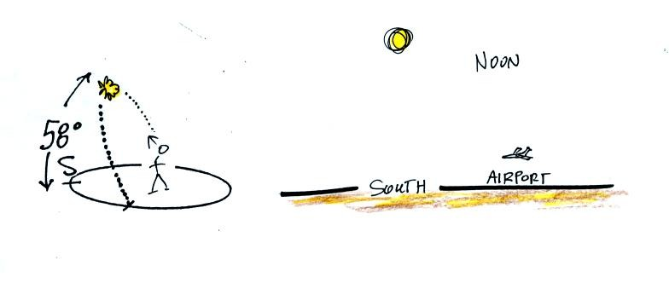
The sun sets exactly in the west at around 6:30 pm on the equinoxes in Tucson
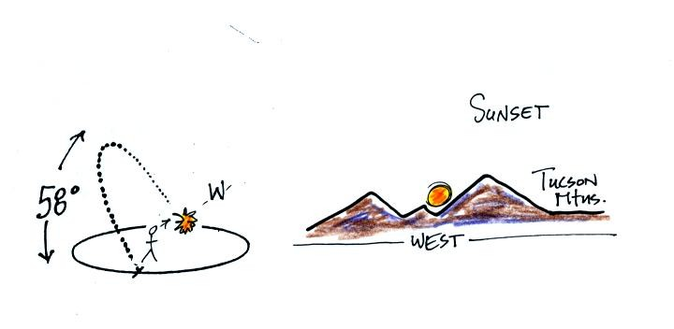
This is a 2 pm class
Most of you are more likely to see the sun set (perhaps) than see the sun rise. The figure below shows you about what you would see if you looked west on Speedway (from Treat Ave.) at sunset. In the winter the sun will set south of west, in the summer north of west (probably further south and north than shown here). On the equinoxes the sun sets exactly in the west.
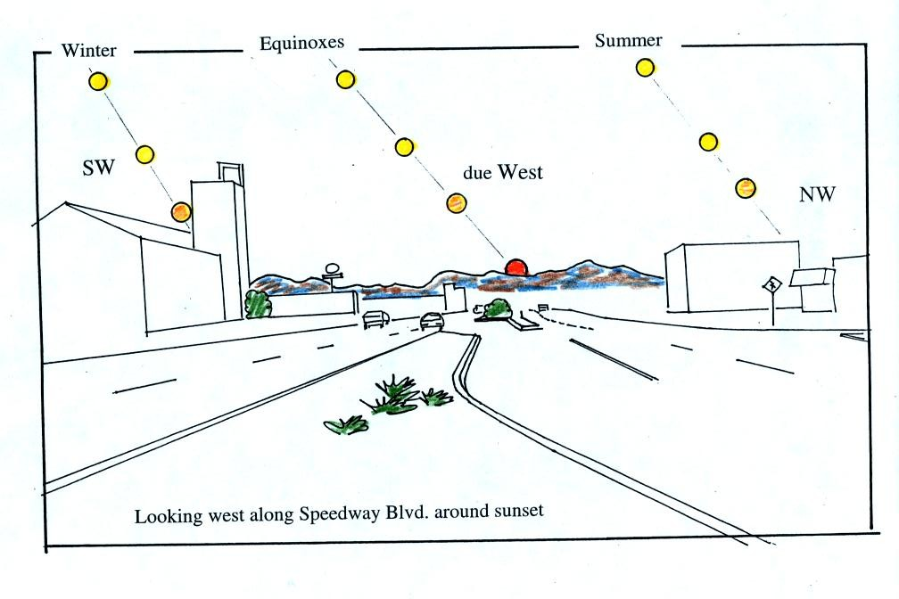
If you aren't careful, you can get yourself seriously injured, even killed, on or around the equinoxes.

The article below appeared in the Arizona Daily Star on or around the fall equinox.

The driver was looking straight at the setting sun. If his windshield was as dirty as the one on my car often is, he wouldn't have been able to see the pedestrian. I have a yellow 1980 Toyota Celica. If you see that car driving west on an east-west oriented street around sunset, LOOK OUT!
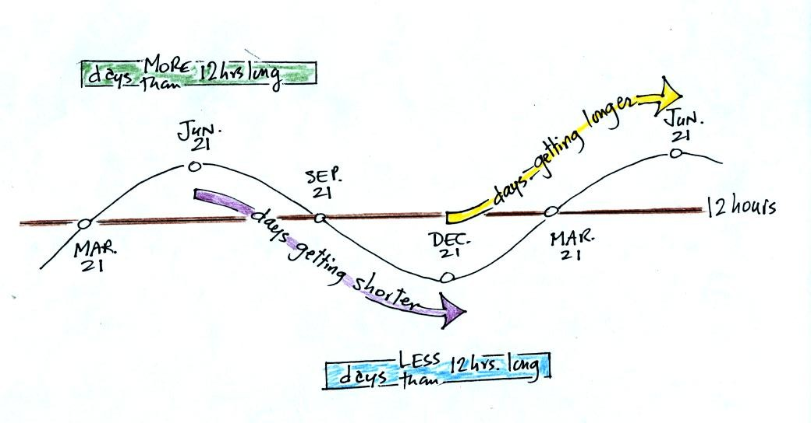
Dec. 21st, the winter solstice, is the shortest day of the year (about 10 hours of daylight in Tucson). The days have slowly been getting longer all semester. This will continue up until June 21, the summer solstice, when there will be about 14 hours of daylight. After that the days will start to shorten as we make our way back to the winter solstice.
The length of the day changes most rapidly on the equinoxes. The spring equinox is on Mar. 20 this year.

On to Topic #2
Do you remember the mysterious Point X near the Equator in the middle of the Pacific Ocean at the end of the Controls of Temperature online notes? That was just an excuse for me to tell you about an awesome field experiment I took part in several years ago.
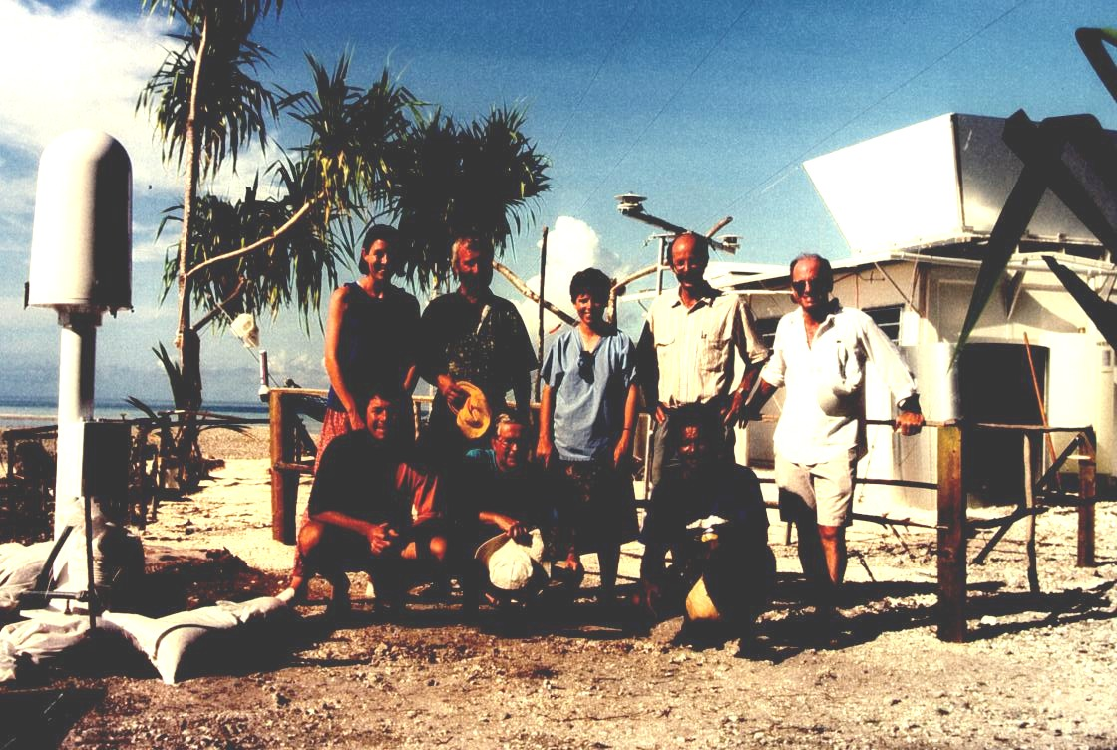
The photograph above appeared on the cover of the April 1994 issue of the Bulletin of the American Meteorological Society. If you look closely you'll notice your NATS 101 instructor (he had been given the nickname "Wilbur" by one of the members of the group, the other bald man's name was Orville). This photo was taken on Kapingamarangi Atoll (shown on the map below), shortly before all the men were about to board ship and leave Kapingamarangi. The two women (Erica at left, Maureen in the middle) were going to remain behind and operate all of the research equipment. The scene looks happy enough, but "Wilbur" revealed that he had taken a liking to one of the two women and was anything but happy.
What we were doing on Kapingamarangi? We were a small part of a much larger field experiment. Wilbur and Orville's job was to install the tall white lightning detector at the left edge of the photograph. They would later travel to Rabaul (on New Britain island) and Kavieng (New Ireland island) in Papua New Guinea and install two more detectors. Papua New Guinea would turn out to be a very different place. Until recently some of the highland tribes there practiced cannibalism. You can also get malaria in Papua New Guinea.
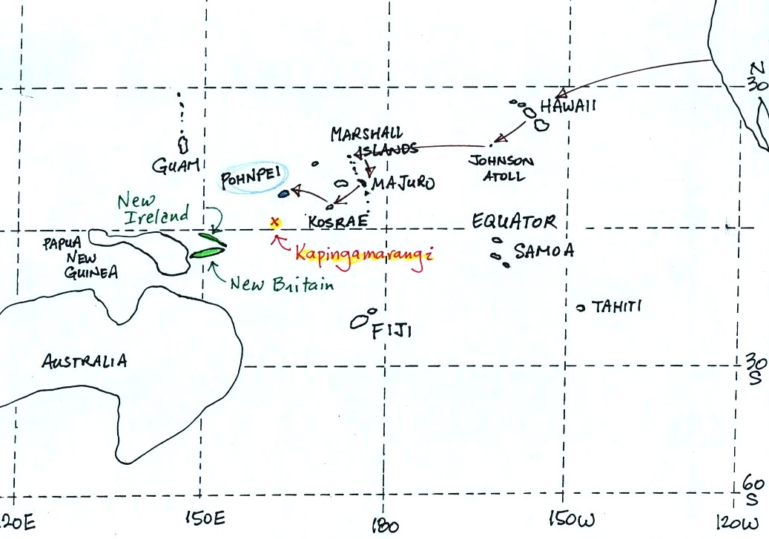
To get to Kapingamarangi you first need to fly to Pohnpei (an island in the Federated States of Micronesia). The route is shown above. Then you take a cargo ship for about a 4 day sail to Kapingamarangi. We had intended to fly to Pohnpei, set sail for Kapinga the next day, and then spend about a month on Kapingamarangi. The ship however was delayed 3 weeks. That gave us plenty of time to visit the island of Pohnpei but ultimately meant we could only spend a few days on Kapingamarangi..
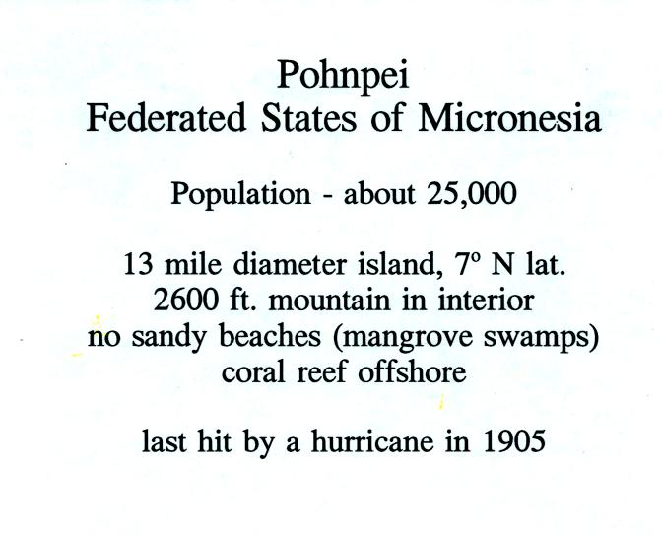
Pohnpei is a fairly large island and, together with some of the other Micronesian islands, is a popular, world-class, snorkeling and scuba diving destination. Pohnpei also has a weather station that is operated by the US National Atmospheric and Oceanic Administration (NOAA).
Here's a reminder of how temperatures change during the year in Tucson.
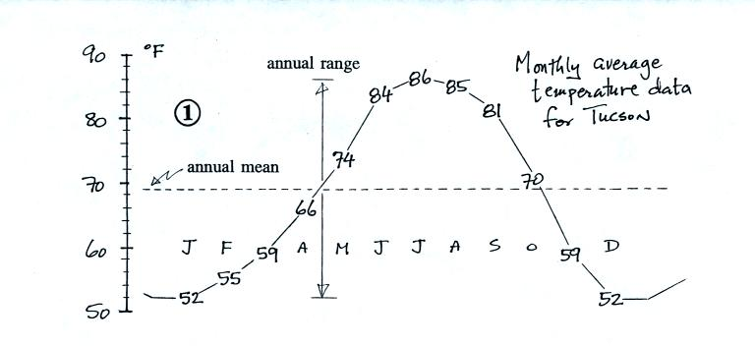
Pohnpei is located at low latitude in the middle of the Pacific Ocean. Both of those factors will reduce the annual range of temperature. How large do you think the annual range is there?
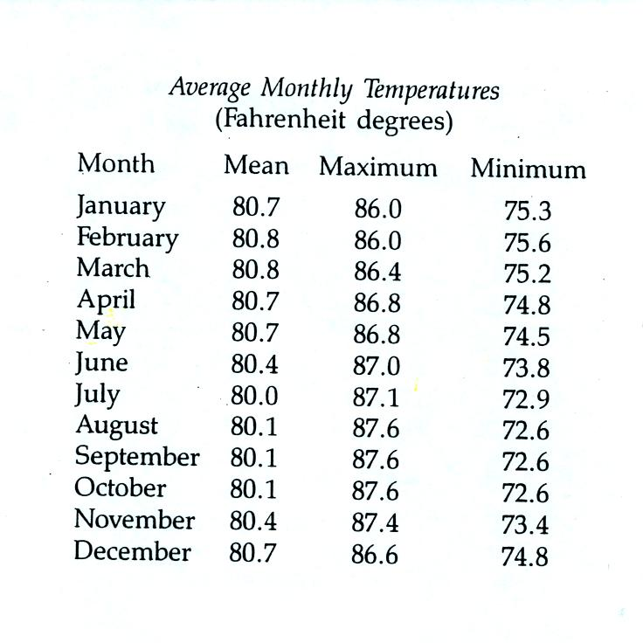
The average monthly temperatures in Pohnpei range from 80.8 F in February and March to 80.0 F in July. That's less than 1 F. The all-time record high temperature is 96 F, it has never dropped below 66 F on Pohnpei.

The following precipitation data show that Pohnpei is also one of the rainiest locations on earth
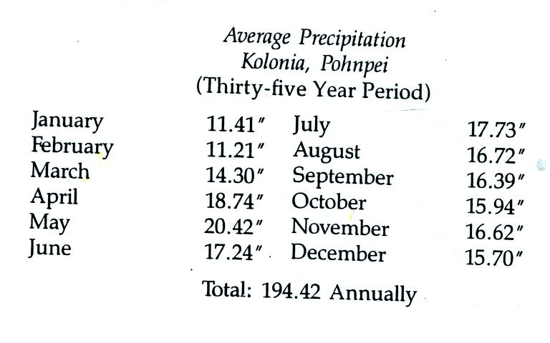
Close to 400 inches of rain may fall in the interior of Pohnpei. The rainiest location on earth is in Hawaii with about 460 inches of rain per year.
Pigs are also an important part of daily life on Pohnpei, Kapingamarangi, and the other islands in Micronesia.
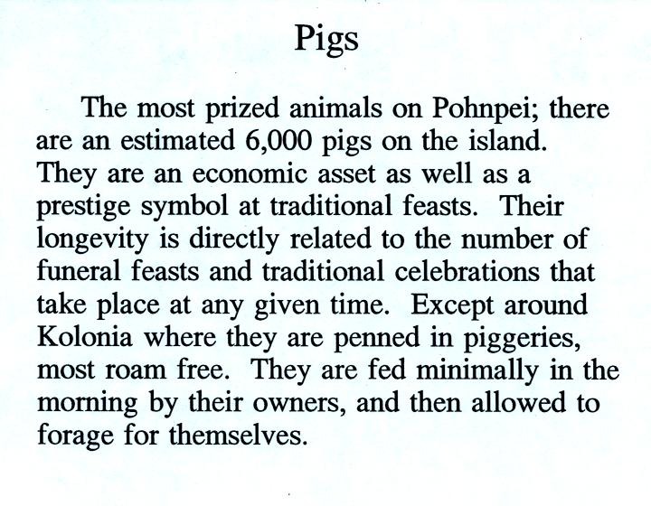
The Micro Glory (shown below) sails back and forth between Pohnpei and Kapingamarangi about once a month. The ship carries supplies to the people on Kapingamarangi and some other small islands. They pay for the supplies with pigs (the pigs are sold on Pohnpei). We shared deck space on the Micro Glory on the trip back to Pohnpei with 20 to 30 pigs (they were hoisted aboard in nets)
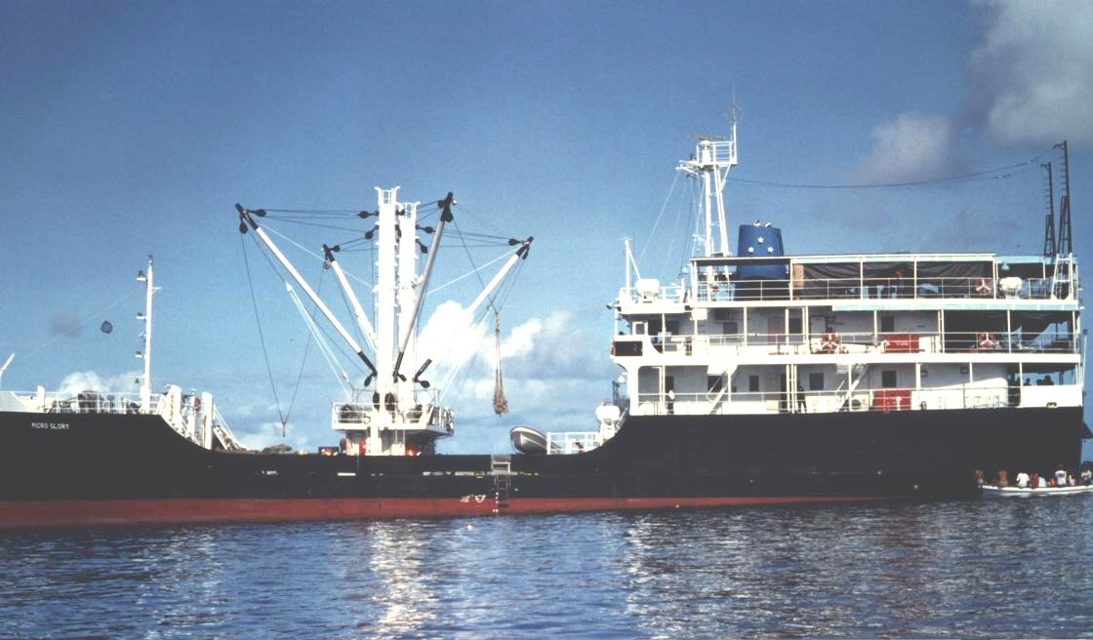
Most of the lower deck in the photo above (under the hoists) was occupied by pigs on the return trip. One of the pigs died on the return trip - that was a very serious matter.
We also had a chance to sample some of the local beverages.
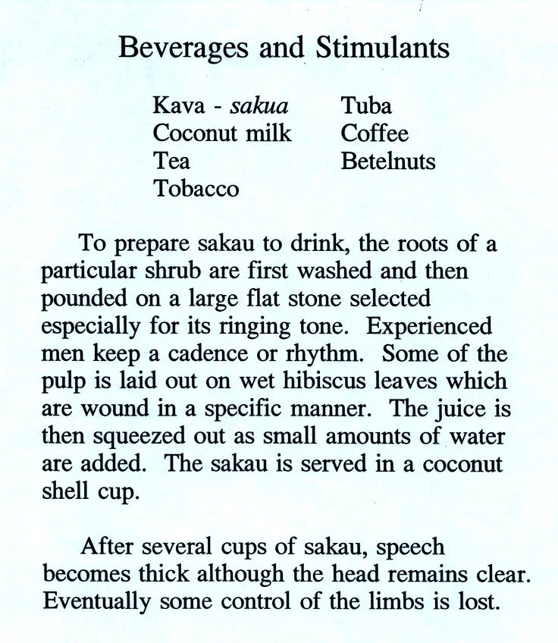
Drinking sakau (as it is called on Pohnpei) turns your mouth and throat numb. It is supposed to relax you, make you sleep more fully, and doesn't seem to have any after effects. Until fairly recently you could buy kava in pill form at local supermarkets. However, because of reports that it can cause serious liver problems, that is no longer the case. There are no reports of liver problems when drinking kava that has been prepared in the traditional way. Here is a link to a Wikipedia article on kava.
We never tried betelnut. Areca nuts are wrapped in betel leaves and chewed together with lime (lime is pretty caustic, that is one of the reasons I didn't try betelnut). The resulting mixture is a mild stimulant (some people add tobacco to the mix). The most interesting aspect, however, is that chewing betelnut colors your mouth and teeth bright red. You don't swallow betelnut, you spit it out. You see the bright red stains on sidewalks and the ground wherever you go. Most hotels will also have a large sign near the entrance reminding guests not to chew betelnut inside the hotel. You can read more about betelnut here.

Topic #3 Introduction to Humidity Variables
Try to read through this material before class on Mon., Mar. 23.
The following is an introduction to an important new topic: humidity (moisture in the air). This topic and the terms that we will be learning and using can be confusing. That's the reason for this introduction. We will be mainly be interested in 4 variables, what they are and what can cause their values to change. The variables are : mixing ratio, saturation mixing ratio, relative humidity, and dew point. You will find much of what follows on page 83 in the photocopied ClassNotes.
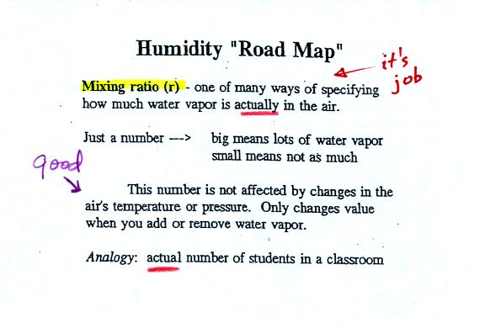
Mixing ratio tells you how much water vapor is actually in the air. Mixing ratio has units of grams of water vapor per kilogram of dry air (the amount of water vapor in grams mixed with a kilogram of dry air). It is basically the same idea as teaspoons of sugar mixed in a cup of tea. You may be tempted to click on the words highlighted in blue. Most of these aren't links. One of them is, it will take you to a hidden optional assignment.
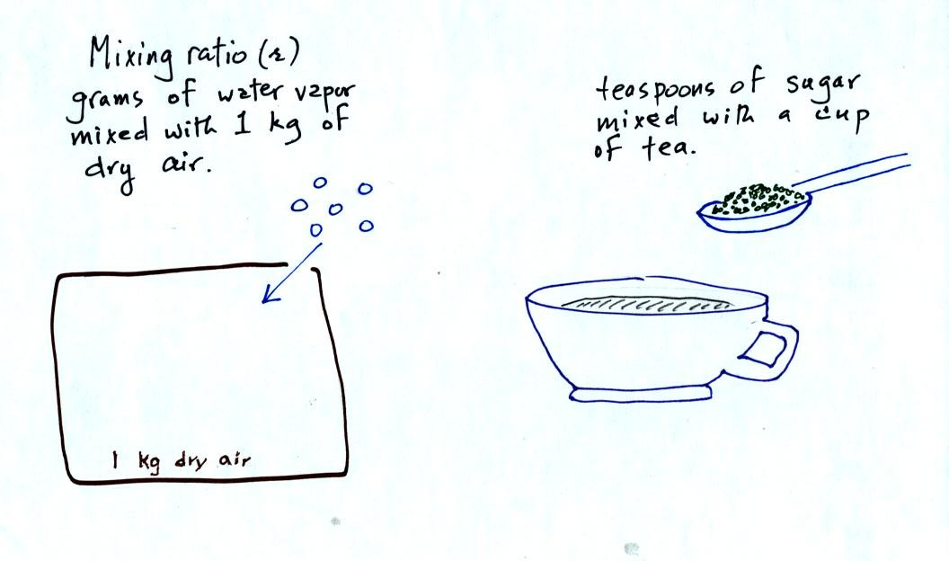
The value of the mixing ratio won't change unless you add water vapor to or remove water vapor from the air. Warming the air won't change the mixing ratio. Cooling the air won't change the mixing ratio (unless the air is cooled below its dew point temperature and water vapor starts to condense). Since the mixing ratio's job is to tell you how much water vapor is in the air, you don't want it to change unless water vapor is added to or removed from the air.
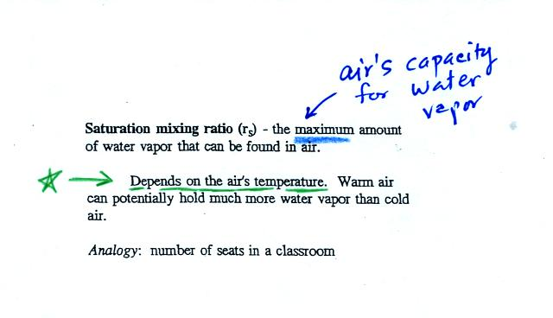
Saturation mixing ratio is just an upper limit to how much water vapor can be found in air, the air's capacity for water vapor. It's a property of air, it doesn't say anything about how much water vapor is actually in the air (that's the mixing ratio's job). Warm air can potentially hold more water vapor than cold air. This variable has the same units: grams of water vapor per kilogram of dry air. Saturation mixing ratio values for different air temperatures are listed and graphed on p. 86 in the photocopied class notes.
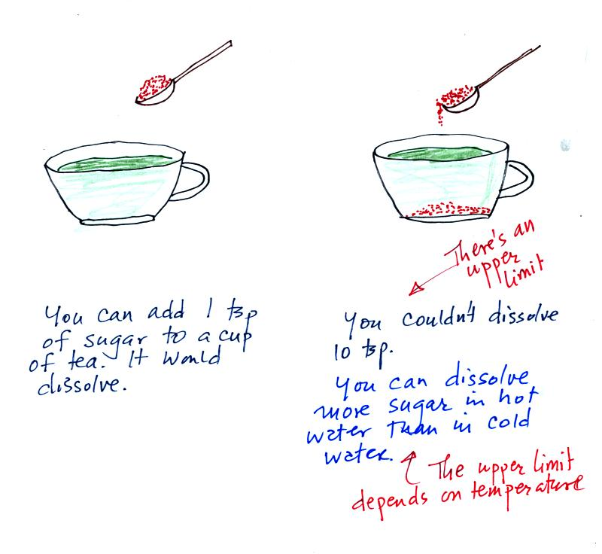
Just as is the case with water vapor in air,
there's a limit to how much sugar can be dissolved in a cup of hot water. You can dissolve more sugar in hot water than in cold water.
The dependence of saturation mixing ratio on air temperature is illustrated below:
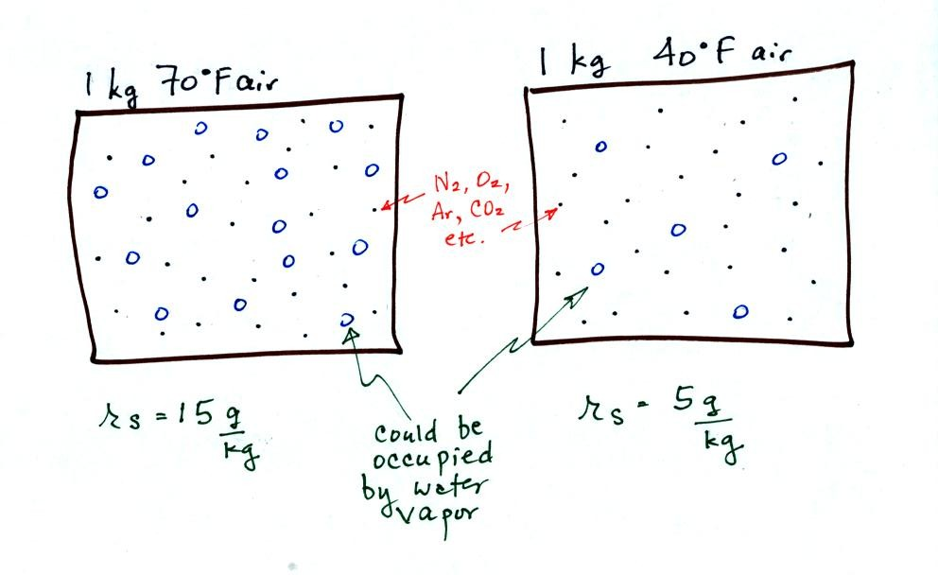
The small specks represent all of the gases in air except for the water vapor. Each of the open circles represents 1 gram of water vapor that the air could potentially hold. There are 15 open circles drawn in the 1 kg of 70 F air; each 1 kg of 70 F air could hold up to 15 grams of water vapor. The 40 F air only has 5 open circles; this cooler air can only hold up to 5 grams of water vapor per kilogram of dry air.
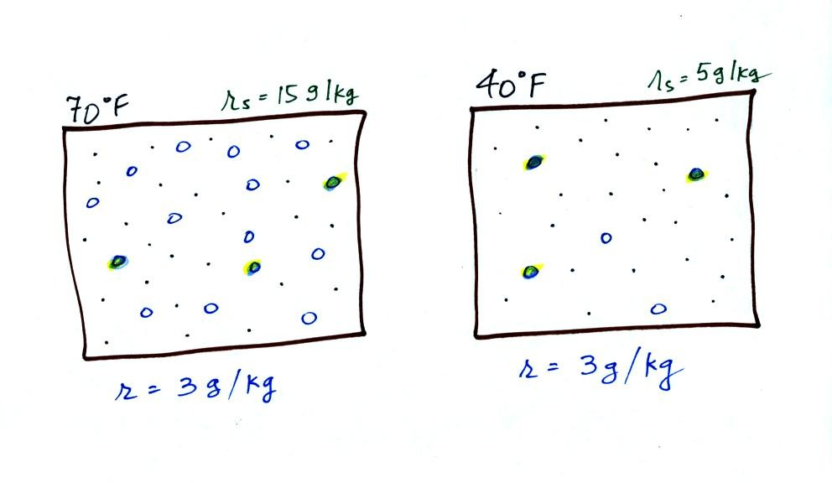
Now we have gone and actually put some water vapor into the volumes of 70 F and 40 F air. The same amount, 3 grams of water vapor, has been added to each volume of air. The mixing ratio, r, is 3 g/kg in both cases.
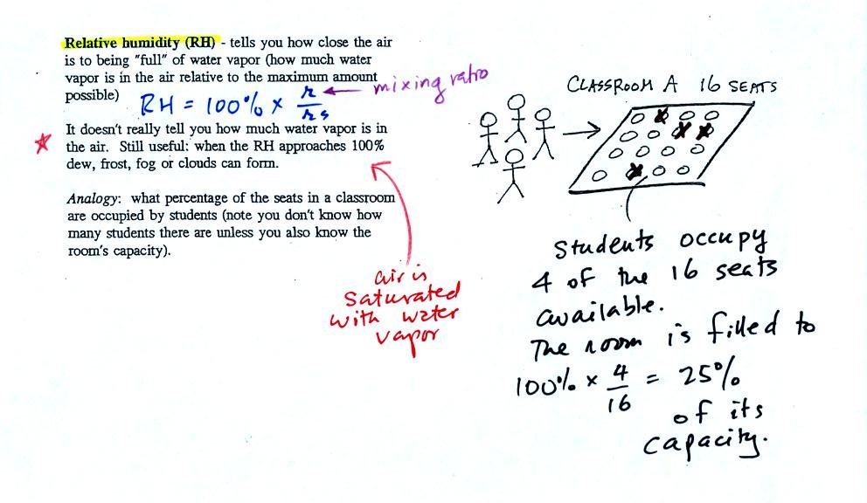
The relative humidity is the variable most people are familiar with, it tells you how "full" the air is with water vapor.
In the analogy (sketched on the right hand side of p. 83 in the photocopied notes) 4 students wander into Classroom A which has 16 empty seats. Classroom A is filled to 25% of its capacity. You can think of 4, the number of students, as being analogous to the mixing ratio. The classroom capacity is analogous to the saturation mixing ratio. The percentage occupancy is analogous to the relative humidity.
Instead of students and a classroom you could think of the 70 F and 40 F air that could potentially hold 15 grams or 5 grams, respectively of water vapor. Here is the Optional Assignment I mentioned I would hide in these notes. It will be due at the beginning of class on Mon., Mar. 23.
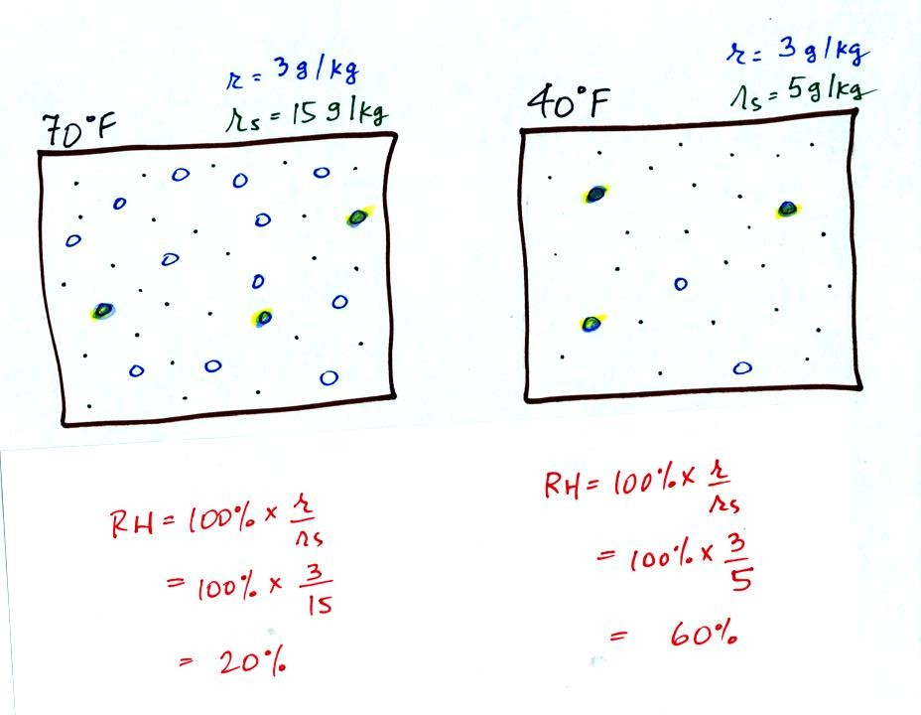
Here are the relative humidities of the 70 F and 40 F air that each contain 3 grams of water vapor. The 70 F air has a low RH because this warm air's saturation mixing ratio is large. The RH in the 40 F is higher even though it has the same actual amount of water vapor because the 40 F air can't hold as much water vapor and is closer to being saturated.
Something important to note: RH doesn't really tell you how much water vapor is actually in the air. The two volumes of air above contain the same amount of water vapor (3 grams per kilogram) but have different relative humidities. You could just as easily have two volumes of air with the same relative humidities but different actual amounts of water vapor.

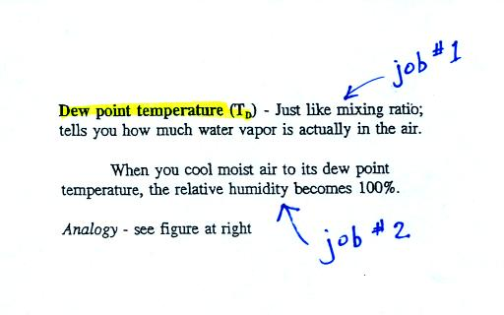
The dew point temperature has two jobs. First it gives you an idea of the actual amount of water vapor in the air. In this respect it is just like the mixing ratio. If the dew point temperature is low the air doesn't contain much water vapor. If it is high the air contains more water vapor.
Second the dew point tells you how much you must cool the air in order to cause the RH to increase to 100% (at which point a cloud, or dew or frost, or fog would form).
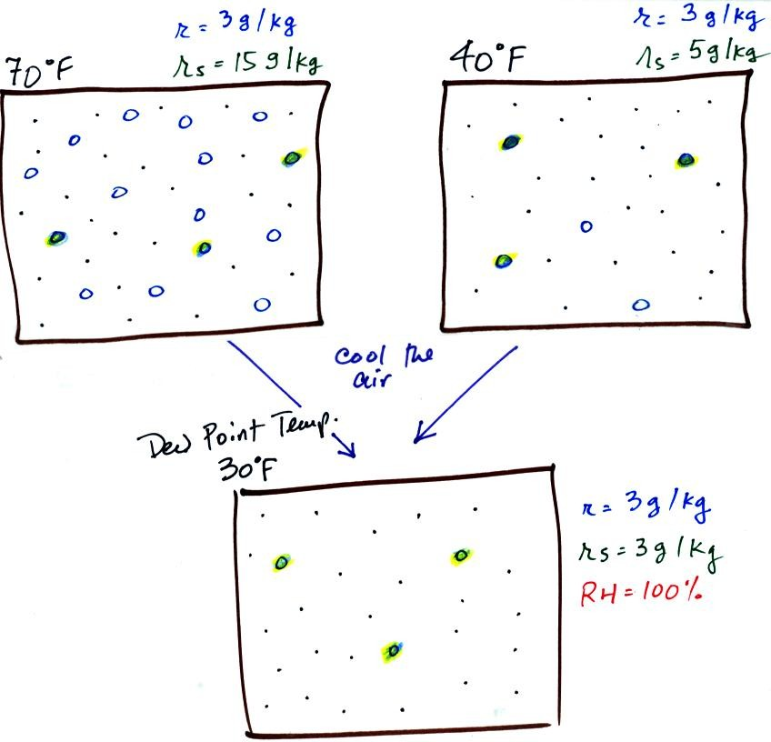
If we cool the 70 F air or the 40 F air to 30 F we would find that the saturation mixing ratio would decrease to 3 grams/kilogram. Since the air actually contains 3 g/kg, the RH of the 30 F air would become 100%. The 30 F air would be saturated, it would be filled to capacity with water vapor. 30 F is the dew point temperature for 70 F air that contains 3 grams of water vapor per kilogram of dry air. It is also the dew point temperature for 40 F air that contains 3 grams of water vapor per kilogram of dry air.Because both volumes of air had the same amount of water vapor, they both also have the same dew point temperature.
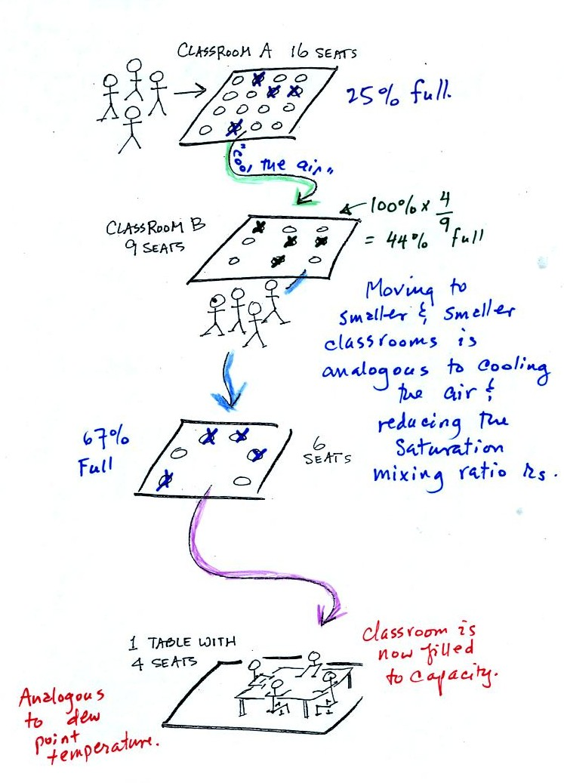
Now back to our students and classrooms analogy on the righthand side of p. 83. The 4 students move into classrooms of smaller and smaller capacity. The decreasing capacity of the classrooms is analogous to the decrease in saturation mixing ratio that occurs when you cool air. Eventually the students move into a classroom that they just fill to capacity. This is analogous to cooling the air to the dew point.
If the 4 students were to move to an even smaller classroom, they wouldn't all fit inside. The same is true of moist air. If you cool moist air below the dew point, some of the water vapor will condense.

