Friday Mar. 6, 2009
Music today was Gone Gone Gone Done Moved On from the Raising Sand CD by Robert Plant and Alison Krauss.
The Controls of Temperature Optional Assignment is due at the start of class next Monday.

A quick review of how/why the greenhouse effect the greenhouse effect warms the earth's surface. This was tacked on to the end of the Wed., Mar. 4 online notes.
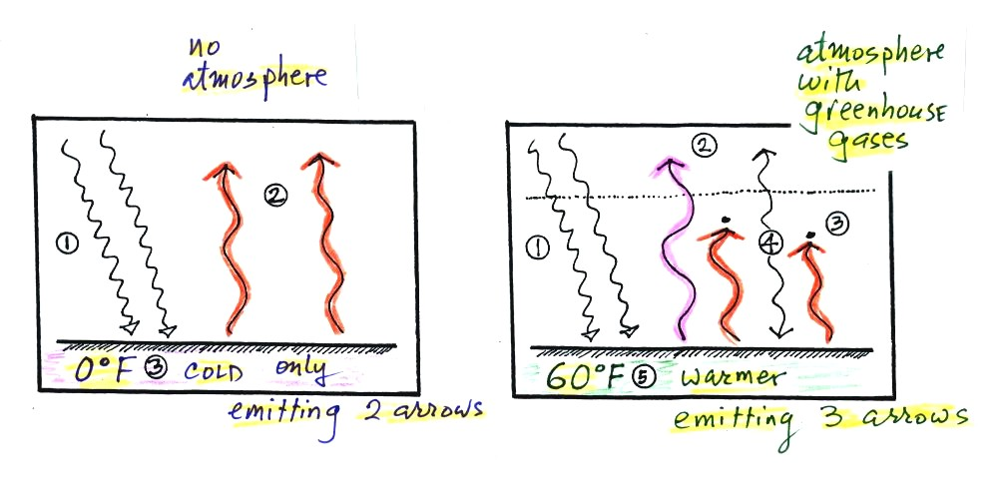
Energy balance with (right) and without (left) the greenhouse effect. At left the ground is emitting 2 units of energy, at right the ground is emitting 3 units. Remember that the amount of energy emitted by something depends on temperature. The ground must be warmer to be able to emit 3 arrows of energy rather than 2 arrows.
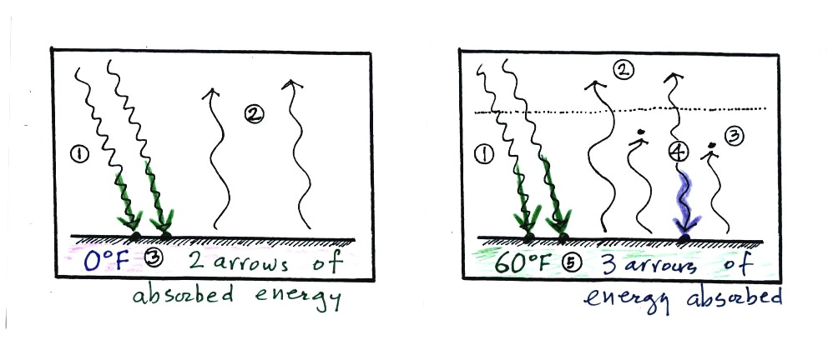

Here's another explanation. At left the ground is getting 2 units of energy. At right it is getting three, the extra one is coming from the atmosphere. Doesn't it make sense that ground that absorbs 3 units of energy will be warmer than ground that is only absorbing 2?

In our simplified explanation of the greenhouse effect we assumed that 100% of the sunlight arriving at the earth passed through the atmosphere and got absorbed at the ground. Next we will look at how realistic that assumption is.
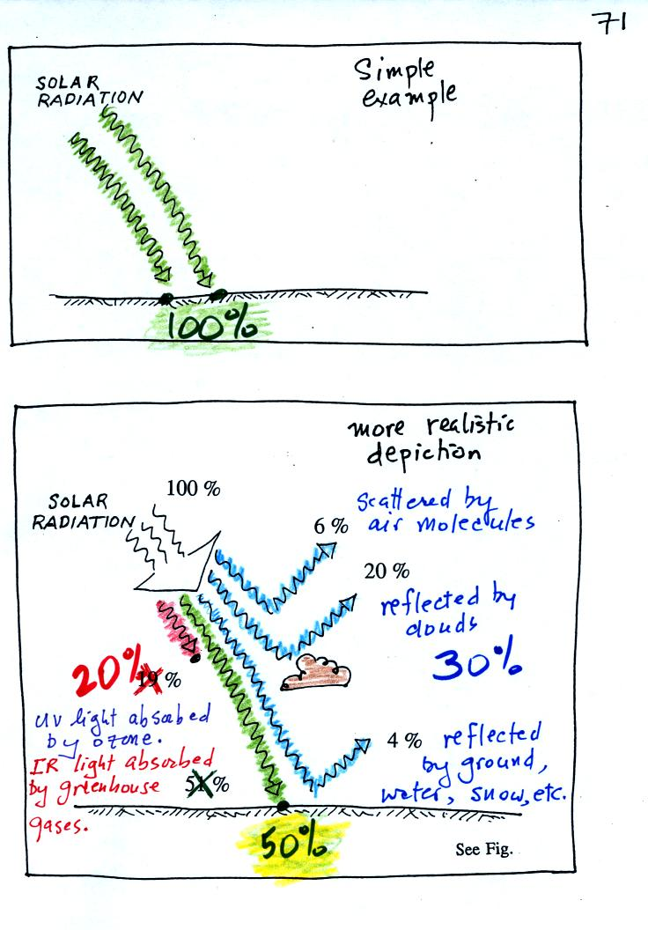
The bottom figure above shows that in reality only about 50% of the incoming sunlight gets absorbed at the ground.
About 20% of the incoming sunlight is absorbed by gases in the atmosphere. Sunlight is a mixture of UV, VIS, and IR light. Ozone and oxygen will absorb a lot of the UV (though there isn't much UV in sunlight) and greenhouse gases will absorb some of the IR radiation in sunlight (Roughly half of sunlight is IR light).
The remaining 30% of the incoming sunlight is reflected back into space (by the ground, clouds, even air molecules).

Next we will look at our simplified version of radiative equilibrium and a more realistic picture of the earth's energy budget. The figure was redrawn after class, some of the colors may have changed.
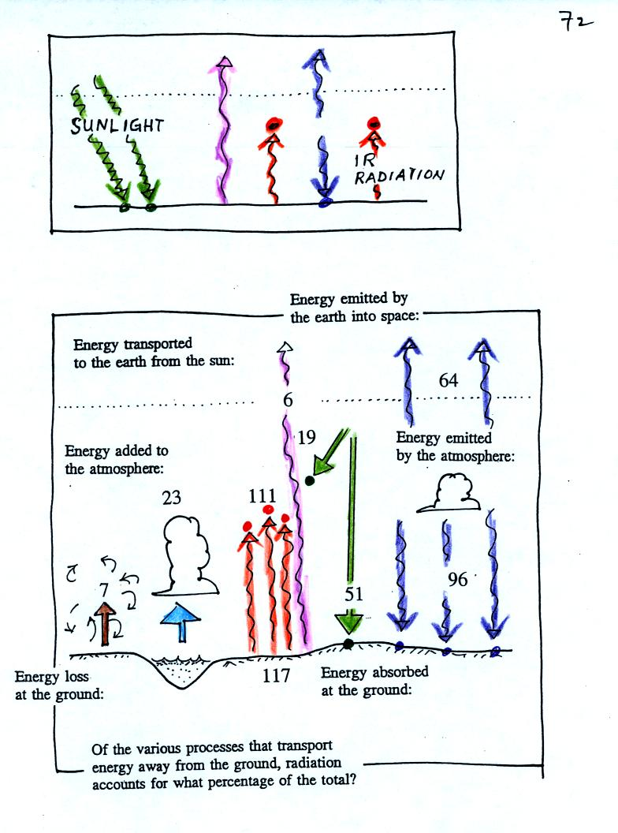
The lower part of the figure is pretty complicated. It would be difficult to start with this figure and find the greenhouse effect in it. However if you understand the upper figure, you should be able to find and understand the corresponding parts in the lower figure.
In the top figure you should recognize the incoming sunlight (green), IR emitted by the ground that passes through the atmosphere (pink), IR radiation emitted by the ground that is absorbed by greenhouse gases in the atmosphere (orange) and IR radiation emitted by the atmosphere (dark blue). Using the colors you can find each of these parts of the energy budget in the bottom figure. Notice that conduction, convection, and latent heat energy transport are needed to bring the overall energy budget into balance. Click here to see a more detailed check to be sure everything is in energy balance.

We'll wrap up the section on radiative equilibrium and the atmospheric greenhouse effect and start some new material today.

You can use the simplified picture of radiative equilibrium to understand the effects of clouds on nighttime low and daytime high temperatures. You'll find this discussed on pps 72a and 72b in the Classnotes.
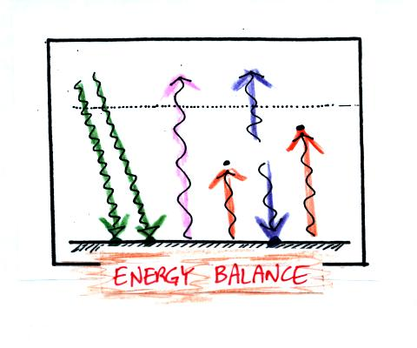
Here's the simplified picture of radiative equilibrium (something you're probably getting pretty tired of seeing). By now you should be able to identify each of the colored arrows in the figure above and explain what they represent.
The two pictures below show what happens at night when you remove the two green rays of incoming sunlight.
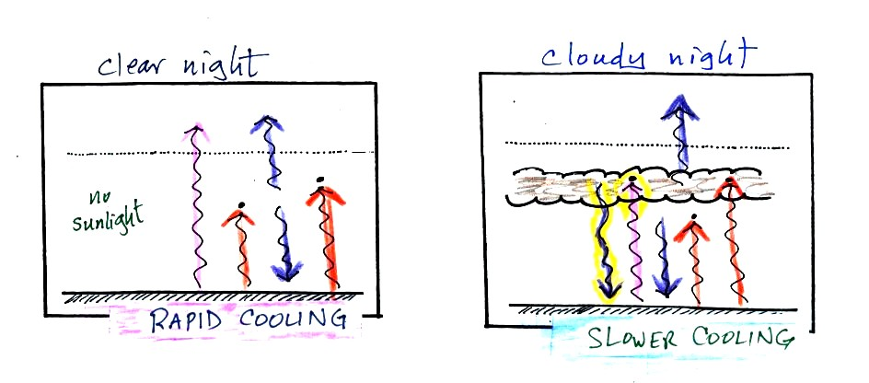
The picture on the left shows a clear night. The ground is losing 3 arrows of energy and getting one back from the atmosphere. That's a net loss of 2 arrows. The ground cools rapidly and gets cold during the night.
A cloudy night is shown at right. Notice the effect of the clouds. Clouds are good absorbers of infrared radiation. If we could see IR light, clouds would appear black, very different from what we are used to (because clouds also emit IR light, if we could see IR light the clouds might also glow). Now none of the IR radiation emitted by the ground passes through the atmosphere into space. It is all absorbed either by greenhouse gases or by the clouds. Because the clouds and atmosphere are now absorbing 3 units of radiation they must emit 3 units: 1 goes upward into space, the other 2 downward to the ground. There is now a net loss at the ground of only 1 arrow.
The ground won't cool as quickly and won't get as cold on a cloudy night as it does on a clear night. That makes for nice early morning bicycle rides this time of the year.
The next two figures compare clear and cloudy days.
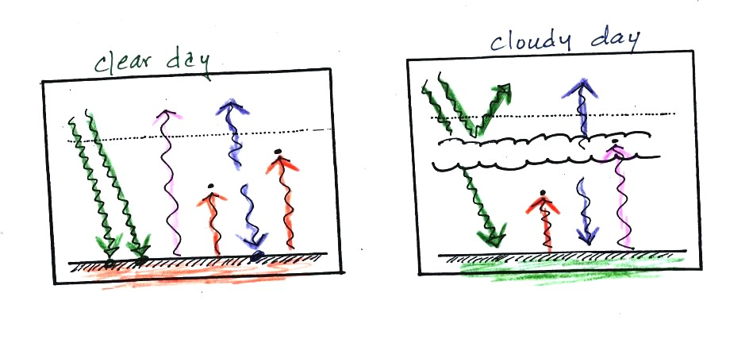
Clouds are good reflectors of visible light. The effect of this is to reduce the amount of sunlight energy reaching the ground in the right picture. With less sunlight being absorbed at the ground, the ground doesn't need to get as warm to be in energy balance.
It is generally cooler during the day on a cloudy day than on a clear day.
Clouds raise the nighttime minimum temperature and lower the daytime maximum temperature.
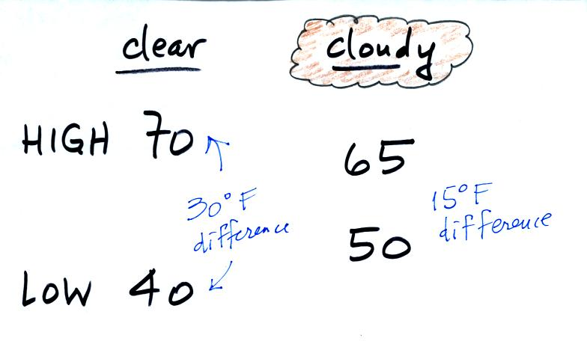
Typical daytime highs and nighttime lows in Tucson for this time of year. Note how the clouds reduce the daily range of temperature.

We'll use our simplified representation of radiative equilibrium to understand enhancement of the greenhouse effect and global warming.
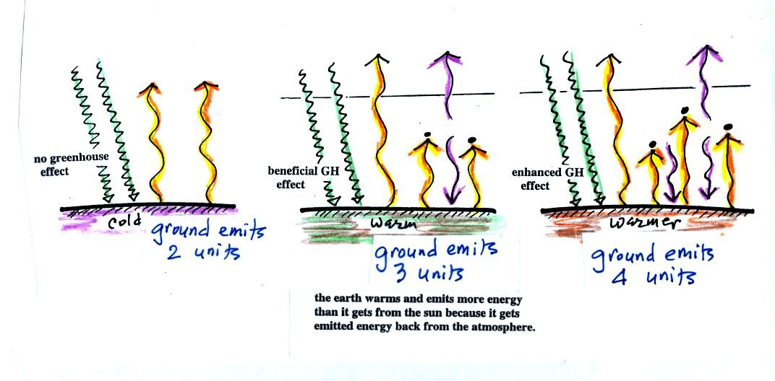
The figure (p. 72c in the photocopied Class Notes) on the left shows energy balance on the earth without an atmosphere (or with an atmosphere that doesn't contain greenhouse gases). The ground achieves energy balance by emitting only 2 units of energy to balance out what it is getting from the sun. The ground wouldn't need to be very warm to do this.
If you add an atmosphere and greenhouse gases, the atmosphere will begin to absorb some of the outgoing IR radiation. The atmosphere will also begin to emit IR radiation, upward into space and downard toward the ground. After a period of adjustment you end up with a new energy balance. The ground is warmer and is now emitting 3 units of energy even though it is only getting 2 units from the sun. It can do this because it gets a unit of energy from the atmosphere.
In the right figure the concentration of greenhouse gases has increased even more (due to human activities). The earth would find a new energy balance. In this case the ground would be warmer and would be emitting 4 units of energy, but still only getting 2 units from the sun. With more greenhouse gases, the atmosphere is now able to absorb 3 units of the IR emitted by the ground. The atmosphere sends 2 back to the ground and 1 up into space.
The next figure shows a common misconception about the cause of global warming.
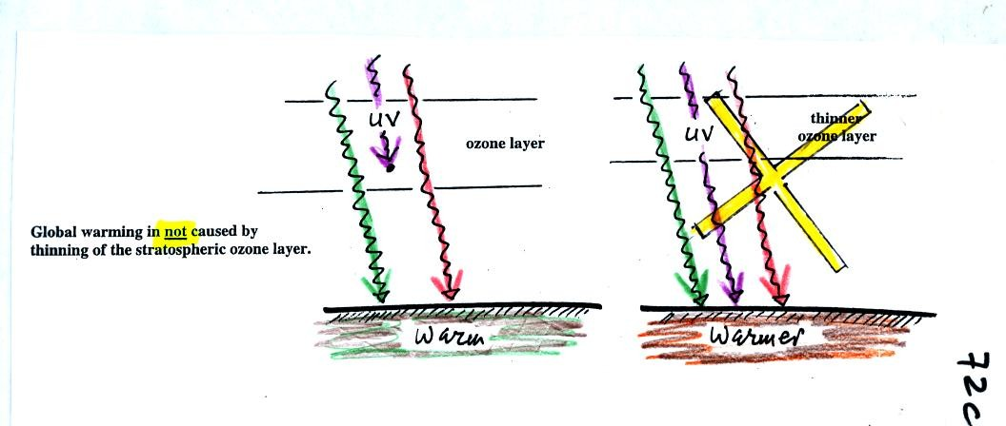
Many people know that sunlight contains UV light and that the ozone absorbs much of the dangerous type of high energy radiation. People also know that release of chemicals such as CFCs are destroying stratospheric ozone and letting some of this UV light reach the ground. That is all correct.
They then conclude that it is this additional UV energy reaching the ground that is causing the globe to warm. This is not correct. There isn't much UV light in sunlight in the first place and the small amount of additional UV light reaching the ground won't be enough to cause global warming. It will cause cataracts and skin cancer and those kinds of problems but not global warming.

We spent the last few minutes in class watching a short video showing Bertrand Piccard and Brian Jones making the first trip around the global nonstop in a balloon. They were competing against a British balloon. The notes shown in class are below.
You'll see two balloons in this video
The first is the Cable & Wireless balloon with
Andy Elson & Colin Prescot
(Elson had at one time been Piccard's partner)
They set off on Feb. 17, 1999 from Spain
and have a 10 day lead over the Swiss balloon
The 2nd balloon is the Breitling Orbiter 3 with
Bertrand Piccard & Brian Jones
they launch on March 1, 1999.

