Wednesday Jan. 28, 2009
Music today was My Song and just the beginning of The Story by Brandi Carlile.
The Practice Quiz is a week from today. The Practice Quiz Study Guide is now available online. Reviews are scheduled for Monday and Tuesday afternoon next week (even though this is a Practice Quiz and doesn't count). Locations aren't yet known.

In order to understand why atmospheric carbon dioxide concentration is increasing and before we look at what the earth's temperature has been doing during this period we will try to understand better how man has been able to change atmospheric CO2 concentrations.
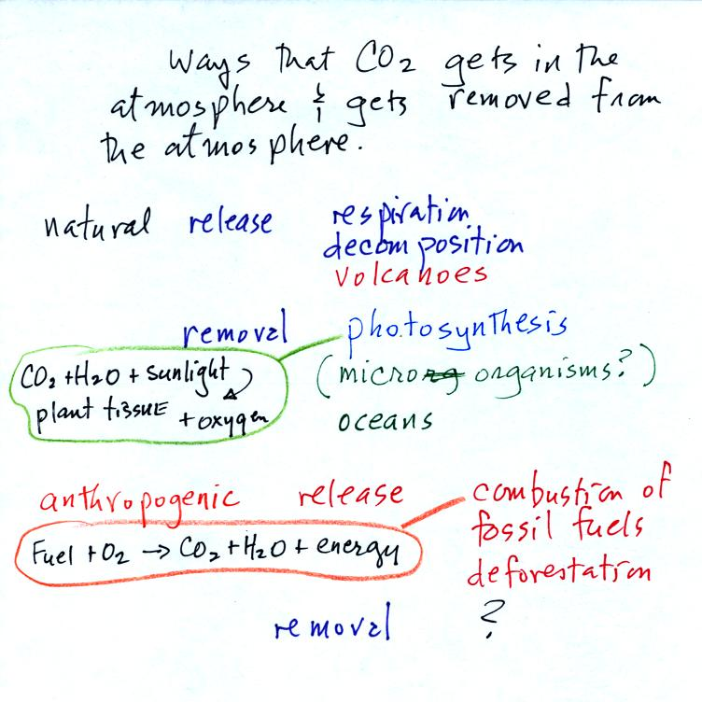
Carbon dioxide is added to the atmosphere naturally by respiration (people breathe in oxygen and exhale carbon dioxide), decay, and volcanoes. Combustion of fossil fuels, a human activity also adds CO₂ to the atmosphere. Deforestation, cutting down and killing a tree will keep it from removing CO₂ from the air by photosynthesis. The dead tree will also decay and release CO₂ to the air.
The chemical equation (added after class) illustrates the combustion of a fossil fuel. The by products are carbon dioxide and water vapor. The steam cloud that you sometimes see come from a rooftop vent or the tailpipe of an automobile (especially during cold wet weather) is evidence of the production of water vapor during the combustion.
Photosynthesis removes CO₂ from the air (in some respects, photosynthesis is the opposite of combustion, photosynthesis manufactures fuel and adds oxygen to the air). CO₂ also dissolves in ocean water.
The ? means your instructor is not aware of an anthropogenic process that removes large amounts of carbon dioxide from the air.
We are now able to better understand the yearly variation in atmospheric CO₂ concentration (the "wiggles" on the Keeling Curve).
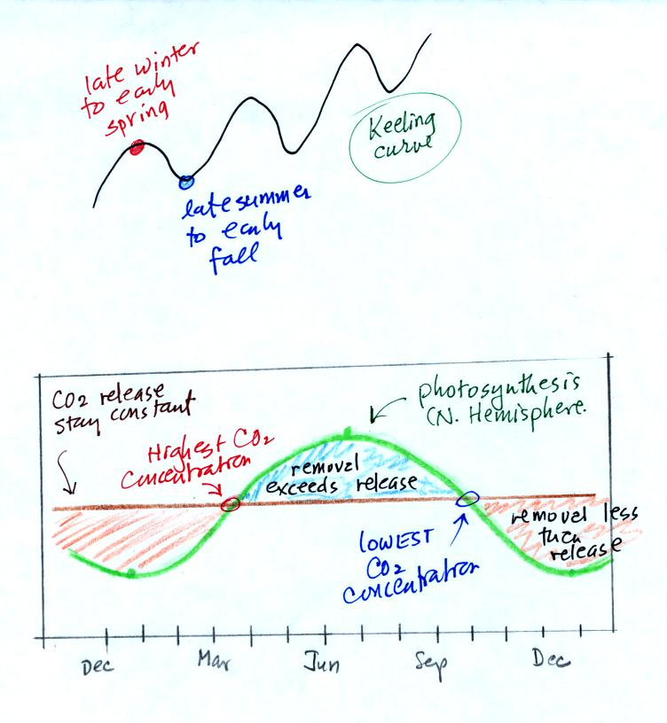
In the bottom curve we assume that the release of CO2 to the air remains constant throughout the year. Photosynthesis will change. Photosynthesis is highest in the summer when plants are growing actively. It is lowest in the winter when many plants are dead or dormant. Atmospheric CO2 concentration will decrease as long as the rate of removal (photosynthesis) is greater than the rate of release (blue shaded portion above). The CO2 concentration will increase when release exceeds removal (red shaded section).
To really understand why human activities are causing atmospheric CO₂ concentration to increase we need to look at the relative amounts of CO₂ being added to and being removed from the atmosphere (like amounts of money moving into and out of a bank account and their effect on the account balance). A simplified version of the carbon cycle is shown below (redrawn after class for improved clarity)
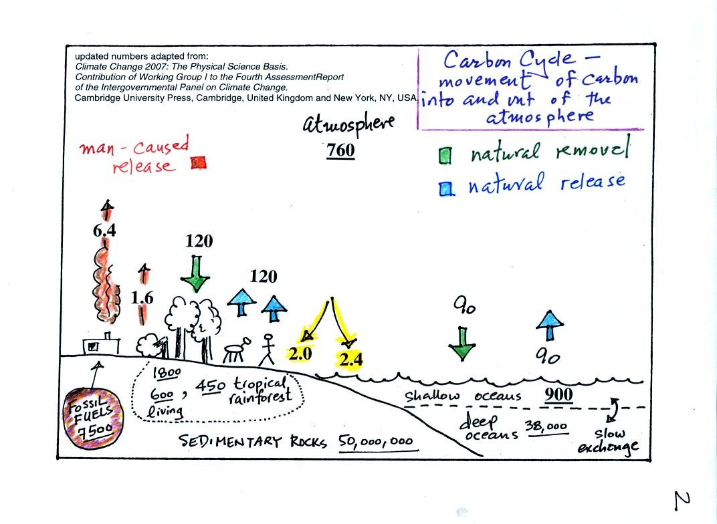
Here are the main points to take from this figure:
1. The underlined numbers show the amount of carbon stored in "reservoirs." For example 760 units* of carbon are stored in the atmosphere (predominantly in the form of CO₂, but also in small amounts of CH₄ (methane), CFCs and other gases; carbon is found in each of those molecules). The other numbers show "fluxes," the amount of carbon moving into or out of the atmosphere every year. Over land, respiration and decay add 120 units* of carbon to the atmosphere every year. Photosynthesis (primarily) removes 120 units every year.
2. Note the natural processes are in balance (over land: 120 units added and 120 units removed, over the oceans: 90 units added balanced by 90 units of carbon removed from the atmosphere every year). If these were the only processes present, the atmospheric concentration (760 units) wouldn't change.
3. Anthropogenic (man caused) emissions of carbon into the air are small compared to natural processes. About 6.4 units are added during combustion of fossil fuels and 1.6 units are added every year because of deforestation (when trees are cut down they decay and add CO₂ to the air, also because they are dead they aren't able to remove CO₂ from the air by photosynthesis)
The rate at which carbon is added to the atmosphere by man is not balanced by an equal rate of removal: 4.4 of the 8 units added every year are removed (highlighted in yellow in the figure). This small imbalance (8 - 4.4 = 3.6 units of carbon are left in the atmosphere every year) explains why atmospheric carbon dioxide concentrations are increasing with time.
4. In the next 100 years or so, the 7500 units of carbon stored in the fossil fuels reservoir (lower left hand corner of the figure) will be dug up or pumped out of the ground and burned. That will add 7500 units of carbon to the air. The big question is how will the atmospheric concentration change and what effects will that have on climate?

*don't worry about the units. But here they are just in case you are interested: Gtons (reservoirs) or Gtons/year (fluxes)
Gtons = 10¹² metric tons. (1 metric ton is 1000 kilograms or about 2200 pounds)

Three times a week many of you leave the Real World and step into what I call NATS 101 World - the 50 minutes or so that you spend in class.
There's a funny thing that seems to happen once or twice a semester. NATS 101 World and the Real World intersect or overlap briefly.
We did an acid rain demonstration in class last Monday. CO2 from some dry ice was bubbled through some Tucson tap water; the CO2 gas turned the water acid. On Tuesday I was at home, in the Real World (more or less), when I came across the following article concerning the acidification of oceans by increasing atmospheric CO2 concentrations. A real world problem that fits in nicely with something we just covered in NATS 101. A copy of the newspaper article was handed out in class. Click here if you'd like to download and print a copy.

So here's where we're at in our discussion of climate change and global warming:
Atmospheric CO₂ concentration was fairly constant between 1000 AD and the mid 1700s.
CO₂ concentration has been increasing since the mid 1700s (other greenhouse gas concentrations have also been increasing).
The concern is that this might enhance or strengthen the greenhouse effect and cause global warming.
The obvious question is what has the temperature of the earth been doing during this period? In particular has there been any warming associated with the increases in greenhouse gases that have occurred since the mid 1700s?
We must address the temperature question in two parts.
First part:
Actual accurate measurements of temperature (on land and at sea)
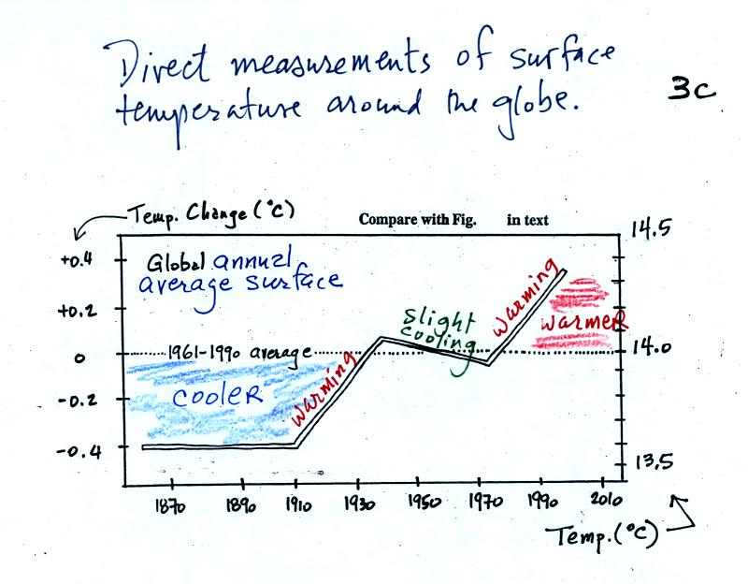
This is based on actual measurements of temperature made (using reliable thermometers) at many locations on land and sea around the globe.
Temperature appears to have increased 0.7º to 0.8º C during this period. The increase hasn't been steady as you might have expected given the steady rise in CO₂ concentration; temperature even decreased slightly between about 1940 and 1970.
It is very difficult to detect a temperature change this small over this period of time. The instruments used to measure temperature have changed. The locations at which temperature measurements have been made have also changed (imagine what Tucson was like 130 years ago). About 2/3rds of the earth's surface is ocean. Sea surface temperatures can now be measured using satellites. Average surface temperatures naturally change a lot from year to year.
The year to year variation has been left out of the figure above so that the overall trend could be seen more clearly. The figure below does show the year to year variation (dotted black line) and the uncertainties (green bars, note how the uncertainty is lower in recent years) in the yearly measurements.
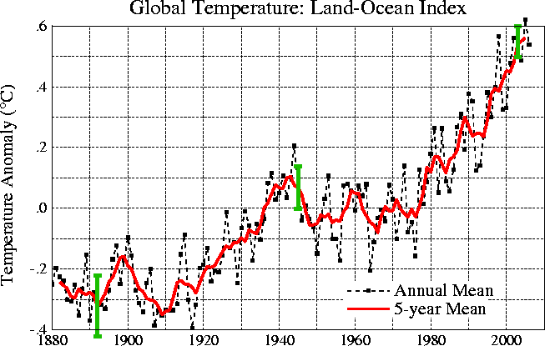
These data are from the NASA Goddard Institute for Space Studies site.
Temperatures here are compared to the 1951-1980 mean.
Temperatures prior to about 1930 were colder than the 1951-1980 mean
and temperatures after 1980 were warmer.
Here's another plot of global temperature change over a slightly longer time period
from the University of East Anglia Climatic Research Unit
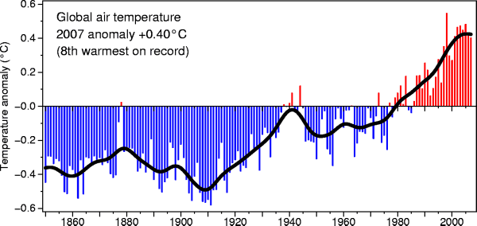
2nd part
Now it would be interesting to know how temperature was changing prior to the mid-1800s. This is similar to what happened when the scientists wanted to know what carbon dioxide concentrations looked like prior to 1958. In that case they were able to go back and analyze air samples from the past (air trapped in bubbles in ice sheets).
That doesn't work with temperature.
Imagine putting some air in a bottle, sealing the bottle, putting the bottle on a shelf, and letting it sit for 100 years. In 2108 you could take the bottle down from the shelf, carefully remove the air, and measure what the CO2 concentration in the air had been in 2008 when the air was sealed in the bottle. You couldn't, in 2108, use the air in the bottle to determine what the temperature of the air was when it was originally put into the bottle in 2008.
With temperature you need to use proxy data. You need to look for something else whose presence, concentration, or composition depended on the temperature at some time in the past.

Here's a proxy data example.
Let's say you want to determine how many students are living in a house near the university.
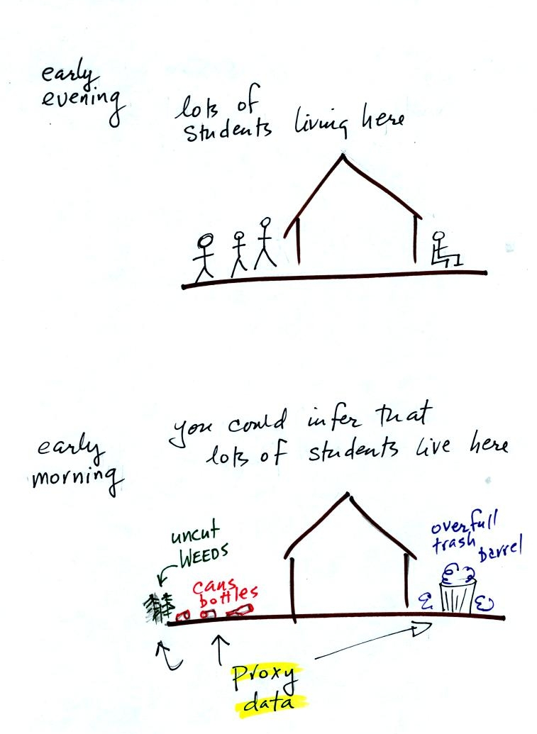
You could walk by the house late in the afternoon when the students might be outside and count them. That would be a direct measurement (this would be like measuring temperature with a thermometer). There could still be some errors in your measurement (some students might be inside the house and might not be counted, some of the people outside might not live at the house).
If you were to walk by early in the morning it is likely that the students would be inside sleeping (or in one of the 8 am NATS 101 classes). In that case you might look for other clues (such as the number of empty bottles in the yard) that might give you an idea of how many students lived in that house. You would use these proxy data to come up with an estimate of the number of students inside the house.
In the case of temperature scientists look at a variety of things. They could look at tree rings. The width of each yearly ring depends on the depends on the temperature and precipitation at the time the ring formed. They analyze coral. Coral is made up of calcium carbonate, a molecule that contains oxygen. The relative amounts of the oxygen-16 and oxygen-18 isotopes depends on the temperature that existed at the time the coral grew. Scientists can analyze lake bed and ocean sediments. The types of plant and animal fossils that they find depend on the water temperature at the time. They can even use the ice cores. The ice, H₂O, contains oxygen and the relative amounts of various oxygen isotopes depends on the temperature at the time the ice fell from the sky as snow.
Here's an idea of how oxygen isotope data can be used to determine past temperature.
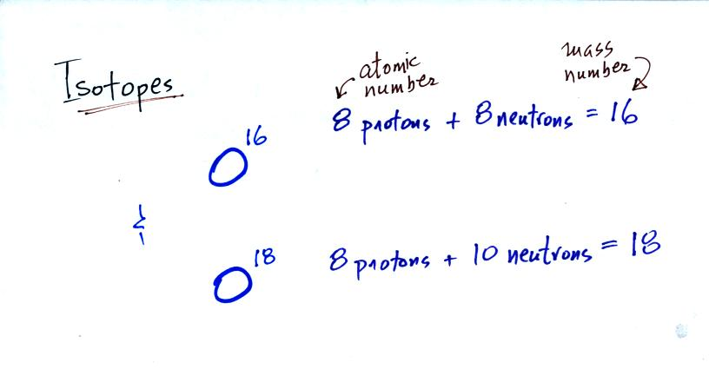
The two isotopes of oxygen contain different numbers of neutrons in their nuclei. Both atoms have the same number of protons.
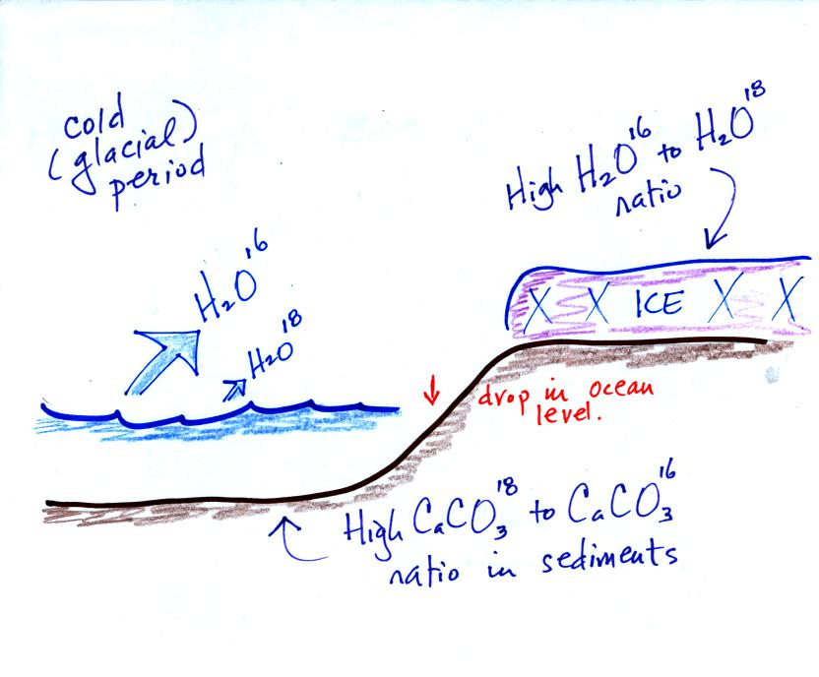
During a cold period, the H₂O¹⁶ form of water evaporates more rapidly than the H₂O¹⁸ form. You would find relatively large amounts of O¹⁶ in glacial ice. Since most of the H₂O¹⁸ remains in the ocean, it is found in relatively high amounts in calcium carbonate in ocean sediments.
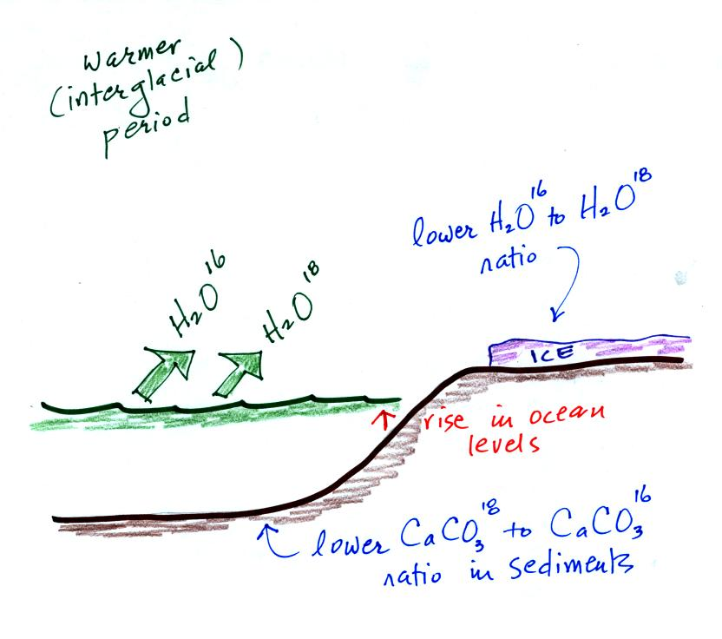
The reverse is true during warmer periods.
Using proxy data scientists have been able to estimate average surface temperatures for 100,000s of years into the past. The next figure (bottom of p. 3 in the photocopied Classnotes) shows what temperature has been doing since 1000 AD. This is for the northern hemisphere only, not the globe.
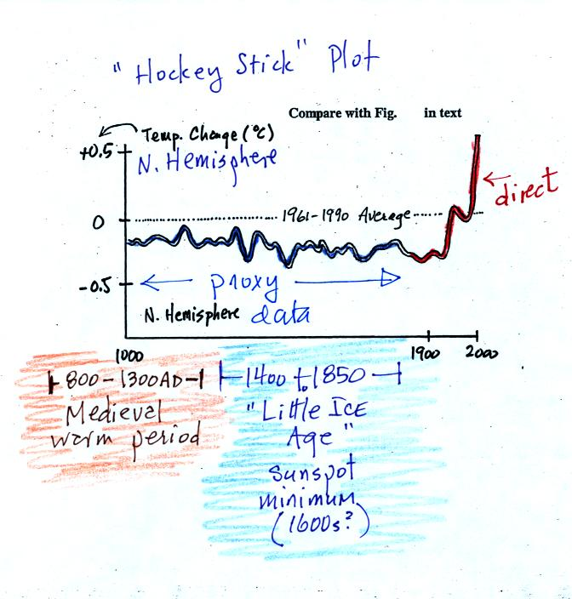
The blue portion of the figure shows the estimates of temperature (again relative to the 1961-1990 mean) derived from proxy data. The red portion is the instrumental measurements made between about 1850 and the present day. There is also a lot of year to year variation and uncertainty that is not shown on the figure above.
Many scientists would argue that this graph is strong support of a connection between rising atmospheric greenhouse gas concentrations and global warming. Early in this time interval when CO2 concentration was constant, there is little temperature change. Temperature only begins to rise in about 1900 when we know an increase in atmospheric carbon dioxide concentrations was underway.
There is historical evidence in Europe of a medieval warm period lasting from 800 AD to - 1300 AD or so and a cold period, the "Little Ice Age, " which lasted from about 1400 AD to the mid 1800s. These are not clearly apparent in the temperature plot above. This leads some scientists to question the validity of this temperature reconstruction. Scientists also suggest that if large changes in climate such as the Medieval warm period and the Little Ice Age can occur naturally, then maybe the warming that is occurring at the present time also has a natural cause.
Here's the figure that the sketch above was based on
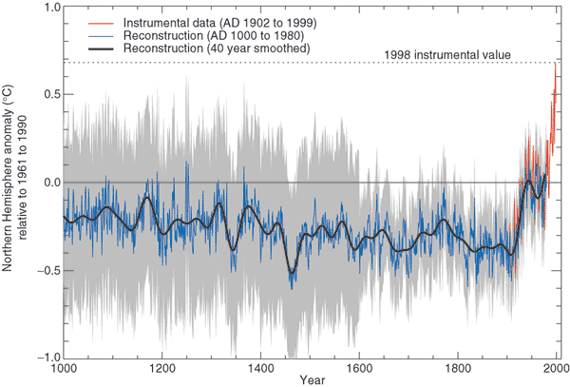
from
Climate Change 2001 - The Scientific Basis
Contribution of Working Group I to the 3rd Assessment Report of the
Intergovernmental Panel on Climate Change (IPCC)
Here's a comparison of several additional estimates of temperature changes over the past 1000 years or so
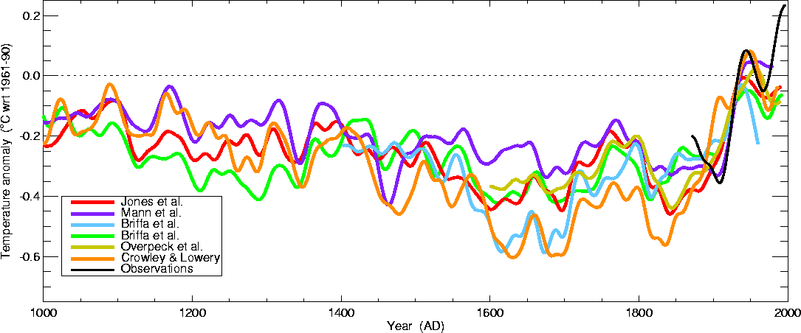
This is from the University of East Anglia Climatic Research Unit again.
Some of these curves do show a little bit more temperature variation between 1000 AD and 1900 AD than the hockey stick plot above.

SUMMARY
There is general agreement that
Atmospheric CO₂ and other greenhouse gas concentrations are increasing and that
The earth is warming
Not everyone agrees on
the Causes (natural or manmade) of the warming,
how much Additional Warming there will be, or
the Effects that warming will have on weather and climate in the years to come

