Wednesday Jan. 21, 2009
The music before class today was "The Mating Game" from Bittersweet.
The first Optional Assignment, writing a haiku poem about the composition of the atmosphere. I'll try to get those returned to you on Friday.
Distribution of the Experiment #1 materials began in class today. If you didn't pick up your materials today you can do so on Friday (probably also next week). This weekend would be a perfect time to start Experiment #1.
The first of the 1S1P Assignments was made today. This is a "bonus assignment," which means this report won't be counted as part of the 4 report limit you are allowed during the semester. This is an extra opportunity to begin to earn 1S1P pts and make your way hopefully to the 45 maximum number of 1S1P pts allowed during the semester. Reports are due on Monday Feb. 2.

We spent most of the class period on the first air pollutant we will be covering: carbon monoxide. The basic information below is found on p. 7 in the photocopied ClassNotes. You'll find additional information at the Pima County Department of Environmental Quality website and also at the US Environmental Protection Agency website.
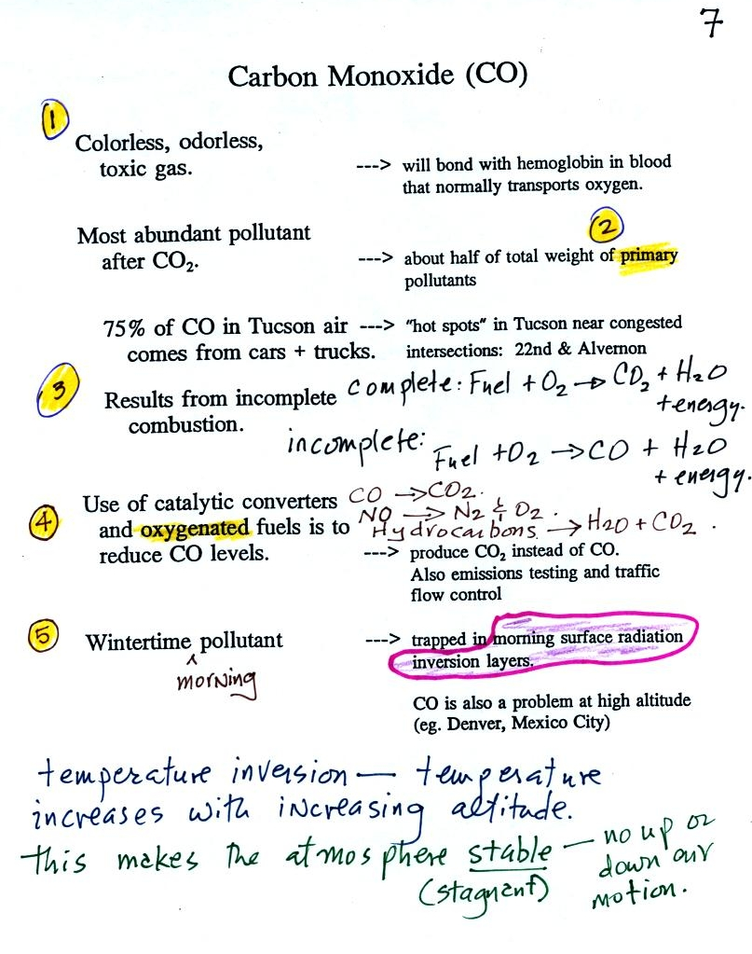
We will be talking about carbon monoxide found both outdoors (where it rarely would reach fatal concentrations) and indoors (where it can be deadly).
Carbon monoxide is insidious, you can't smell it or see it and it can kill you. Once inhaled, carbon monoxide molecules bond strongly to the hemoglobin molecules in blood and interfere with the transport of oxygen throughout your body.
CO is a primary pollutant (Point 2 above). That means it goes directly from a source into the air, CO is emitted directly from an automobile tailpipe into the atmosphere for example. The difference between primary and secondary pollutants is probably explained best in a series of pictures.
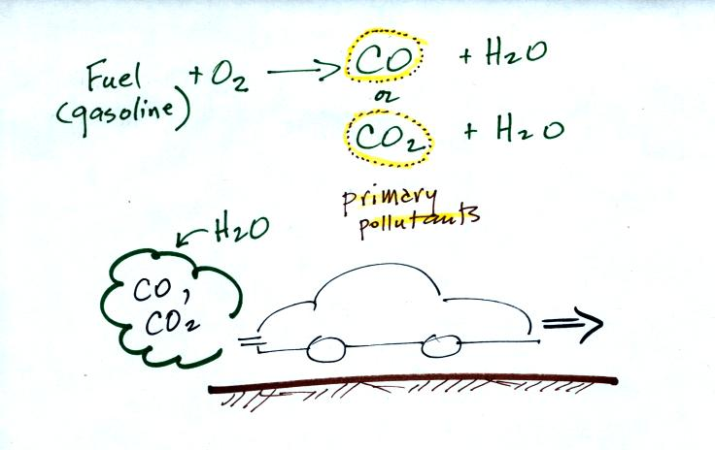 | 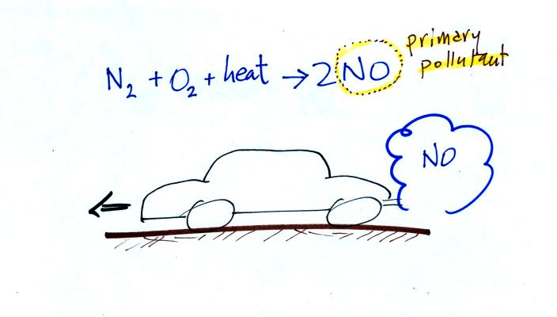
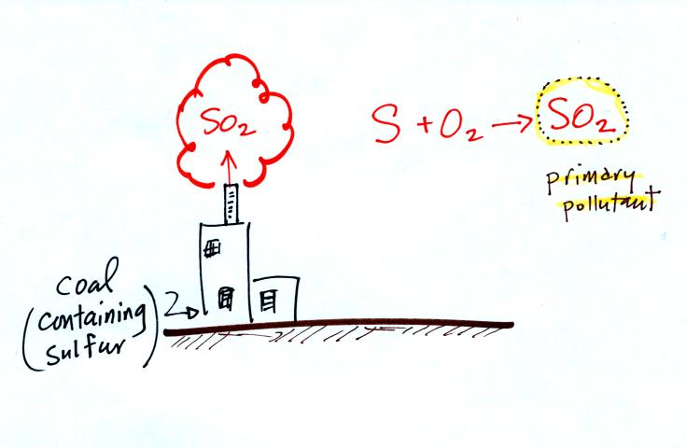 | 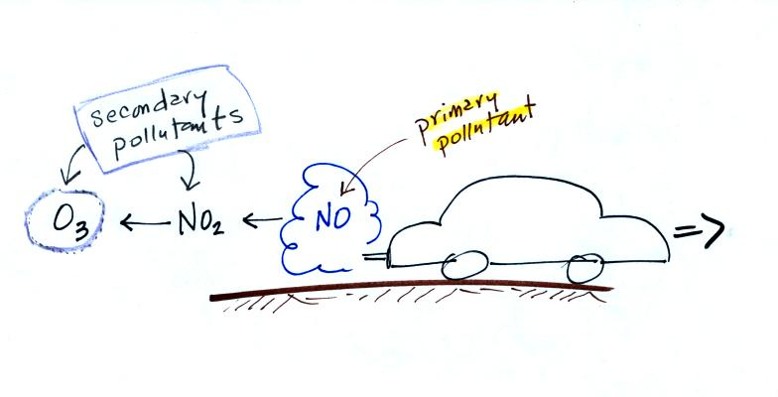
Nitric oxide, NO, and sulfur dioxide, SO₂, are also primary pollutants. Ozone is a secondary pollutant (and here we are referring to tropospheric ozone, not stratospheric ozone). It shows up in the atmosphere only after a primary pollutant has undergone a series of reactions.
Point 3 explains that CO is produced by incomplete combustion of fossil fuel (insufficient oxygen). Complete combustion would produce carbon dioxide, CO₂. Cars and trucks produce much of the CO in the atmosphere.
Point 4: Vehicles must now be fitted with a catalytic converter that will change CO into CO₂ (and also NO into N₂ and O₂ and hydrocarbons into H₂O and CO₂). In Pima County vehicles must also pass an emissions test every year and special formulations of gasoline (oxygenated fuels) are used during the winter months to try to reduce CO emissions.
In the atmosphere CO concentrations peak on winter mornings (Point 5). Surface temperature inversion layers form on long winter nights when the sky is clear and winds are calm. The ground cools quickly and becomes colder than the air above. Air in contact with the cold ground ends up colder than air above. Air temperature increases with increasing altitude in a temperature inversion layer and this produces a very stable (stagnant) layer of air at ground level. A very reasonable wintertime morning temperature profile in Tucson is shown at the top of p. 9 in the photocopied Classnotes.
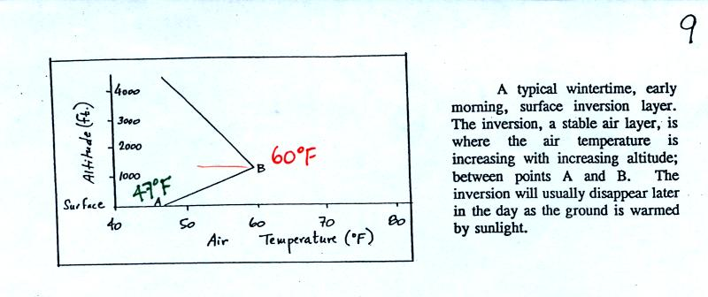
Temperature increases from 47º F at the ground (Point A) to about 60º F at 1000 feet altitude (Point B), that's the stable inversion layer. Temperature begins to decrease with increasing altitude above Point B.
There is very little vertical mixing in a stable air layer.
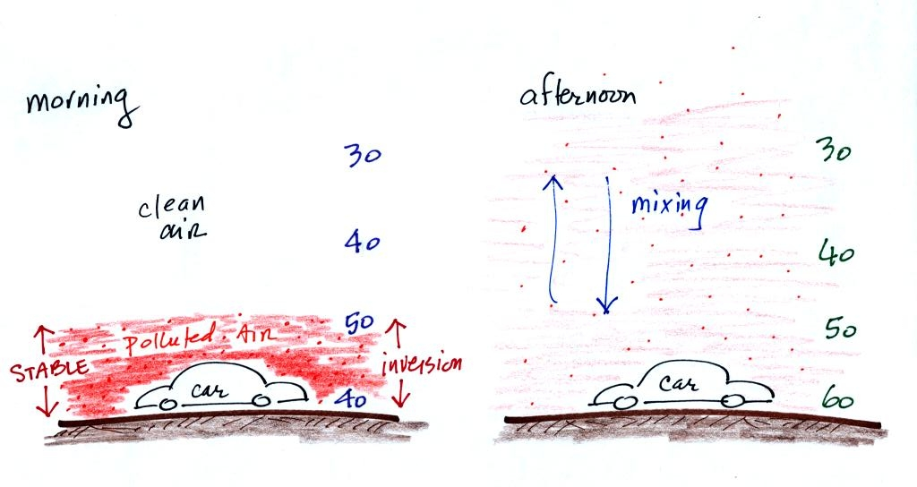

When CO is emitted into the thin stable layer (left figure above), the CO remains in the layer and doesn't mix with cleaner air above. CO concentrations build.
In the afternoon, the ground warms, and the atmosphere becomes more unstable. CO emitted into air at the surface mixes with cleaner air above. The CO concentrations are effectively diluted.
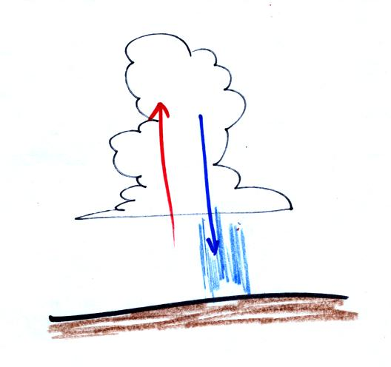
Thunderstorms contain strong up (updraft) and down (downdraft) air motions. Thunderstorms are a sure indication of unstable atmospheric conditions. When the downdraft winds hit the ground they spread out horizontally. These surface winds can sometimes reach 100 MPH, stronger than many tornadoes. An unusually strong and narrow thunderstorm downdraft is called a microburst.

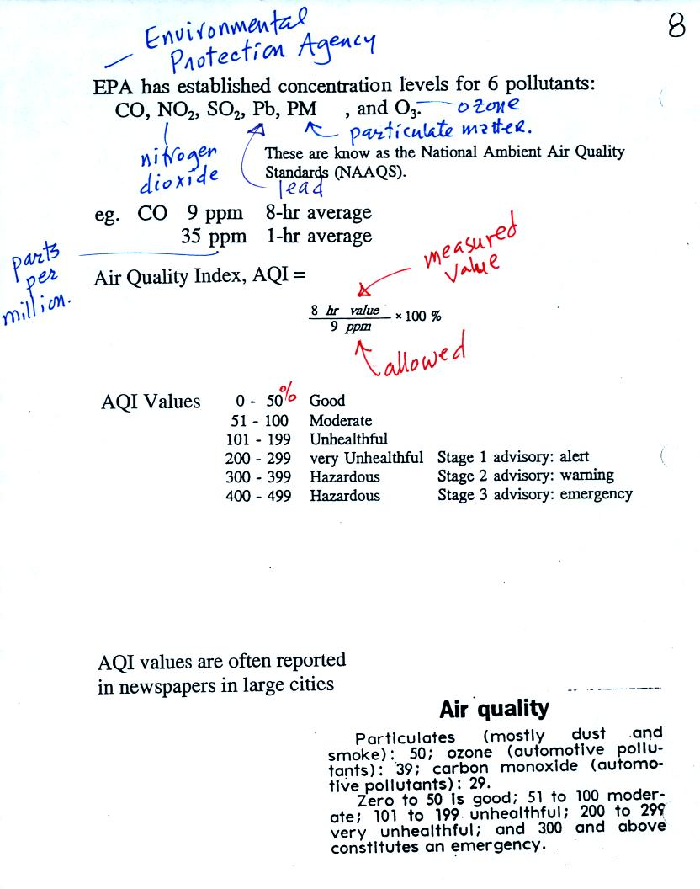
Six main air pollutants are listed at the top of this page. Concentrations of some or all of these pollutants are monitored daily in many cities. The atmospheric concentration of lead has decreased significantly since the introduction of unleaded gasoline. PM stands for particulate matter. These small particles are invisible, remain suspended in the air, and may be made of harmful materials. We'll talk about them in a little more detail next week.
CO, O₃ and particulate matter are the pollutants of most concern in Tucson and pollutant concentrations are reported in the newspaper or on television using the Air Quality Index (formerly the pollutant standards index). This is basically the measured value divided by the allowed value multiplied by 100%. For carbon monoxide, concentrations up to 35 ppm (parts per million) for a 1 hour period and 9 ppm for an 8 hour period are allowed. Current Air Quality Index values for Tucson are available online.
Yearly changes in the AQI values for ozone and carbon monoxide measured in Tucson in 1993 are plotted at the bottom of p.9 in the photocopied Classnotes. This figure wasn't shown or discussed in class.
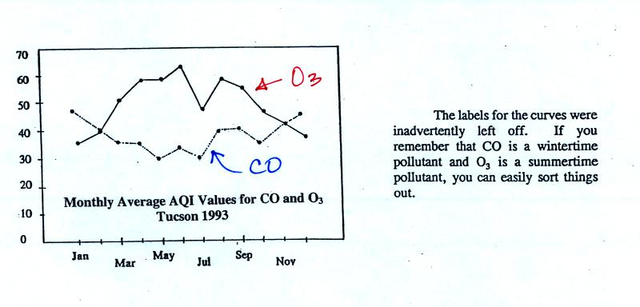
There are a couple of things to note in this figure. First the highest AQI values for carbon monoxide are observed in the winter. CO is a winter morning pollutant. The highest ozone AQI values are observed in the summer. Ozone, it turns out, is a summer afternoon pollutant (we'll learn why on Friday). Also ozone AQI values almost reach 70 in the summer. There are many people that think this is high enough to present a risk to people with existing lung disease.

So are we have been talking about carbon monoxide found in the atmosphere. Carbon monoxide is also a serious hazard indoors where is can build to much higher levels than would ever be found outdoors. You may remember having heard about an incident at the beginning of the school year in 2007. Carbon monoxide from a malfunctioning hot water heater sickened 23 Virginia Tech students in an apartment complex. The CO concentration is thought to have reached 500 ppm. You can get an idea of what kinds of health effects concentrations this high could cause from the figure below (from p. 9 in the photocopied Classnotes).
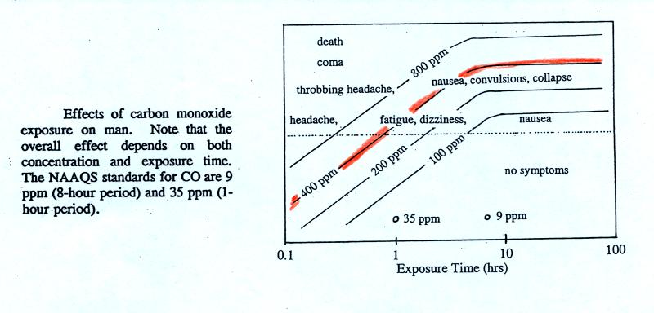
To get an idea of what effects 500 pm CO concentrations could cause, we will follow the 400 ppm line (shaded orange) from left to right. At exposure times less than 1 hour you should experience no symptoms. Beginning at 1 hour you might experience headache, fatique, and dizziness. Exposures of a few hours will produce throbbing headache, nausea, convulsions, and collapse. The 400 ppm trace level approaches the level where CO would cause coma and death. At Virginia Tech several students were found unconscious and one or two had stopped breathing.
Carbon monoxide alarms are relatively inexpensive and readily available at any hardware store. They will monitor CO concentrations indoors and warn you when concentrations reach hazardous levels. Indoors CO is produced by gas furnaces and water heaters that are either operating improperly or aren't being adequately vented to the outdoors. A few hundred people are killed indoors by carbon monoxide every year in the United States. You can learn more about carbon monoxide hazards and risk prevention at the Consumer Product Safety Commission web page.

We didn't have time to cover this next section in class.
I have a bad habit of "beating some concepts to death." Temperature inversions and atmospheric stablility versus instability is one example. We didn't have time to cover the follwoing figure (found on p. 10 in the photocopied ClassNotes) in class.
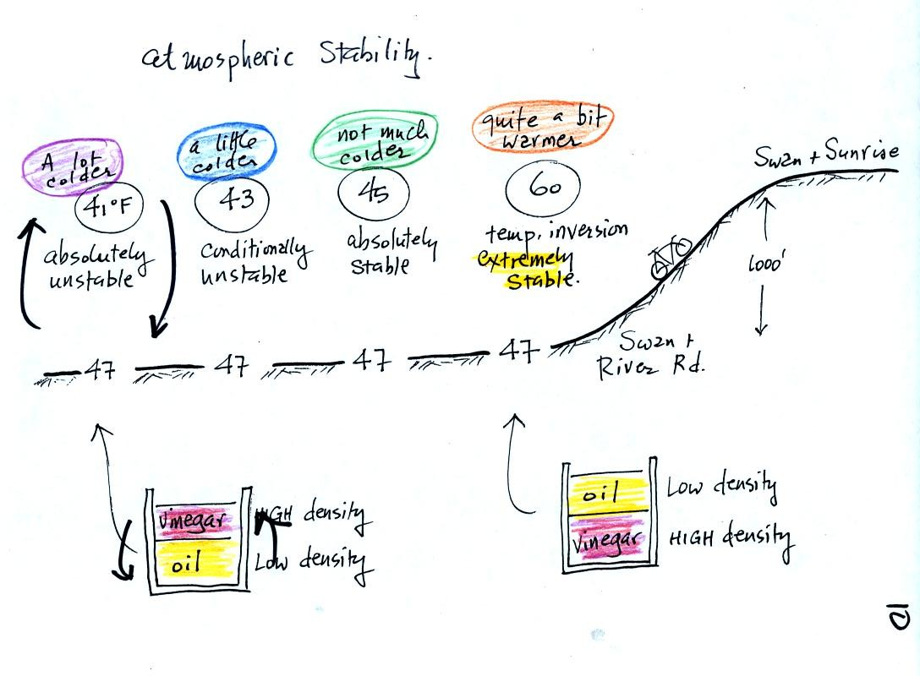
This rather busy and confusing picture just illustrates how small changes in how air temperature changes with increasing altitude can determine whether the atmosphere will be stable or unstable. Just for the purposes of illustration imagine riding a bicycle north from Swan and River Rd up the hill to Swan and Sunrise (fhe figure shows an elevation change of 1000 ft, it is actually quite a bit less than that)
At far left the air temperature goes from 47º F to 41º F, a drop of 6º F. This is a fairly rapid rate of decrease with increasing altitude and would make the atmosphere absolutely unstable. The atmosphere wouldn't remain this way. Air at the ground would rise, air higher up would sink, and the temperature profile would change. In some ways it would be like trying to pour vinegar on top of oil in a glass. The lower density oil would rise because it would "want" to float on top of the higher density vinegar.
The next picture shows air temperature decreasing a little more slowly with increasing altitude. This small change makes the atmosphere conditionally unstable (we won't go into what the conditions might be). The atmosphere is frequently in this state.
The atmosphere cools only 2º F in the next picture. This creates an absolutely stable atmosphere. Air at the ground will remain at the ground and won't rise and mix with air higher up. Compare this with the glass containing vinegar and a layer of oil on top. The two layers won't mix.
Air temperature in the last figure actually increases with increasing altitude. This is a temperature inversion and is very common on winter mornings. The atmosphere is extremely stable under these conditions.
Temperature inversions are something you can check out for yourself: head north on Swan Rd. on your bicycle early in the morning. You will pass through some pretty cold air as you cross the Rillito River. By the time you get to Sunrise, the air can be 10 degrees warmer and will seem balmy compared to the cold air at the bottom of the hill. If you're up for a real hill-climbing challenge continue north on Swan past Skyline. You'll find a short but very steep section of road at the far north end of Swan.

The following material was covered in class
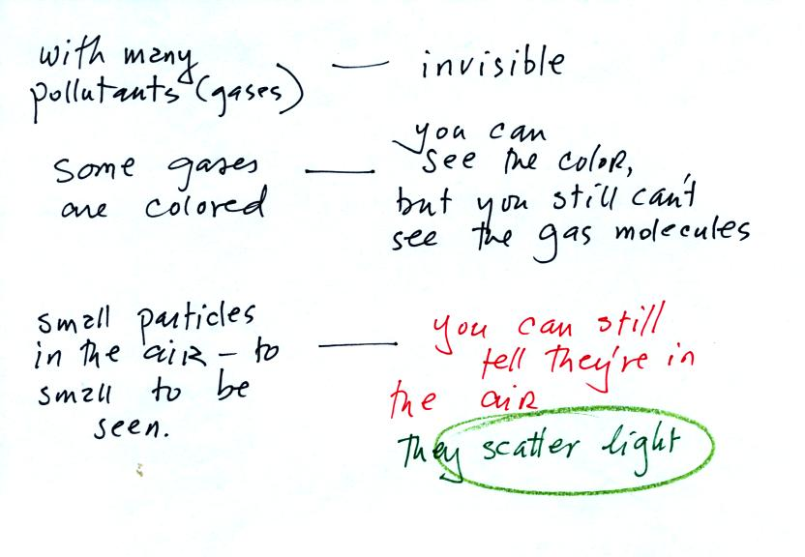
Finally in the last 10 minutes of class we did a short demonstration illustrating the scattering (splattering) of light. We will be making a smog cloud in class on Friday . Being able to see the smog cloud will depend on the fact that the cloud droplets scatter light. We would probably not be able to see the cloud otherwise, the cloud droplets are just too small.
In the first part of the demonstration a narrow beam of intense red laser light was shined from one side of the classroom to the other.
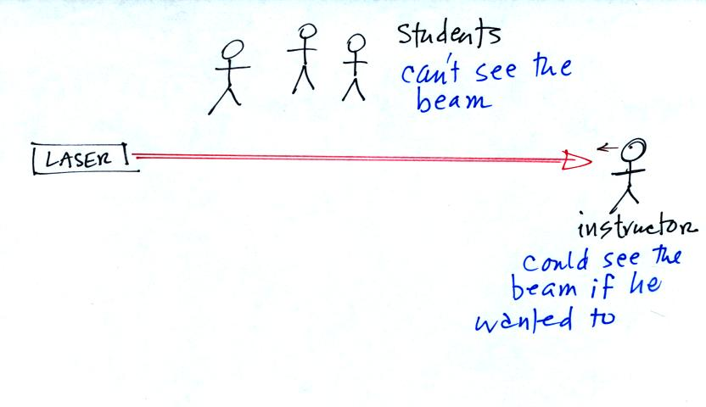
The instructor would have been able to see the beam if he had walked to the far wall and looked back along the beam of light (that wouldn't have been a smart thing to do because the beam is strong enough to damage his eyes). The students in the class weren't able to see the beam because they were looking at it from the side.
Students were able to see a bright red spot where the laser beam struck the wall.
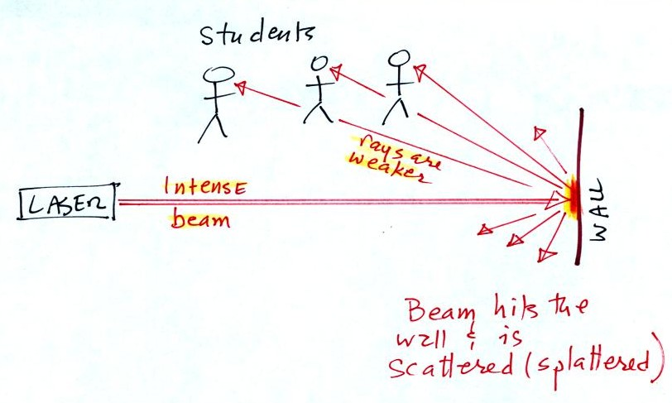
This is because when the intense beam of laser light hits the wall it is scattered (splattered is a more descriptive term). Weaker rays of light are sent out in all directions. There is a ray of light sent in the direction of every student in the class. They see the light because they are looking back in the direction the ray came from. It is safe to look at this light because the rays are weaker than the initial beam.
Next we clapped some blackboard erasers together so that some small particles of chalk dust fell into the laser beam.
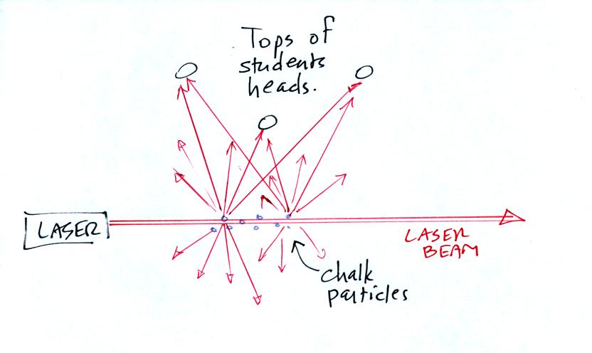
Now instead of a single spot on the wall, students saws lots of points of light coming from different positions along the laser beam. Each of these points of light was a particle of chalk, and each piece of chalk dust was intercepting laser light and sending light in all directions. Each student saw a ray of light coming from each of the chalk particles.
We use chalk because it is white, it will scatter rather than absorb visible light. What would you have seen if black particles of soot had been dropped into the laser beam?
In the last part of the demonstration we made a cloud by pouring some liquid nitrogen into a cup of water. The numerous little water droplets made very good scatterers.
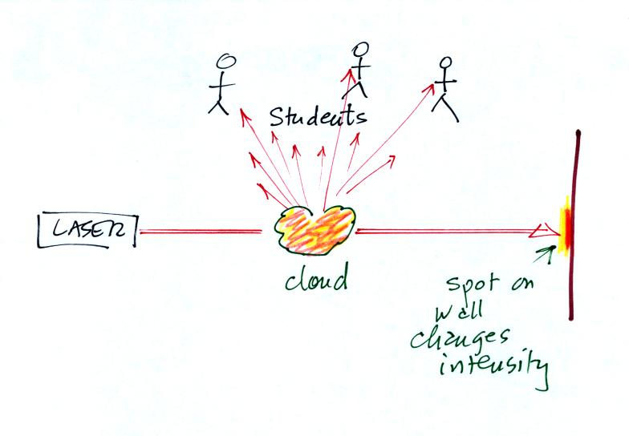
The laser light really lit up and turned the small patches of cloud red. The cloud did a very good job of scattering laser light. So much light was scattered that the spot on the wall fluctuated in intensity (the spot dimmed when lots of light was being scattered, and brightened when not as much light was scattered).
One last comment not mentioned in class. Air molecules are able to scatter light too, just like cloud droplets. Air molecules are much smaller than cloud droplets and don't scatter much light. That's why you were able to see light being scattered by air before we put chalk particles or cloud droplets into the beam. Outdoors you are able to see sunlight (much more intense than the laser beam used in the class demonstration) scattered by air molecules. Sunlight is white and is made up of violet, blue, green, yellow, orange, and red light. Air molecules have an unusual property: they scatter the shorter wavelengths (violet, blue, green) much more readily than the longer wavelength colors in sunlight (yellow, orange, and red). When you look away from the sun and look at the sky, the blue color that you see are the shorter wavelengths in sunlight that are being scattered by air molecules. We'll come back to this later in the semester.

