Wednesday Feb. 11, 2009
A little bit of the beginning of Survivor: The Australian Outback was shown before class today. This to celebrate the fact that the new season of Survivor, your instructor's favorite television show, begins this Thursday. So there was no music today (other than the Survivor theme song).
Experiment #2 materials were handed out in class today. More materials will be available in class on Friday. There are several people that haven't yet returned Expt. #1 materials. Please do so as soon as you can so that they can be cleaned and handed out to Expt. #2 people.
The in-class Optional Assignment from Monday was returned. If you don't see a score marked on your paper you earned full credit (0.3 extra credit points). Have a look at the answers, because we don't always grade your entire paper.
Quiz #1 is one week from today. Here is a preliminary Quiz #1 Study Guide. Quiz #1 will cover material from both the Practice Quiz Study Guide and the Quiz #1 Study Guide.
A new Optional Assignment was handed out today. This assignment is due at the start of class next Monday, Feb. 16. Assume a 1 mb per 10 meter rate of pressure decrease with increasing altitude in Question #10.
A handout with all the weather symbols used to plot weather data using the station model notation together with cloud symbols was handed out in class. You can download a copy here or pick up a copy in class on Friday.

A bunch of weather data has been plotted (using the station model notation) on a surface weather map in the figure below. 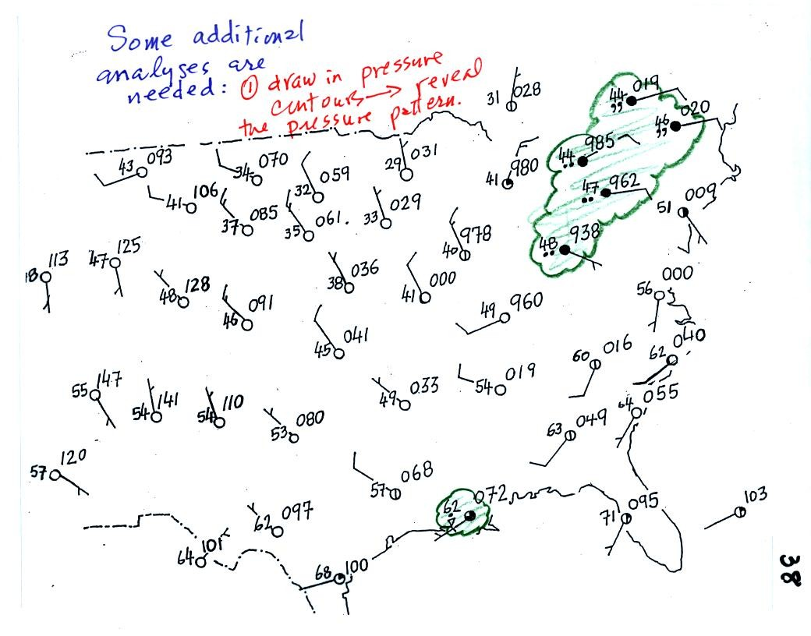
Plotting the surface weather data on a map is just the beginning. For example you really can't tell what is causing the cloudy weather with rain (the dot symbols are rain) and drizzle (the comma symbols) in the NE portion of the map above or the rain shower along the Gulf Coast. Some additional analysis is needed. A meteorologist would usually begin by drawing some contour lines of pressure to map out the large scale pressure pattern. We will look first at contour lines of temperature, they are a little easier to understand.
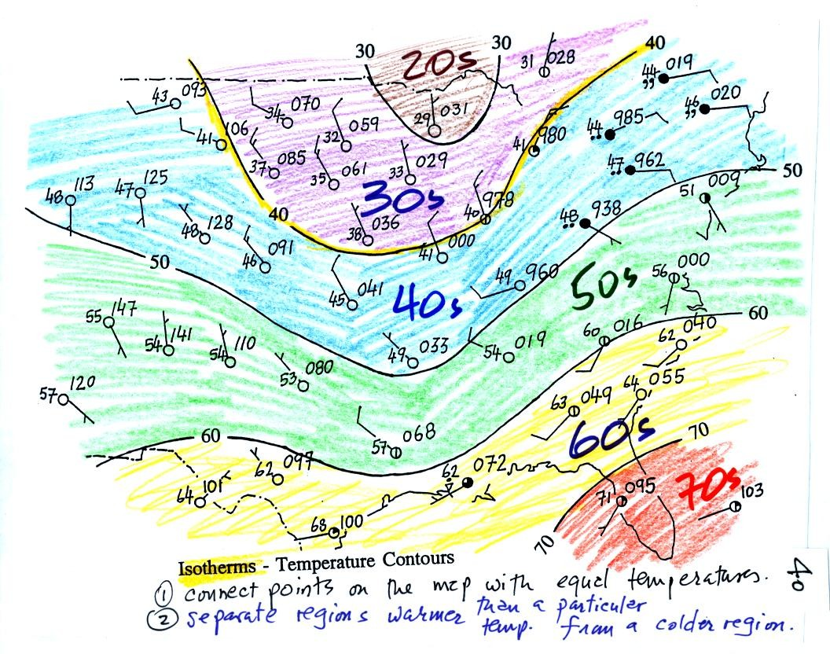
I told you I would finish coloring the map when I got back to my office.
Isotherms, temperature contour lines, are usually drawn at 10 F intervals. They do two things: (1) connect points on the map that all have the same temperature, and (2) separate regions that are warmer than a particular temperature from regions that are colder. The 40º F isotherm highlighted in yellow above passes through a city which is reporting a temperature of exactly 40º. Mostly it goes between pairs of cities: one with a temperature warmer than 40º and the other colder than 40º. Temperatures generally decrease with increasing latitude: warmest temperatures are usually in the south, colder temperatures in the north.
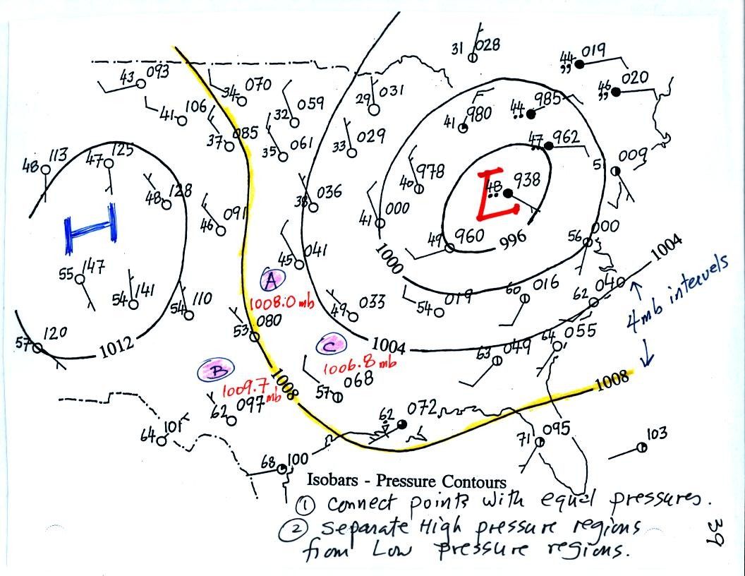
Now the same data with isobars drawn in. Again they separate regions with pressure higher than a particular value from regions with pressures lower than that value. Isobars are generally drawn at 4 mb intervals. Isobars also connect points on the map with the same pressure. The 1008 mb isobar (highlighted in yellow) passes through a city at Point A where the pressure is exactly 1008.0 mb. Most of the time the isobar will pass between two cities. The 1008 mb isobar passes between cities with pressures of 1009.7 mb at Point B and 1006.8 mb at Point C. You would expect to find 1008 mb somewhere in between those two cites, that is where the 1008 mb isobar goes.
The pattern on this map is very different from the pattern of isotherms. On this map the main features are the circular low and high pressure centers.

You can really start to say alot about the weather once you have mapped out the pressure pattern. Differences in pressure create a force that causes the wind to blow. Wind motions then can lead to stormy or fair weather.
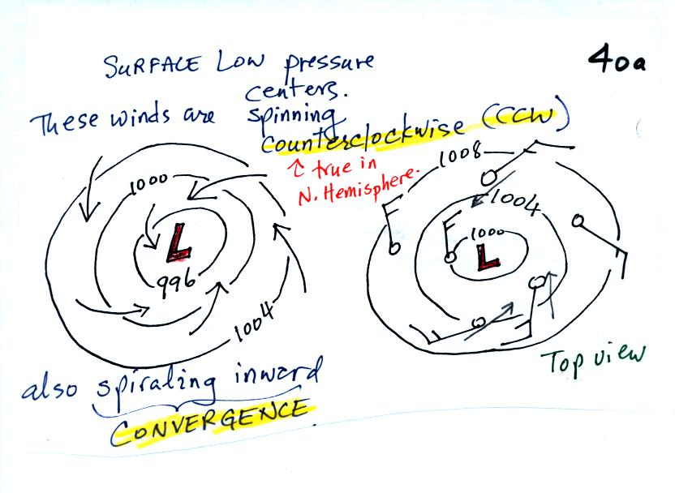

Air will start moving toward low pressure (like a rock sitting on a hillside that starts to roll downhill), then something called the Coriolis force will cause the wind to start to spin (we'll learn more about the Coriolis force later in the semester). Winds spin in a counterclockwise (CCW) direction around surface low pressure centers. The winds also spiral inward toward the center of the low, this is called convergence. [winds spin clockwise around low pressure centers in the southern hemisphere but still spiral inward]
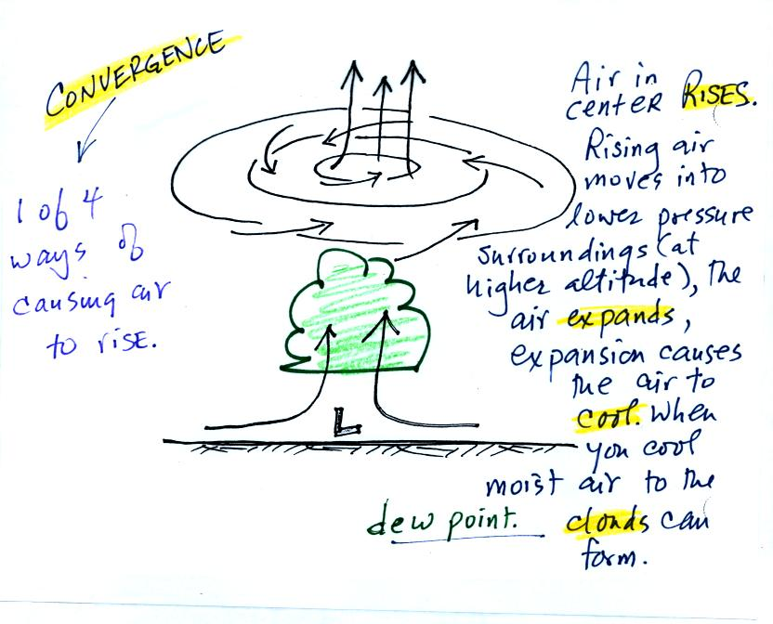
When the converging air reaches the center of the low, the starts to rise. Rising air expands (because it is moving into lower pressure surroundings at higher altitude) and cools. If the air is moist clouds can form and then begin to rain or snow. Thus you often see cloudy skies and stormy weather associated with surface low pressure.
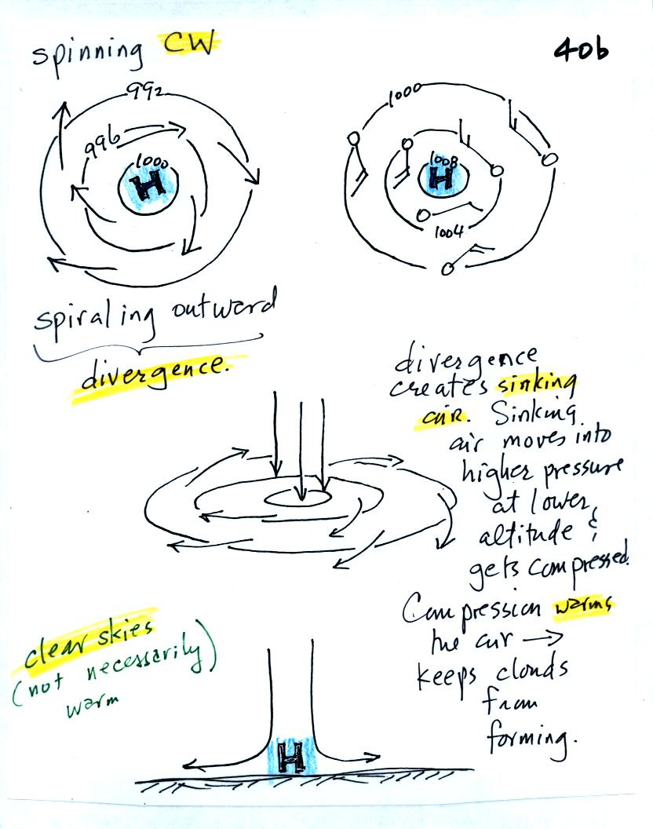
Surface high pressure centers are pretty much just the opposite situation. Winds spin clockwise (counterclockwise in the southern hemisphere) and spiral outward. The outward motion is called divergence.
Air sinks in the center of surface high pressure to replace the diverging air. The sinking air is compressed and warms. This keeps clouds from forming so clear skies are normally found with high pressure (clear skies but not necessarily warm weather, strong surface high pressure often forms when the air is very cold).

The pressure pattern will also tell you something about where you might expect to find fast or slow winds. In this case we look for regions where the isobars are either closely spaced together or widely spaced. (I'm using some more carefully drawn pictures from the Spring 2008 class)

Closely spaced contours means pressure is changing rapidly with distance. This is known as a strong pressure gradient and produces fast winds. It is analogous to a steep slope on a hillside. If you trip, you will roll rapidly down a steep hillside, more slowly down a gradual slope.
The winds around a high pressure center are shown above using both the station model notation and arrows. The winds are spinning clockwise and spiralling inward slightly.
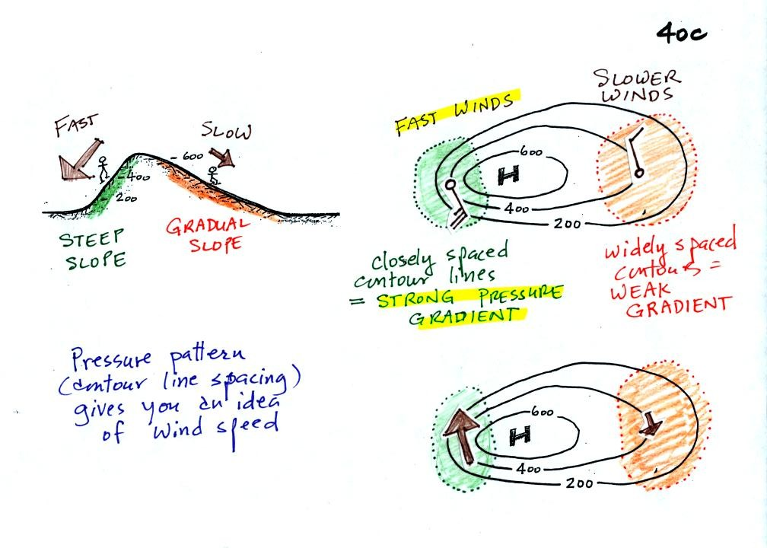
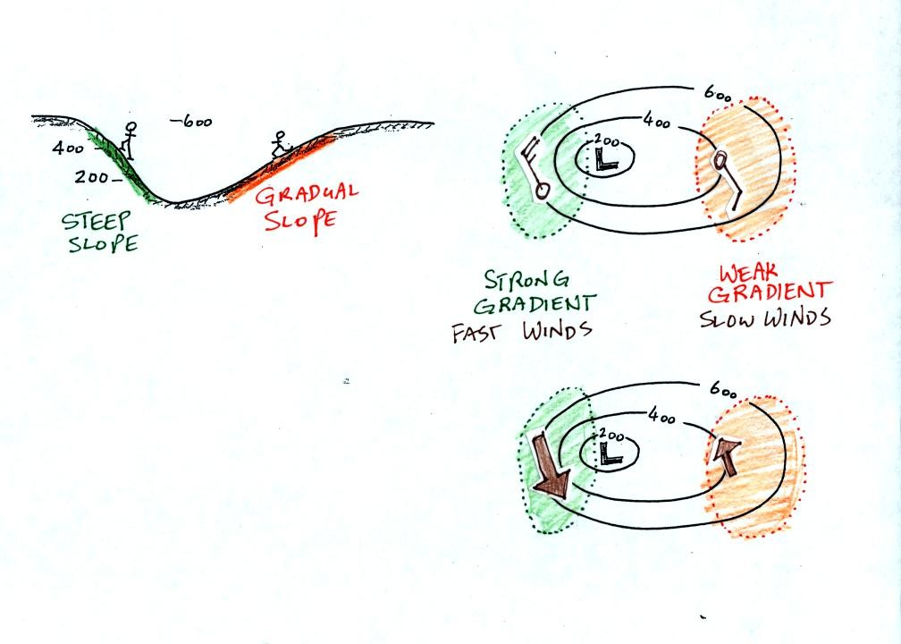
Winds spin counterclockwise and spiral inward around low pressure centers.
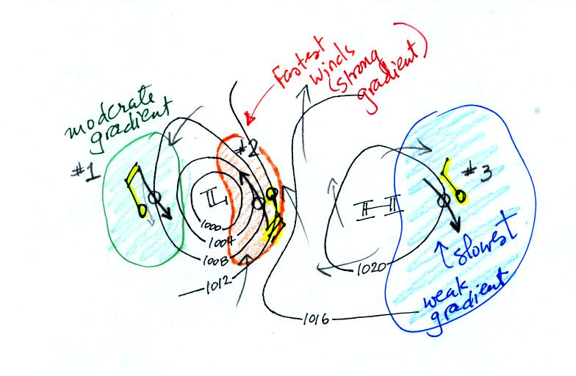
This is the figure from the bottom of p. 40c. The fastest winds (blowing from the SSE) are found in the center of the picture. The slowest winds are found on the right side of the figure where the contours are far apart. Note the southerly winds in the middle of the picture would probably be warmer (because they are coming from the south) than the NW winds at the right and left sides of the pictures.

The pressure pattern determines the wind direction and wind speed. Once the winds start to blow they can affect and change the temperature pattern. The figure below shows the temperature pattern you would expect to see if the wind wasn't blowing at all or if the wind was blowing straight from west to east. The bands of different temperature are aligned parallel to the lines of latitude. Temperature changes from south to north but not from west to east.
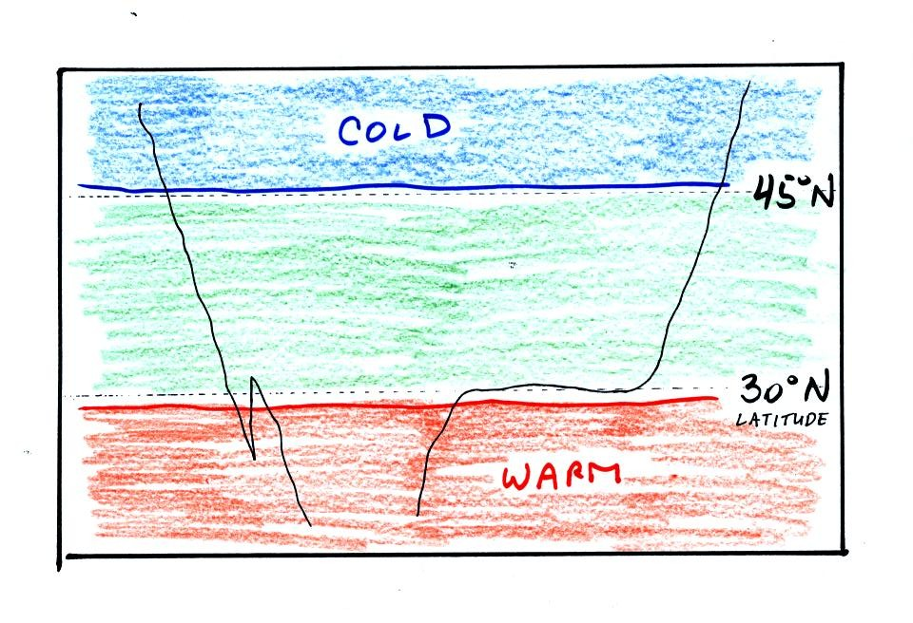

This isn't a very interesting picture. It gets a little more interesting if you put centers of high or low pressure in the middle.

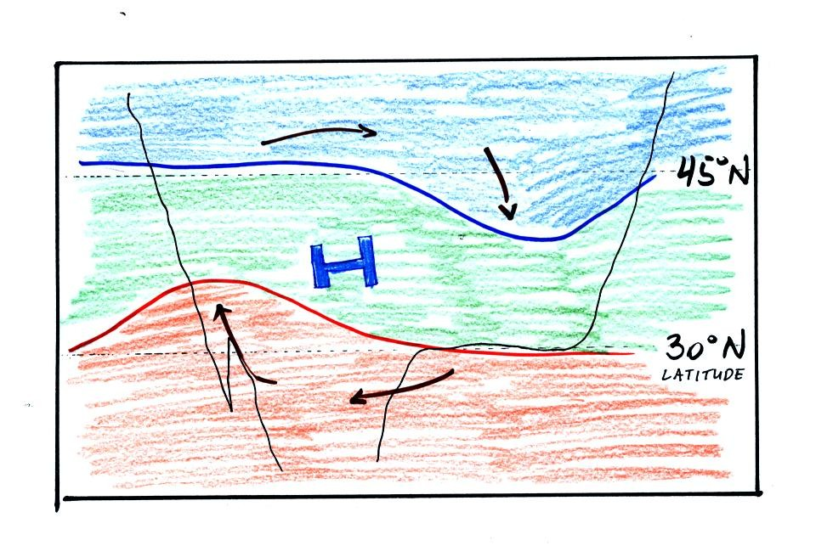
The clockwise spinning winds move warm air to the north on the western side of the High. Cold air moves toward the south on the eastern side of the High. The diverging winds also move the warm and cold air away from the center of the High.
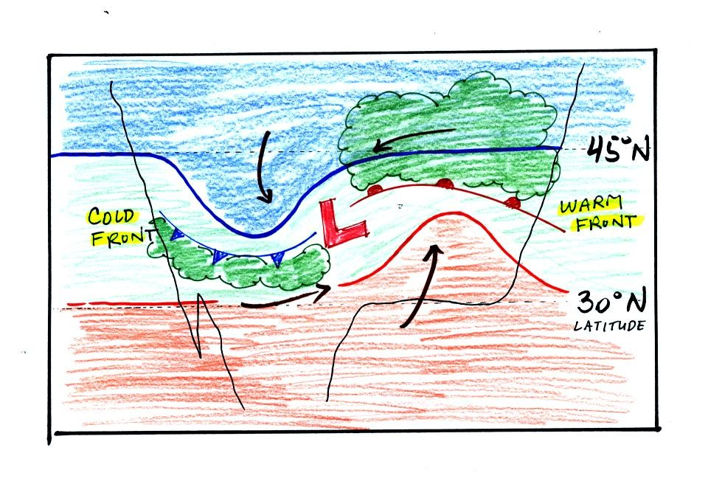

Counterclockwise winds move cold air toward the south on the west side of the Low. Warm air advances toward the north on the eastern side of the low.
The converging winds in the case of low pressure will move the air masses of different temperature in toward the center of low pressure and cause them to collide with each other. The boundaries between these colliding air masses are called fronts. Fronts are a second way of causing rising air motions (rising air expands and cools, if the air is moist clouds can form)
Cold air is moving from north toward the south on the western side of the low. The leading edge of the advancing cold air mass is a cold front. Cold fronts are drawn in blue on weather maps. The small triangular symbols on the side of the front identify it as a cold front and show what direction it is moving. The fronts are like spokes on a wheel. The "spokes" will spin counterclockwise around the low pressure center (the axle).
A warm front (drawn in red with half circle symbols) is shown on the right hand side of the map at the advancing edge of warm air. It is also rotating counterclockwise around the Low.
Clouds can form along fronts (often in a fairly narrow band along a cold front and over a larger area ahead of a warm front). We need to look at the crossectional structure of warm and cold fronts to understand better why this is the case.
This type of storm system is referred to as an extratropical cyclone (extra tropical means outside the tropics, cyclone means winds spinning around low pressure) or a middle latitude storm. Large storms also form in the tropics, they're called tropical cyclones or more commonly hurricanes.
We'll review and learn a lot more about front in class on Friday.

