Friday Apr. 24, 2009
Music this afternoon was "Alone Again Or" by Calexico. Calexico will be appearing at The Rialto next Friday night.
An additional topic has been added to 1S1P Assignment #3.

The following figure is on p. 166 in the photocopied ClassNotes.
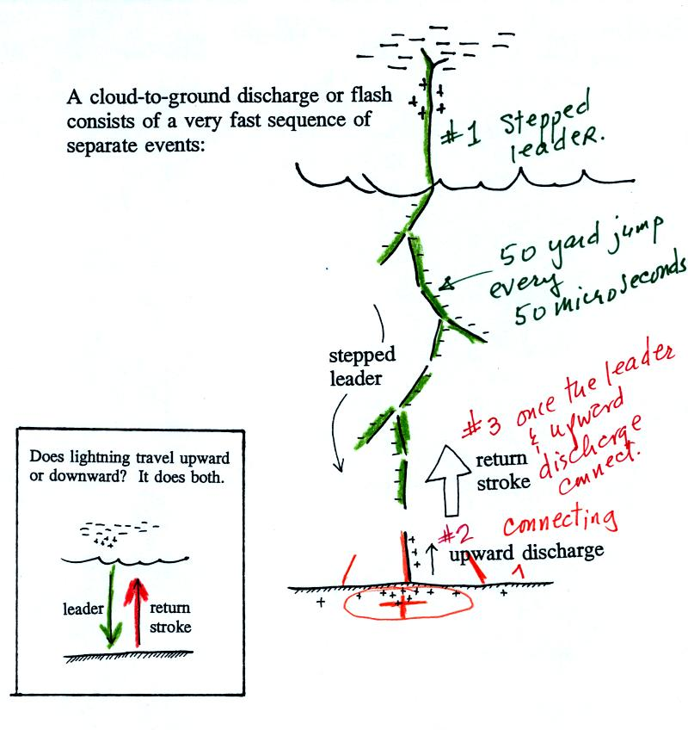
Most cloud to ground discharges begin with a negatively-charged downward-moving stepped leader. It makes its way down toward the cloud in 50 m jumps that occur every 50 millionths of a second or so. Every jump produces a short flash of light. An upward discharge is initiated when the stepped leader nears the ground. A powerful return stroke travels back up the channel (and out into all the branches) once the upward discharge and the stepped leader meet. These three steps are shown in additional detail below.
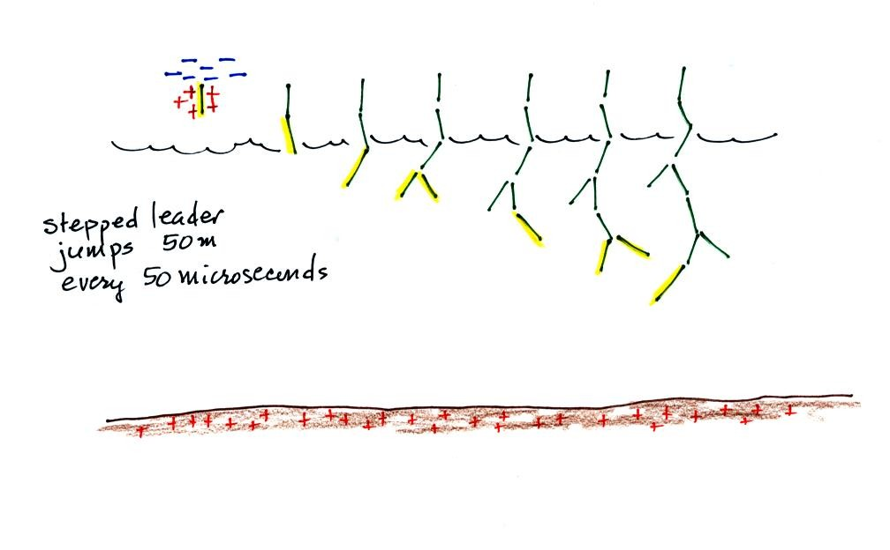
A sequence of stepped leader steps. Each of the channels in the drawing should actualy be superimposed on each other. There is just a single channel that every 50 microseconds of so gets 50 meters longer.
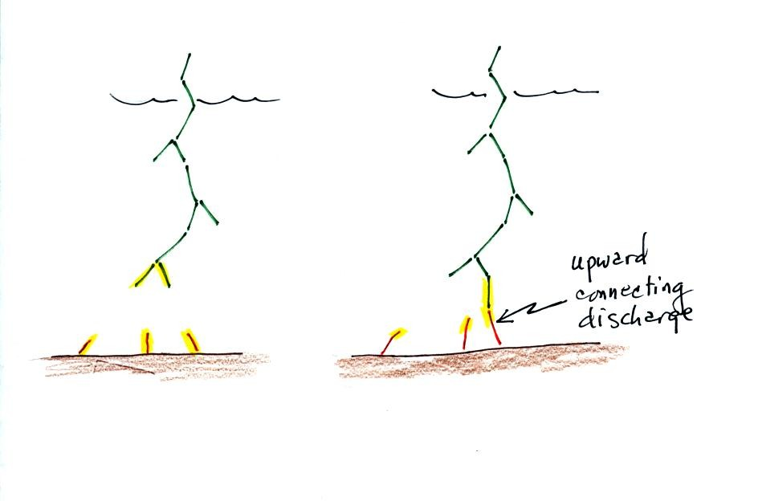
Several positively charged upward discharges begin to travel upward from the ground. One of these will eventually intercept the stepped leader.
This is what determines what will be struck by the lightning. Lightning doesn't really know what it will strike until it gets close to the ground.
Lightning rods take advantage of this principle.
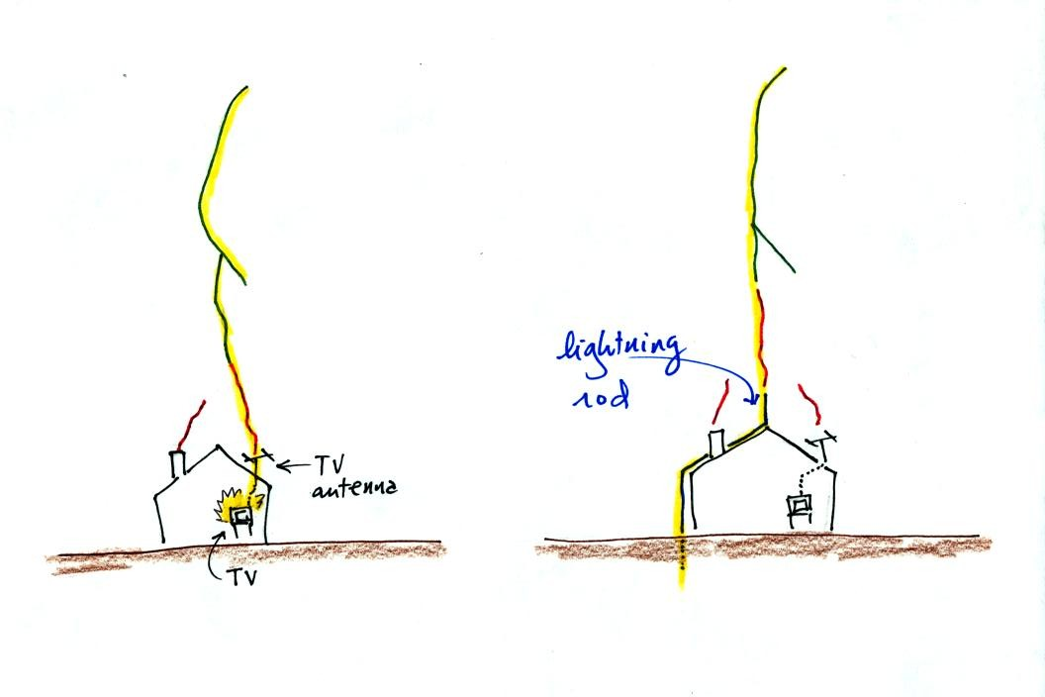
Houses with and without lightning rods are shown above. When lightning strikes the house without a lightning rod the powerful return stroke travels into the house destroying the TV and possibly starting the house on fire.
A lightning rod is supposed to intercept the stepped leader and safely carry the lightning current around the house and into the ground.
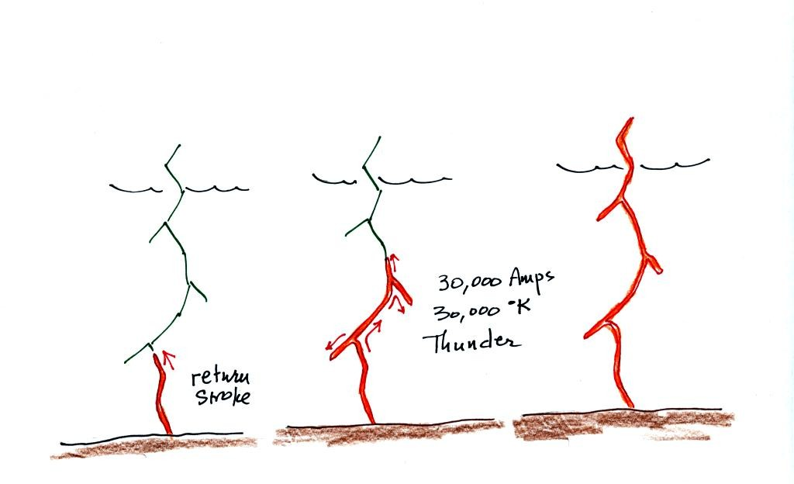

The connection between the stepped leader and the upward discharge creates a "short circuit" between the charge in the cloud and the charge in the ground. A powerful current travels back up the channel from the ground toward the cloud. This is the return stroke. Large currents (typically 30,000 amps in the first return stroke) heat the air to around 30,000K (5 times hotter than the surface of the sun) which causes the air to explode. When you hear thunder, you are hearing the sound produced by this explosion.
Stepped leader - upward connecting discharge - return stroke animation
Many cloud-to-ground flashes end at this point. In about 50% of cloud to ground discharges, the stepped leader-upward discharge-return stroke sequence repeats itself with a few subtle differences.
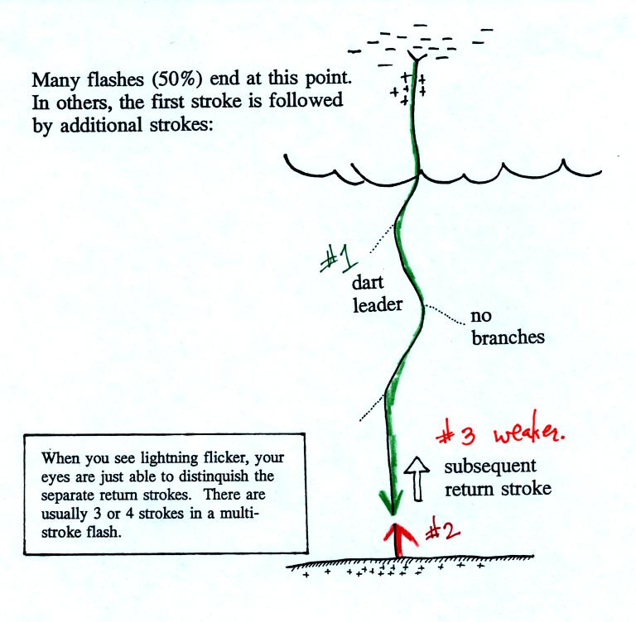
A downward dart leader travels from the cloud to the ground. The dart leader doesn't step but travels smoothly and follows the channel created by the stepped leader (avoiding the branches). It is followed by a slightly less powerful subsequent return stroke that travels back up the channel to the cloud.
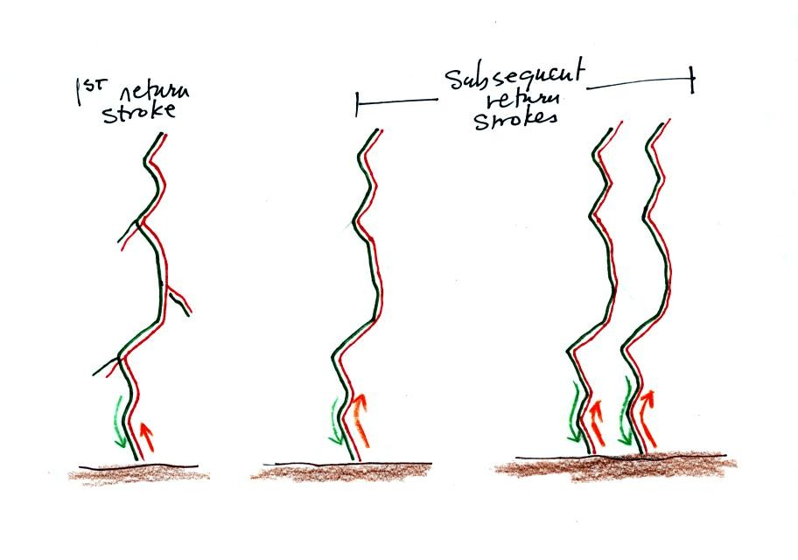
A normal still photograph would capture the separate return strokes superimposed on each other. If you bumped or moved the camera during the photograph the separate return strokes would be spread out on the image.
The image above shows a multiple stroke flash consisting of 4 separate return strokes.
There is enough time between separate return strokes (around 1/10 th second) that your eye can separate the individual flashes of light.
When lightning appears to flicker you are seeing the separate return strokes in a multiple stroke flash. The whole flash usually lasts 0.5 to 1 second.

Here are some unusual types of lightning.
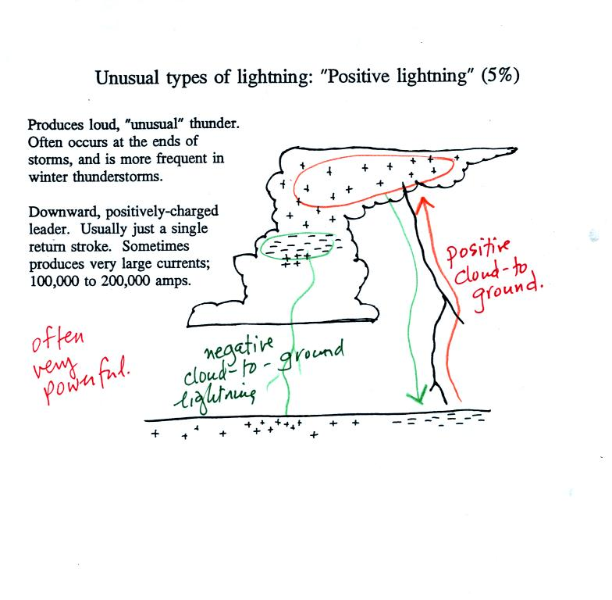
Occasionally a lightning stroke will travel from the positive charge region in the top of the thunderstorm cloud to ground. These types of strikes are more common at the ends of storms and in winter storms. This is probably because the top part of the cloud gets pushed sideways away from the middle and bottom portions of the cloud. Positive strokes are very powerful. They sometimes produce an unusually loud and long lasting clap of thunder.
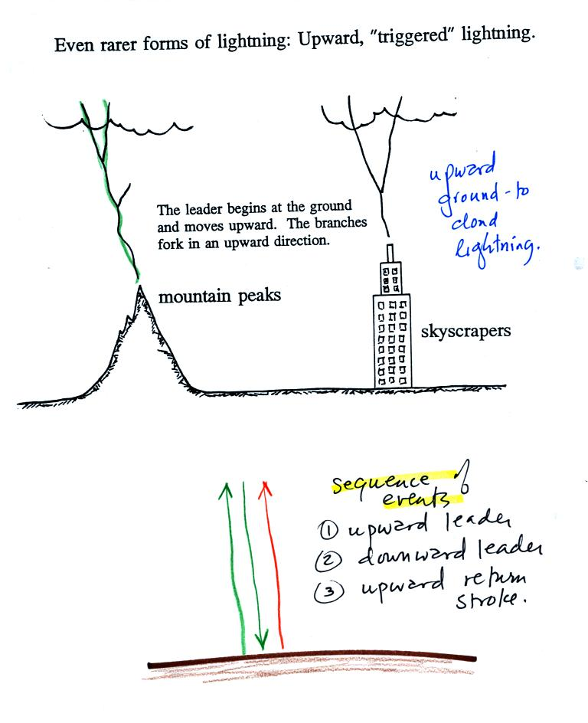
Here's an even rarer form of lightning. Lightning sometimes starts at the ground and travels upward. Upward lightning is generally only initiated by mountains and tall objects such as a skyscraper or a tower of some kind. Note the discharge is different in another way also. These discharges are initiated by an upward leader. This is followed by not by a return stroke but by a more normal downward leader. Once the 2nd leader reaches the ground, an upward return stroke travels back up the channel to the cloud.
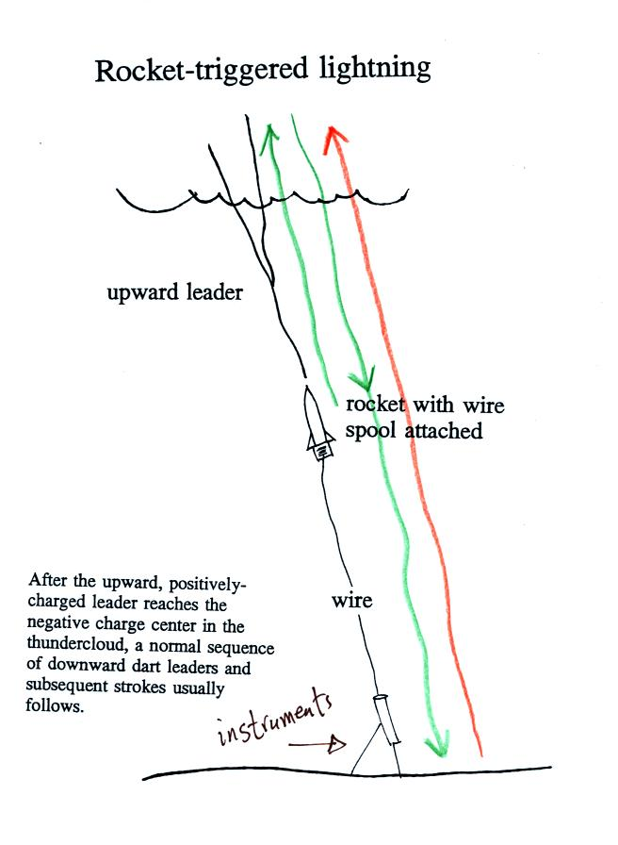
Scientists are able to trigger lightning by firing a small rocket up toward a thunderstorm. The rocket is connected by a thin wire to the ground. When the rocket gets 50 to 100 m above the ground upward lightning will develop off of the top of the wire.
Scientists are able to take closeup photographs and make measurements of lightning currents using triggered lightning. Triggered lightning can also be used to test the operation of lightning protection devices. A short video showing rocket triggered lightning experiments being conducted in northern Florida was shown in class.

When lightning strikes the ground it will often melt the soil (especially sandy soil) and leave behind a rootlike structure called a fulgurite (the spelling in the figure below is incorrect). A fulgurite is just a narrow (1/2 to 1 inch across) segment of melted sand (glass). The video showed archaeology students excavating around the lightning triggering site after the summer's experiments. They were able to uncover and reveal a very long (perhaps world record length) fulgurite.

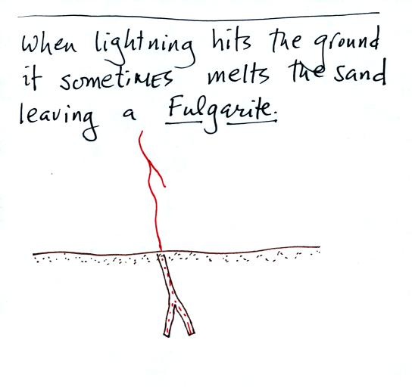
The video showed archaeology students excavating around the lightning triggering site after the summer's experiments. They were able to uncover and reveal a very long (perhaps world record length) fulgurite.

Lightning is a serious weather hazard and kills just under 100 people every year in the United States. We discussed some lightning safety rules that you should keep in mind during thundery weather.

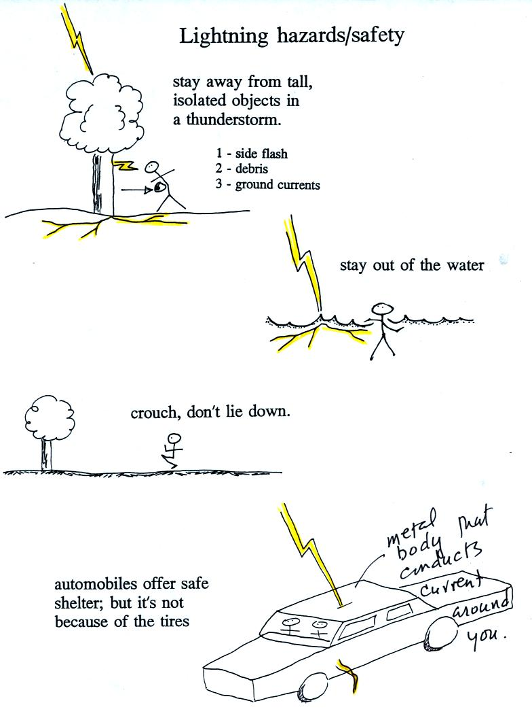

Stay away from tall isolated objects during a lightning storm. You can be hurt or killed just by being close to a lightning strike even if you're not struck directly.

An automobile with a metal roof and body provides good protection from lightning. The lightning current will travel through the metal and around the passengers inside. The rubber tires really don't play any role at all. The people in Florida that were triggering lightning were inside a metal trailer and were perfectly safe. All of the connections made to equipment outside the trailer was done using fiber optics, there were no metal wires entering or leaving the trailer.
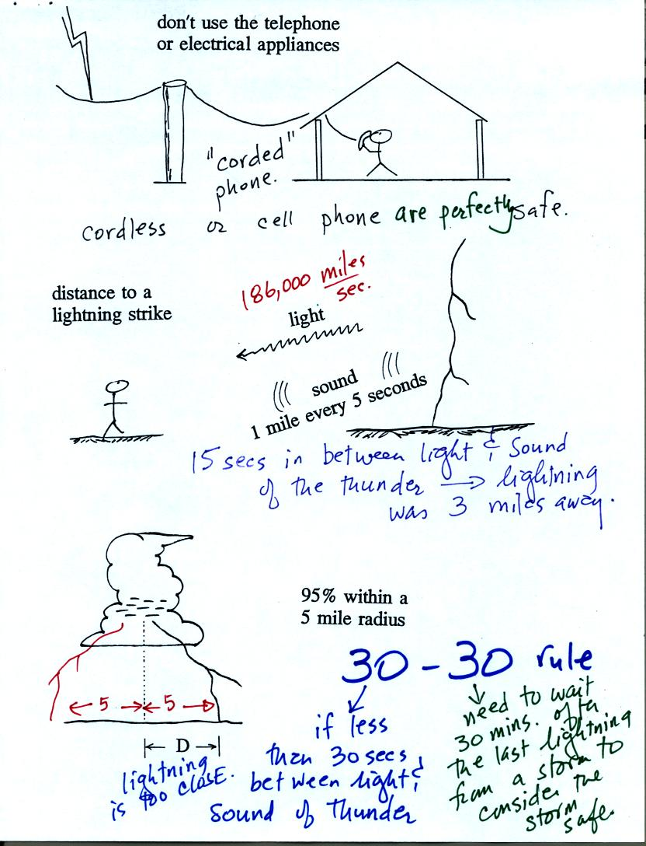
You shouldn't use a corded phone and electrical appliances during a lightning storm because lightning currents can follow wires into your home. Cordless phones and cell phones are safe. It is also a good idea to stay away from plumbing as much as possible (don't take a shower during a lightning storm, for example). Vent pipes that are connected to the plumbing go up to the roof of the house, an ideal location to be struck.

To estimate the distance to a lightning strike count the number of seconds between the flash of light and when you first hear the thunder. Divide this by 5 to get the distance in miles.
The latest lightning safety recommendation is the 30/30 Rule.
The 30/30 rule
People should seek shelter if the delay in seconds between a lightning flash and its thunder is 30 seconds or less.
People should remain under cover until 30 minutes after the final clap of thunder.

