Physical properties of the atmosphere

The vertical structure of the atmosphere.

To first order, the gas pressure at the bottom of an atmospheric column balances the downward force of gravity on the column. This is called hydrostatic balance and is written as
dP(z) = -g(z) ρ(z) dz (1)
where P is pressure of the air, z is height, g is the gravitational acceleration and ρ is mass density of the air. This means that as you add a layer of atmosphere of density ρ, that is dz thick, the pressure at the bottom of the layer is higher than whatever the pressure is at the top of the layer by dP. The minus sign is because gravity is pulling down while the component of pressure that is balancing gravity is pointing up.
We will normally evaluate equations in mks units. Pressure is force per unit area and has units of kg m/s² per m² = ‘pascal’. 1 bar = 1000 mb ~ 1 ‘atmosphere’ because the average surface pressure of the Earth’s atmosphere is 1013 mb. 1 mb = 100 pascals. Pressure has the units of an energy density, joules/m³, and it is related to energy density but it is not an energy density.
Gases are compressible. The equation of state for an ideal gas in microscopic units is
P = N k_{B} T (2)
where N is the number density of the gas in molecules per unit volume, k_{B} is Bolzmann’s constant: 1.3806503 x10⁻²³ in joules/K and T is the temperature of the gas in Kelvin.
The macroscopic version of the ideal gas law is
P = n R T (3)
where n is the gas number density expressed in moles per unit volume where a mole is 6.0221415 × 10²³ gas molecules and R is the gas constant 8.31441 J/mole/K.
Writing the gas law in terms of mass density rather than number density yields
P = nm/m R T = ρ R/m T (4)
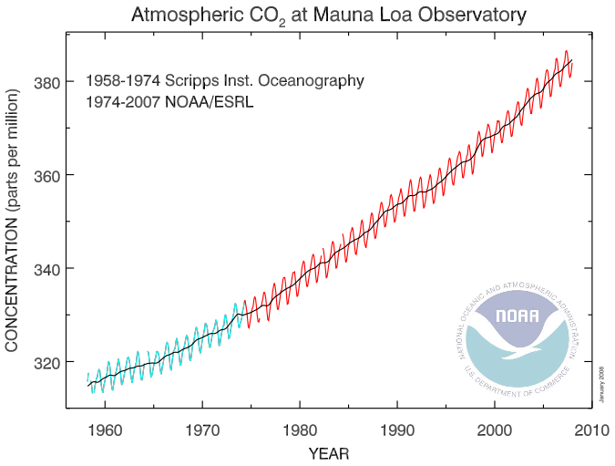
where m is the mass of one mole of gas molecules in kg. It is called the mean molecular mass because air in the Earth’s atmosphere is made up of N₂, O₂, Ar, H₂O, CO₂, etc. The average mass of a mole of dry air is 28.97 g or 0.02897 kg. This is true up to the altitude of the homopause (about 100 km) above which the molecules are no longer mixed up and at higher altitudes, their concentration with increasing height decays with height by weight.
Strictly speaking the mean molecular mass of air varies because the concentration of the water in the air varies. Since water has a molecular weight of 16 g/mole, adding water to an air parcel lightens it a bit. This can have some effect on the buoyancy of air parcels. Water can make up as much as 4% of the air molecules in tropical, near-surface conditions. CO₂ concentrations are also increasing but this is a subtler effect as CO₂ mixing ratios are ~ 380 ppm.

Plugging (4) into (1) we get
dP(z) = -g(z) m(z) P(z) /(RT(z)) dz
Rewriting this yields
dP(z)/P(z) =dln(P(z)) = -g(z) m(z)/(RT(z)) dz = -dz/H(z) (5)
where H(z) = H_{P}(z) = RT/mg which is known as the pressure scale height.
Integrating (5) we get
$P(z_{2})=P(z_{1})\text{exp}\left[−\int_{z_{1}}^{z_{2}}{\frac{dx}{H(x)}}\right]$
So pressure decays approximately exponentially with altitude with a scale height of H. Atmospheric density does the same. A typical pressure scale height in the mid-troposphere is
8 x 250 /0.02897 /9.81 ~ 7,000 m = 7 km. At the surface where it is warmer, pressure scale heights are ~8 km.
Note that the warmer the atmosphere is, the larger H is which causes pressure to decay more slowly with altitude. At lower temperatures, H is smaller and pressure decays more rapidly with altitude.
Pressure height as a thermometer: Therefore, accurately measuring the height of a pressure surface can provide a very accurate measure of the average temperature at lower altitudes which can be quite useful for observing climate change.
Winds: This also means that when a warm air mass sits next to a cold air mass, the pressures aloft will be higher over the warm air mass causing a horizontal pressure gradient aloft. At latitudes greater than about 10º, this pressure gradient will cause a wind. So the ability to remote sense such horizontal pressure gradients yields an indirect measure of winds.

Strictly speaking the vertical pressure structure is exactly exponential only if atmospheric temperature does not change with altitude (‘isothermal’), but the exponential behavior is crudely true because atmospheric temperatures only vary from ~200K to 200K. Another subtlety is that g decreases gradually with altitude.
Pressure as a vertical coordinate: Pressure decreases monotonically with altitude and so can be used as a vertical coordinate and in fact is used as such in equations describing atmospheric dynamics because it simplifies the equations. Passive nadir sounders, that is atmospheric sounders that measure thermal emission from the atmosphere determine temperature and atmospheric composition and winds as a function of pressure, not altitude, based on the spectral width of absorption lines that depends on pressure as we shall see shortly.

Approximate Pressure versus altitude
The height of a pressure surface depends on the surface pressure and the average temperature of the atmosphere between the surface and the pressure level. There is an average or typical relation between pressure and altitude which is useful for going back and forth between pressure and altitude approximately.

Pressure altitude above mean sea level (msl)
100 mb 16 km
200 mb 12 km
300 mb 9 km
500 mb 5.5 km
700 mb 3 km
800 mb 2 km
900 mb 1 km
1000 mb 0 km

At colder temperatures the pressures will correspond to somewhat lower altitudes. At higher temperatures, the pressures will correspond to slightly higher altitudes.

Temperature change with altitude
Because temperatures generally decrease with altitude in the troposphere, the term temperature lapse rate has been defined where lapse rate = -dT/dz.
The dry adiabatic temperature lapse rate is g/C_{p} ~ 10K/km. Adiabatic means that as an air parcel is lifted or sinks, there is no heat exchanged with the environment. EvZ gives the derivation.
Except right at the surface, the dry adiabat is the most extreme temperature decrease with altitude that is physically permissible. If the decrease in temperature with altitude were to become momentarily even more extreme, then the atmosphere will correct because lighter air sits below denser air and any perturbation will cause the atmosphere to turn over (hot air rising and cold air sinking) and correct back to the dry adiabat. This causes turbulence.
Usually vertical temperature gradients in the atmosphere are more stable because of 2 reasons. First, latent heat released as water vapor condenses out of the air as air cools as it rises makes the temperature decrease with altitude smaller. Second, except in convection, most sinking air sinks rather slowly, losing energy radiatively as it sinks. So as it sinks it compressionally heats but loses energy as well so it warms at a slower vertical rate than the dry adiabat.
When in doubt, the standard vertical termperature gradient in the troposphere is -6.5 K/km.
In the stratosphere, temperatures generally increase with altitude.
EvZ Figure 8-1. Average vertical temperature structure of Earth’s atmosphere

Linear change in temperature with altitude

It is useful to note for more quantitative applications, a more accurate equation for pressure versus altitude over short vertical intervals uses the fact that temperature varies linearly with altitude.
T(z₂) = T(z₁) + dT/dz (z₂-z₁)
So, over an altitude interval where changes in temperature are linearly proportional to changes in altitude we can substitute changes in T for changes in z. Defining dT/dz = $\overset{˙}{T}$, we get from (5)
dln(P(z)) = -g(z) m(z)/(RT(z)) dz =-g(z) m(z)/(RT(z))/$\overset{˙}{T}$ dT
If the interval is short we can assume g and m do not change over the vertical interval so that
$d\text{ln}\left(P\right)\text{=-}\frac{\text{gm}}{R\overset{˙}{T}}\frac{\text{dT}}{T}\text{=-}\frac{\text{gm}}{R\overset{˙}{T}}d\text{ln}\left(T\right)$ (6)
$\text{ln}\left(P\right)|_{P_{1}}^{P_{2}}\text{=-}\frac{\text{gm}}{R\overset{˙}{T}}\text{ln}\left(T\right)|_{T_{1}}^{T_{2}}$ (6)
Raising each side to exp gives
$\frac{P_{2}}{P_{1}}=\text{exp}\left[−\frac{\text{gm}}{R\overset{˙}{T}}\text{ln}\left(\frac{T_{2}}{T_{1}}\right)\right]=\text{exp}\left[\text{ln}\left({\left[\frac{T_{1}}{T_{2}}\right]}^{\frac{\text{gm}}{R\overset{˙}{T}}}\right)\right]={\left[\frac{T_{1}}{T_{2}}\right]}^{\frac{\text{gm}}{R\overset{˙}{T}}}$ (6)
So we have a power law relation between P and T (or equivalently changes in altitude) over intervals where the vertical temperature gradient (= − temperature lapse rate) is constant and the gravity and mean molecular mass do not change much over the interval. IF $\overset{˙}{T}$=0, we have an isothermal atmosphere and then the exponential form is exactly correct.
To estimate –gm/R$\overset{˙}{T}$, assume a typical lapse rate of 6.5K/km. (Be warned, the “lapse rate” is –dT/dz, defined so because in the troposphere the temperature usually decreases with height.) –gm/R$\overset{˙}{T}$ = 9.81x0.02897/8.3144/0.0065 ~ 10x3x10⁻²x1.2x10⁻¹/6.5x10⁻³ ~ 0.5x10¹⁻²⁻¹⁺³ = 5.
Assume T₁= 250K and T₂ = 243.5K (1 km higher) and the pressure P₁ = 500 mb. Then P₂ = 500mb (243.5/250)⁵ = 435 mb.
Had we used the exponential form using the average temperature between the two levels so the pressure scale height would be RT/mg = 7.2 km, the answer would have been 500mb exp(-1/7.2) = 435 mb.
So the difference is subtle but for precise determinations of pressure versus altitude, this power law relation is more accurate. Note that for wind determination, we want to know pressure versus height to a few meters if possible.

Density scale height
When temperature varies with altitude, one can derive a density scale height:
$H_{ρ}=\frac{H_{P}}{1+\frac{\text{dT}}{\text{dz}}\frac{H_{P}}{T}}$
So, in the troposphere where dT/dz <0, the density scale height is larger than the pressure scale height (as much as ~13 km with an adiabatic lapse rate and warm conditions at the surface). So density falls off more slowly with altitude than pressure. In the stratosphere, where dT/dz > 0, the density scale height is smaller than the pressure scale height and so density decreases more rapidly with altitude than pressure.

Atmospheric Composition
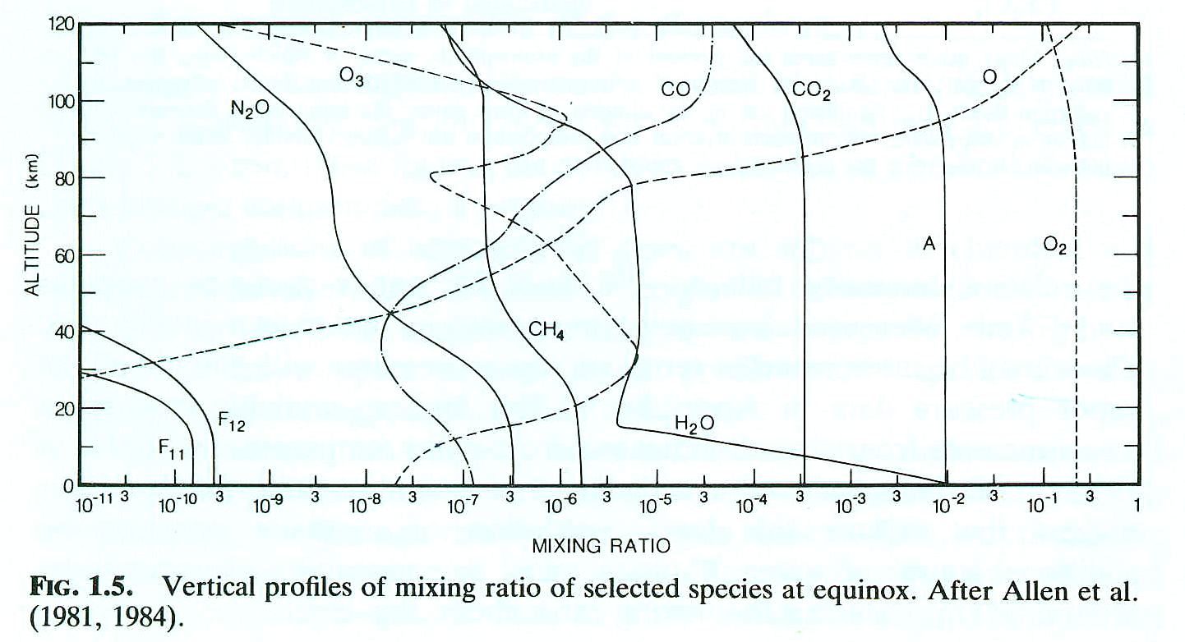
From GOODY & YUNG

Mixing ratio Definitions

Volume mixing ratio: number of molecules of a particular species per unit volume divided by the total number of molecules in the air per unit volume

Mass Mixing ratio: mass density of a particular species divided by the total mass density of the air.

See also EvZ figures 8-3 about composition and 8-2 about absorption spectra vs species

