Class 1: Introduction and Overview

Ordering the textbook. It sells for ~$132. It can also be found online at http://www3.interscience.wiley.com/cgi-bin/bookhome/112100916

The problem/motivation: Why do we do remote sensing?
On Earth, we want to
- Understand basic climatological behavior
- Understand the “physics” of the weather and climate system
- Make new discoveries: water vapor behavior and processes in the UT/LS
- Accurately predict weather
- Accurately predict future climate under different scenarios (GHG emissions)
Planetary science and astronomy:
- First order behavior, new discoveries, refinements in understanding

Solution:
Geophysical systems are generally complex, and understanding them generally requires observations combined with modeling that (attempts to) reproduce their behavior

State estimation:
We also need to measure the properties of the weather/climate system, focused on the atmosphere as well as properties of the ocean, land surface and cryosphere. The atmospheric state is temperature, pressure, moisture and other gaseous constituents, clouds, aerosols, precipitation, winds and surface properties with high spatial and temporal resolution.

Understanding of the physics and chemistry comes from studying observations and deducing the mechanisms controlling for instance clouds or water vapor distribution or the locations and intensity of the jets.

Specific Roles for Remote Sensing for Weather and Climate
- Initialize weather models
- Provide constraints to determine processes and evaluate and later refine model representations of these processes
- Determine what the climate and weather system is actually doing: Determine climatology and trends
- Determine the overall radiative energy balance, solar in and IR out

Measurement definition: In-situ vs. Remote Sensing
In-Situ: Measurements of an object made at the object, in the atmosphere of the atmosphere in contact with the instrument.
Example: A barometer measures the force that pressure exerts on it (usually by a displacement proportional to the force)

Remote sensing: Measures properties of a system from a remote location. The measurements involve waves or particles that interact with the system that travel to and are measured by the instrument.

Examples:
- Electromagnetic radiation (this class),
  - also medical imaging
- seismic tomography of Earth’s interior, e.g.
http://wwwrses.anu.edu.au/seismology/ar97/faletic.html
http://www.geo.ucalgary.ca/~wu/SeismTomog.html
- acoustic sounding of the ocean,
- gamma rays and neutrons for probing hydrogen (water) in the surface,
http://science.nasa.gov/headlines/y2002/28may_marsice.htm
- gravity for measuring the movement of ground water mass,
http://daac.gsfc.nasa.gov/hydrology/grace_groundwater.shtml
http://www.nasa.gov/vision/earth/lookingatearth/grace-20061212_prt.htm
- gravitational waves for astronomy

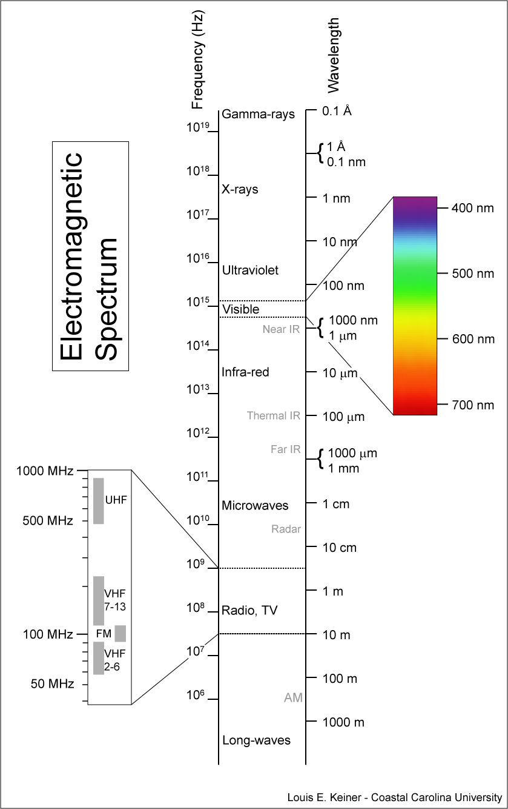
What is remote sensing, overview of approaches and key types/techniques
- Satellite platform overview and history chart
- Importance of wavelength diversity due to opacity
- Sources of radiation: solar, terrestrial, stellar, manmade (active)
Also emission versus reflection/scattering versus transmission

Key Questions:

How do we “invert” the EM measurements to determine temperature and water vapor?

What is the information content: what each remote sensing approach can and can’t do

Data assimilation: How do get the information of the measurements into weather models?

Strengths and weaknesses of remote sensing
Advantage: COVERAGE.
Remote sensing can sample a much larger area or volume that can be accomplished for a reasonable cost with in-situ measurements.

Weakness: The weakness of remote sensing is the accuracy and resolution of remote sensing observations are almost always worse than what is possible via in-situ measurements. Remote sensing measurements are often calibrated/validated by in-situ measurements.

Example: Mars Sample Return is VERY expensive but allows detailed laboratory analysis that can’t be done at Mars.

Example: An example is a truly global balloon network versus satellite observations. A global network would require ships or aircraft positioned every 100 km (?) across the globe launching 2 or more balloons each day. Ship and aircraft time is VERY expensive. Can they survive severe storms which is actually when you need them most?
Weather and climate require a global perspective. A global perspective can only be achieved via satellite observations.

Signal sources: Active (manmade) vs. Passive (natural source) Remote Sensing
Advantages and disadvantages

Goals of remote sensing
Desired 4-D measurements of the state of the weather/climate system
Atmosphere: Temperature (incl. stability), pressure, moisture, constituents, clouds, aerosols, winds, divergence, fluxes
Ocean: Temperature, salinity, currents, surface roughness
Cryosphere: Snow and Ice coverage and thickness, temperature, liquid water on surface
http://www.nasa.gov/vision/earth/lookingatearth/greenland_slide.html
Land surface: vegetation, soil moisture, snow cover and thickness, albedo, emissivity

Distinction between Climate vs. Weather objectives
Importance of stable, very accurate, unambiguous, long term measurements for climate

