Rationale: why are we interested in Atmospheric Science?

Atmospheric Science is an applied science focused on understanding Earth’s atmosphere as well as the atmospheres of other planets. Below are a number of issues and reasons for this science grouped largely into 4 categories: weather forecasting, atmospheric chemistry, climate change and planetary atmospheres.

Weather forecasting, Numerical Weather Prediction (NWP)
The need for weather forecasting has been around pretty much since the appearance of modern humans. It can be critical to agriculture, human safety and successful warfare. The Norwegian school which developed the air mass and fronts mid-latitude cyclone was an outgrowth of World War I. Forecasting skill has grown tremendously over the past decades as shown in the figure below. The increase in forecasting skill is due to a combination of improvements in model realism, the advent of satellite observations, development of techniques to assimilate the observations into the forecast cycle and dramatic increases in computing power (most of which is used by NWP in the data assimilation process).

Figure 1. 500 hPa = 500 mb height skill versus time. 500 hPa height is a useful variable with which to evaluate skill because it is tied to the temperature in the lower half of the troposphere and steering winds. See QJRMS 128, p. 652 (2002) ECMWF. From www.bom.gov.au/bmrc/basic/wksp16/pdf_docs/Mon/Simmons_Monday.pdf

Interestingly the figure above shows forecasting skill in the Southern Hemisphere has caught up with that in the Northern Hemisphere despite the relatively sparse conventional observations like radiosondes in the Southern Hemisphere. This Southern Hemisphere skill clearly reveals the impact of the satellite observations on the forecasts and implies further that forecasting 500 mb heights in the Southern Hemisphere must be somewhat easier than in the Northern Hemisphere. The figure below shows the locations of the observations assimilated into the NWP cycle in a three hour period in 2004.

Figure 2. from www.bom.gov.au/bmrc/basic/wksp16/pdf_docs/Mon/Simmons_Monday.pdf

Figure 3. Assessment of the information content and impact of each class of observational data. DFS = “Degrees of Freedom for signal”. From Paul Poli’s presentation at the 2007 COSMIC conference. See http://www.cosmic.ucar.edu/oct2007workshop/program.html.

The information content of these observations is summarized in Figure 3. Note that the number of observations is correlated with but definitely not equal to the information content. In particular, note that GPS Radio Occultation which is a new observational type and specialty in our Department is having significant impact on the weather forecasts despite relatively few observations.

Wildfires
A relatively new area of importance for weather forecasting is forecastying conditions conducive for fires initiation and the evolution of fires. The figure below shows a satellite image the fires and resulting smoke patterns in and off of Southern California and Baja California. Note the clear signature of the easterly Santa Ana winds that produced the hot and dry conditions and intense winds that were in large part responsible for the intensity and very problematic aspects of the fires. These conditions are the result of a combination of high topography to the east and low topography to the west, a high pressure to the north/northeast occurring in the fall a couple of years after a year of much rainfall. Southern California has a “Mediterranean climate” with rain primarily in the winter and spring and little or no rain in the summer and fall. As a result, the vegetation is very dry in the late fall. When a high pressure occurs to the north, it causes descending hot dry air in the region. The flow from the higher altitude plateau to the east to the lower coastline to the west causes rapid warming due to adiabatic compression. Furthermore the rugged mountains create a venturi effect which causes high winds to blow through the mountain passes creating conditions very favorable for rapid expansion of fires and a situation very difficult for firefighters. On top of all that, the US does not clear the growth of tinder which builds up and leads to large fires. On top of that there has been a great deal of building in these fire prone areas. This may have been related to the phenomenal growth during the 2004-2005 rainfall season that brought 37.25 inches of rainfall to downtown Los Angeles measured at USC making it the second wettest season in Los Angeles since records began in 1877. One of the many reasons California is concerned about global warming is it may bring an increase in these destructive windfires as temperatures over land increase faster than those over the water causing relative humidity over land to drop on average.

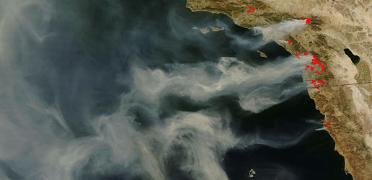

Figure 4. Southern California Fires October 24, 2007. Note how the wind direction reveals the Santa Ana wind conditions
Dr. David Bright, a former student of Professor Mullen, has used NOAA forecasts to determine where conditions are ripe for a certain class of thunderstorm where lightning occurs but the precipitation does not reach the surface, a set of conditions ripe for initiating fires. These forecasts are used by the Forest Service to decide where and when firefighters may be needed.

Tornadoes
Tornadoes are a special type of thunderstorm in which the winds rotate in a tight spiral a mile or less across and can reach speeds over 300 mph. The geometry of the central US creates a very unique set of conditions that produce the worst tornadoes on the planet. Bangladesh is a distant second.
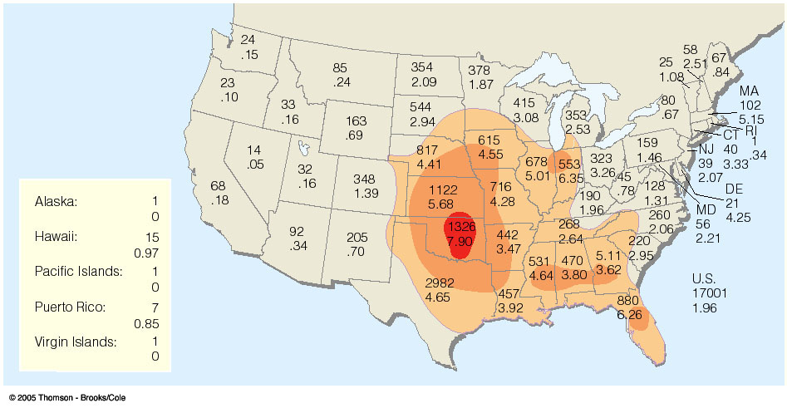

The conditions that produce tornadoes are summarized in the left hand figure below. The actual process that is believed to lead to tornadoes is summarized on the right.
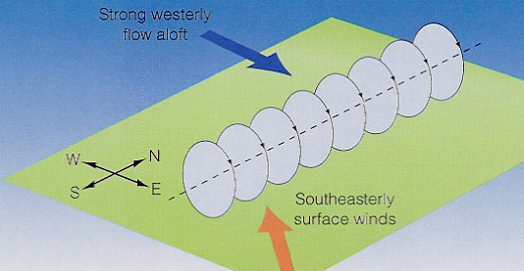
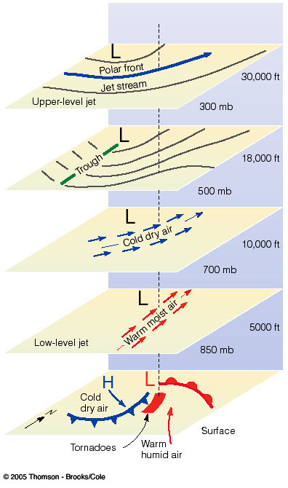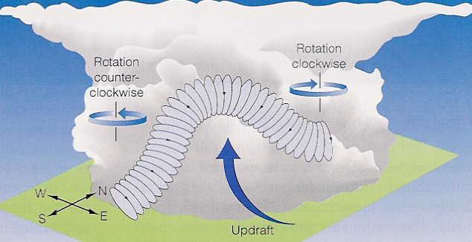

Oklahoma which is the bull’s eye in the map of tornado frequency and intensity, is home to and a network of instrumentation and the National Severe Storms Laboratory (NSSL) that Bob Maddox used to head, focused on weather modeling to better understand and predict these events. There is concern that the frequency and intensity of these events may increase with global warming.

Hurricanes
These are large scale warm core tropical cyclones (as opposed to mid-latitude cyclones which are cold core storms). While the US is very concerned about Atlantic hurricanes, the the area of the most frequent typhoons is southeast Asia (see Figure below). One of the reasons the Taiwanese were interested in the GPSRO COSMIC mission was to improve typhoon (=hurricane) forecasting. NOAA’s National Hurricane Center (NHC) is responsible for forecasting these events in the western North Atlantic and eastern North Pacific for the US and Mexico. Prediction involves trying to predict both the storm track and intensity.
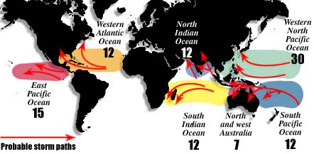
Figure 7. Typical number of named tropical storms annually by region and their paths.

Hurricanes are heat engines that extract and convert huge amounts of energy from the warm shallow ocean, into latent heat and then sensible heat via the condensation of water vapor. For some quick calculations on hurricane energetics, see my 336 class notes from fall 2006 http://www.atmo.arizona.edu/courses/spring07/atmo336s3/lectures/sec2/hurricanes4.html.
As with tornadoes, there is concern that in a warmer world with more latent heat available int eh air that hurricanes may become more intense.

Precipitation
Precipitation is critical to land based life and is very difficult to predict, particularly summertime precipitation which can be very small in scale.
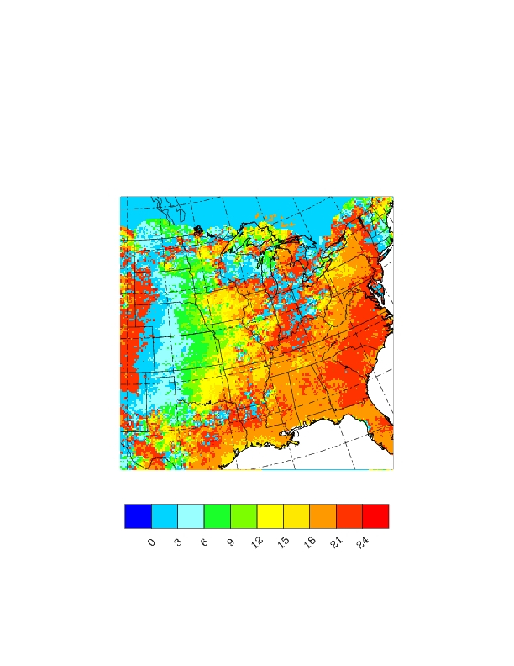
Figure #. UTC time of summertime peak rainfall revealing eastward thunderstorm squall line propagation from the Rockies thru the midwest. From A. Kursinski and S. Mullen, 2007.

The squall line propagation in the figure above which was derived from radar data shows the clear sign of squall line propagation initiated on the Rockies which then propagates for hours to the east associated with conditional instability, vertical wind shear and plenty of warm, moist air at low levels entering the region from the Gulf of Mexico via a nocturnal jet. Models are not yet able to properly represent this squall line behavior.

The scale of summertime precipitation is generally quite a bit smaller scale than winter precipitation. This is one of the reasons summertime precipitation is so difficult to predict and so poorly predicted by weather and climate models. The figure below shows two days in summer 2004 showing how domain averaged precipitation in northern Sinaloa predicted by the Weather Research and Forecasting (WRF) model changed as the initial precipitable water vapor (PWV) was changed. The model was run with 1.8 km resolution to capture the rugged topography of the region. The slope of the right hand curve indicates that on that day, for every 1 mm of water added to the water column, the precipitation increased by 6 mm. 1-sigma uncertainties in the PWV in the region are typically 3 to 5 mm. This kind of sensitivity to initial conditions makes accurate precipitation forecasting VERY difficult, even when the model is performing very well.

Figure #. Two days in 2004 showing WRF predicted precipitation sensitivityto changes in the initial water vapor field in the NAM region (Kursinski et al., CLIVAR Exchanges April 2008)

Alternative Energy Production: Solar and Wind Power plants

A big problem: The United States’ dependence on foreign oil…
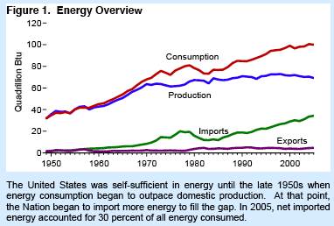

Roughly $1.5B leaves the US each day to purchase foreign crude oil.
An obvious solution, particularly here in the Southwest, is solar energy (although the Federal Government has apparently not taken this seriously this)….

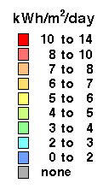
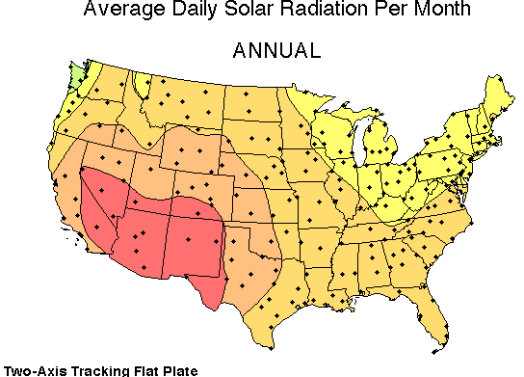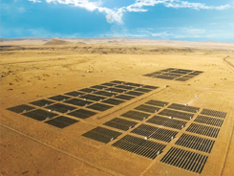
Figure #. a. Available solar power. b. TEP experimental solar cell evaluation field.

Making solar energy work requires an understanding of clouds and an approach to dealing with the intermittent power output because of clouds as well as the basic diurnal cycle of power generation.

ATMOSPHERIC CHEMISTRY:

Urban air pollution
The recognition of the need for pollution standards began essentially in the late1940s and early 1950s with two disasters, one in the US and one in London. Both were related to shallow inversions in fall/winter that trapped locally generated smog close to the surface creating horrific breathing conditions for the local population. See http://www.pbs.org/now/science/smog.html.
In Pennsylvania, Between Oct. 26 and 31, 1948, 20 people were asphyxiated and over 7,000 were hospitalized or became ill as the result of severe air pollution over Donora, Washington County, the Monongahela River town of 14,000. Eventually, the state legislature passed the clean streams law in 1965 and began to enact state wide clean air regulations in 1966. In 1970, the legislature passed an "Environmental Bill of Rights" which stated that "the people have a right to clean air, [and] pure water…." Simultaneously, the national government established the Environmental Protection Agency, and Congress passed the Clean Air Act.
London was hit with the Great Smog of 1952. The bright lights of Piccadilly Circus theaters stayed on all day. Conductors walked in front of buses with flashlights to guide the way. Gas masks became a fashion item. And funeral parlors and florists couldn't meet the demand of increased hospitalizations and deaths. Four years later, the British Parliament introduced the Clean Air Act 1956 which legislated for zones where smokeless fuels had to be burnt and relocated power stations to rural areas. The Clean Air Act 1968 introduced the use of tall chimneys to disperse air pollution for industries burning coal, liquid or gaseous fuels.
Smog in Los Angeles was first noted in 1943. Smog is associated with a strong inversion that sits over Los Angeles most of the time and together with mountains to the north and east and predominant westerlies, traps the smog near the surface. The Clean Air Act of 1970 allowed California to do its own thing because of the severe problems in Los Angeles. The Clean Air Act of 1970 requires the Environmental Protection Agency (EPA) to develop and enforce regulations to protect the general public from exposure to airborne contaminants that are known to be hazardous to human health. This law is an amendment to the Clean Air Act originally passed in 1963.
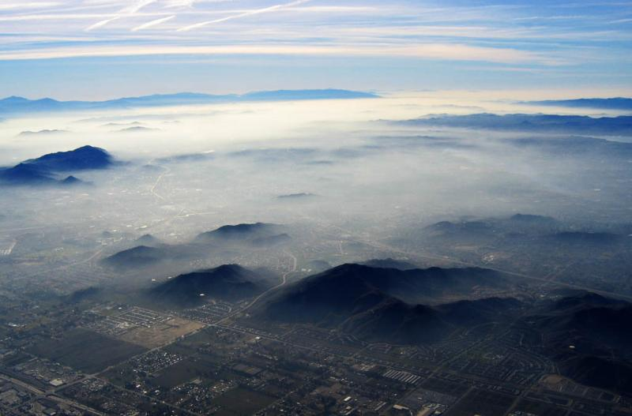
Figure #. Scattered light from photochemical smog in Los Angeles

Note these three problems discussed above are all associated with capping thermal inversions indicating that both chemistry and dynamics are critical to urban air quality.
Also recently, Congress has mandated that NOAA provide forecasts of air quality, an area of new work.

The Ozone Hole
. Stratospheric chemistry has been an area of focus in atmospheric science because ozone protects the Earth’s surface from weaker UV that has sufficient energy to break DNA bonds. Clearly the UV shield provided by stratospheric ozone has been around since before life crawled out of the sea to become land creatures. This also means the large amount of molecular oxygen in the atmosphere has been around even longer. Depletion of stratospheric ozone would have consequences for land based life, at the very least an increase in skin cancer.
The ozone hole over Antarctica was discovered in 1985 by a group of British scientists launching ozone sondes in Antarctica. Subsequent work revealed that US satellites had been observing the hole for years but data processing algorithms had thrown the low ozone data out as being too low to be realistic. The hole forms each Austral spring when sunlight begins hitting stratospheric clouds above Antarctica releasing chorine in a form that catalytically reacts with and destroys ozone which triggered rapid depletion of the ozone there. The key reactions are heterogeous, that is, they involve reactions on the surfaces of cloud particles.
Antarctica is a special place in that temperatures above there become extremely low in the winter which is critical to the formation of certain cloud types which are critical to setting up the chemistry for the rapid depletion of ozone. Temperatures in the Arctic generally do not become as cold for reasons believed to be tied to the asymmetric distribution of topography in the zonal (east-west) direction which breaks up the zonal vortex over the pole and mixes in air from lower latitudes which limits the minimum temperatures that can be reached in the Arctic.
Once understood, the chemical cycle responsible for the ozone depletion was relatively straightforward and could be shut off by stopping the release of CFCs into the atmosphere which resulted in the 1980 Montreal Protocol to eliminate the production and release of CFCs into the air.

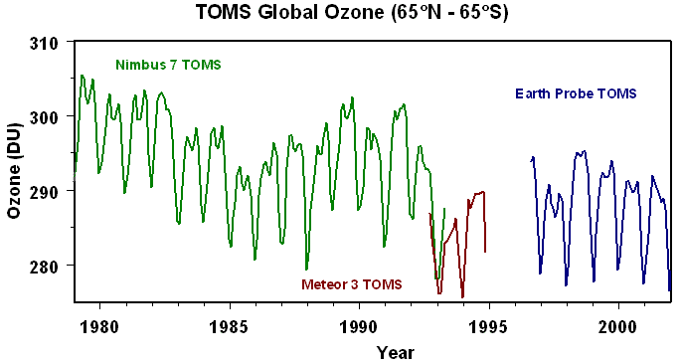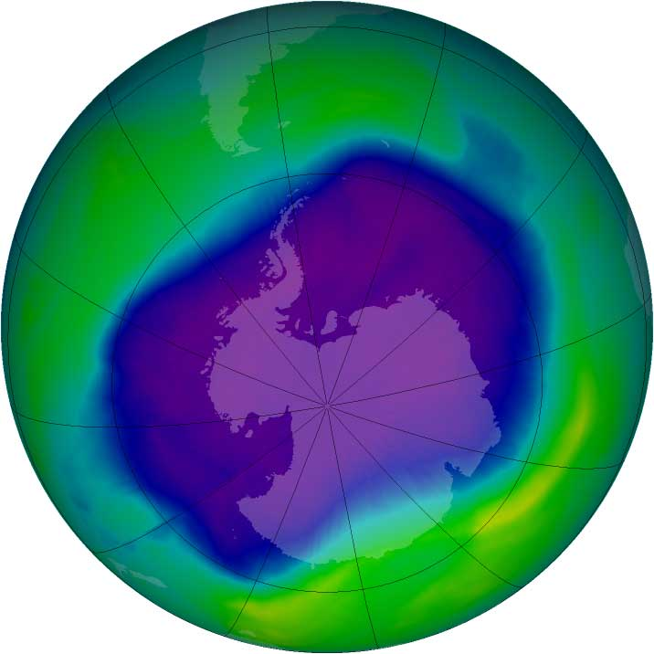
Global ozone trend (DU is Dobson units). Biggest ozone hole ever recorded in September 2006

NASA GSFC ozone web page

Climate: future, present and past,

The El Nino/Southern Oscillation (ENSO) dominates variability at low latitudes. This coupled ocean-atmosphere oscillation is tied to the Walker and Hadley circulations and affects precipitation across much of the world. Coupled ocean-atmosphere models attempt to predict it and have demonstrated some skill with the large El Ninos predicted better than the weaker ones. This is an area where we don’t understand the atmospheric side well except as it reacts to the sea surface temperatures (SST). We need to understand what the atmosphere’s role in leading the ocean and causing the ENSO oscillation to switch phase as well as affect the intensity of the strength of the El Nino.
Free tropospheric water vapor difference between weak El Nino in Feb 2007 and La Nina in Feb 2008. Red is where the highest free troposphere column water occurred during the El Nino and blue is where the wettest column occurred during the La Nina.

Our climate is changing and it is likely due at least in part to human influences. CO₂ concentrations in the atmosphere are increasing (see Figure).

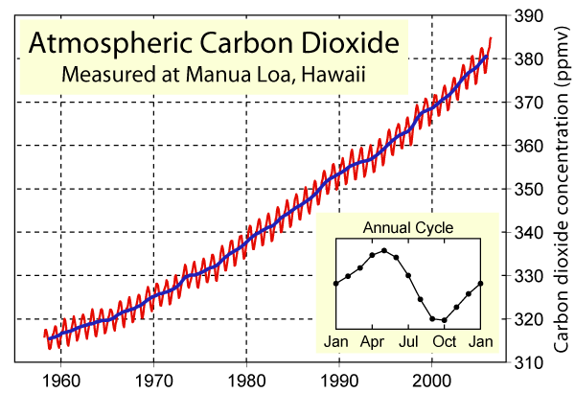

This alters the infrared radiation reducing the cooling IR out to space which causes the Earth to warm and increasing the IR radiation into the surface causing the surface to warm.
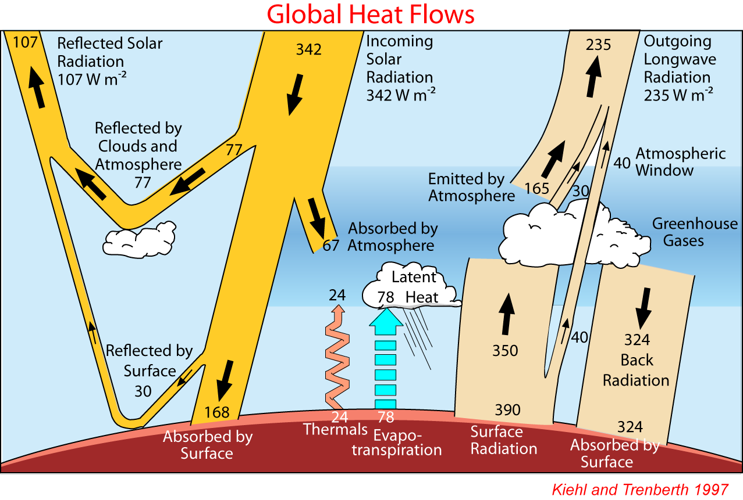

Once these changes start, the system starts to react and change…
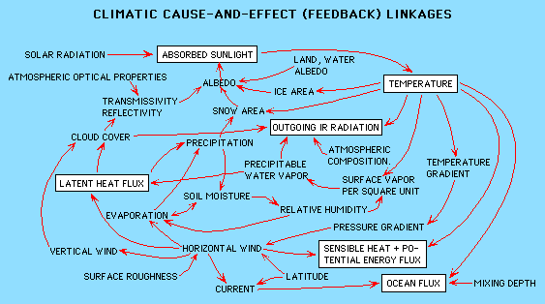
Some of the feedbacks in the climate system

The reactionary changes (feedbacks) are complex, much more so than anything related to the ozone hole problem, and are therefore difficult to model. This leads to uncertainty about how climate will change. Models do seem to be getting some aspects generally correct…
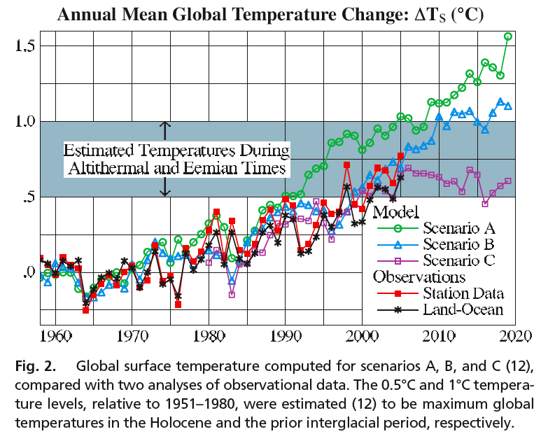
from Jim Hansen paper.

The water or hydrological cycle is certainly an area of tremendous concern. Changes in the water cycle are difficult to predict. Changes in clouds and precipitation are particularly difficult. Even the water vapor feedback is tricky. In the US, the western states appear to be the most vulnerable to changes in the hydrological cycle. These regions are already relatively dry
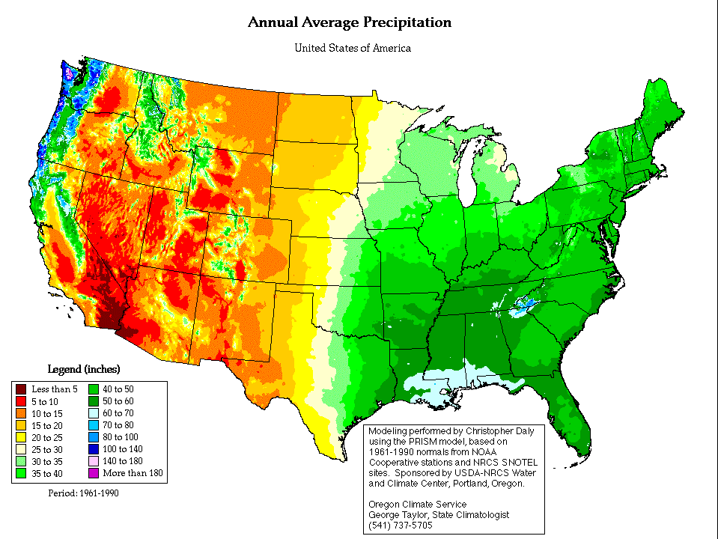
Increasing temperatures would mean later snowfall and earlier snowmelt reducing snowpack which is the natural water reservoir on which most of the western states rely. Earlier melt would mean drier late summers. Furthermore, the winter storm systems may shift farther northward so a state like Arizona may receive less winter precipitation and begin looking more like Sonora. If so Arizona will have to rely more on summertime precipitation. This may change as well but is very poorly represented in models. If the land heats up faster than the oceans as models predict and seems to be happening (see below and above), our North American monsoon may intensify as the Indian Asian monsoon is predicted to do. Faster warming over the land would also cause relative humidity over land to decrease causing continental interiors to dry out, not a good scenario.
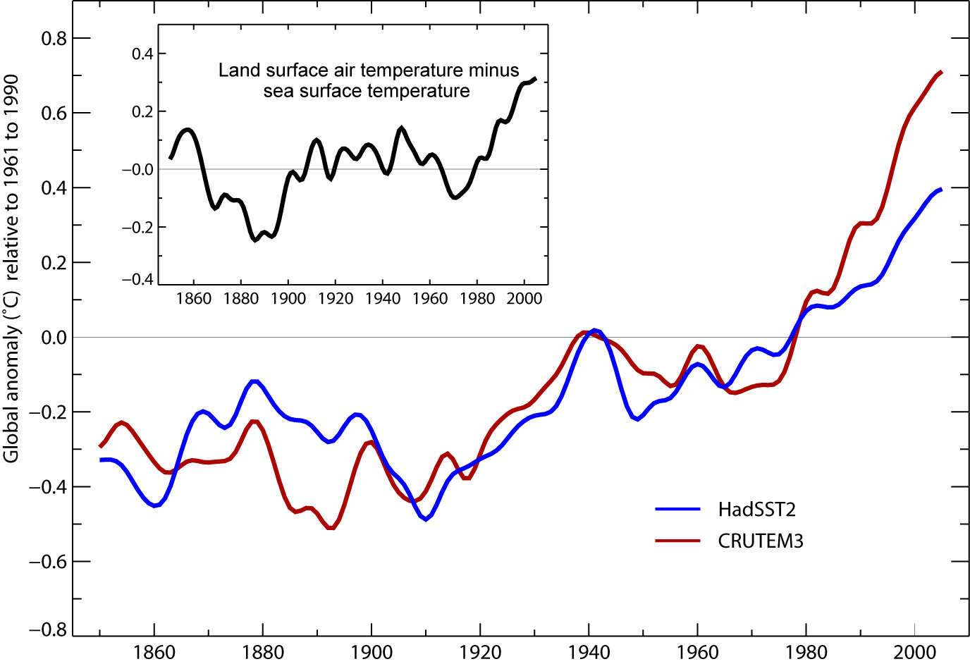
Measured/estmated ocean and land temperatures over the past 150 years.

Global warming may cause Mass extinctions to occur because of the rapid poleward migration of the isotherms.
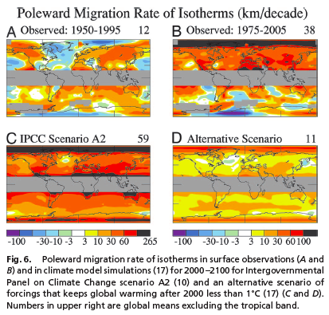
From Hansen et al., 2006

Planetary atmospheres
It is interesting to understand planetary atmospheres for their own sake. A wide variety of atmospheres exist in our solar system all of which have been visited by spacecraft except for Pluto and Charon. Models like WRF are being migrated over to Mars and Titan. Data assimilation systems like the multi-model ensemble Data Assimilation Research Tool (DART) developed by NCAR are also being migrated to the other planets. At a more basic level, new solar systems and planets are being discovered. Initial discoveries have been large planets very close to their sun because these objects are most easily detected. Eventually more Earth like terrestrial planets will be observed as well. Observing chemical signatures of life like the massive amount of oxygen in Earth’s atmosphere is a holy grail of these observations.
Comparitive planetology which is the comparison of the physics and chemistry of other planets and their behavior with that on Earth yields a deeper understanding of Earth and planets in general. It also exposes the distinction of two basic levels of knowledge about our atmosphere, that which is understood based upon a deep understanding of the physics and chemistry and that which is climatological behavior based on observations without a deep understanding of the reason behind the behavior. Such climatological knowledge is not easily transferred to predict behavior of other planets that have very different compositions, temperatures, rotational periods, gravity etc.

Thermal structure of the atmospheres of the outer planets from Voyager radio occultations.

Typical vertical thermal structure of Earth’s atmosphere
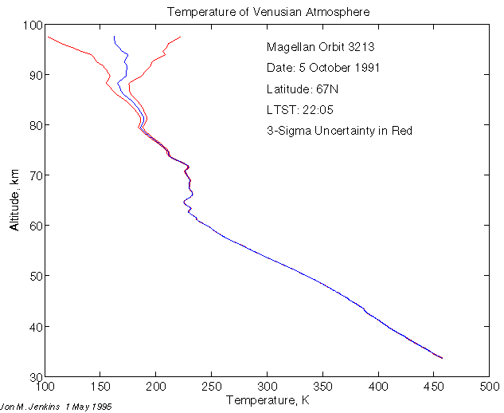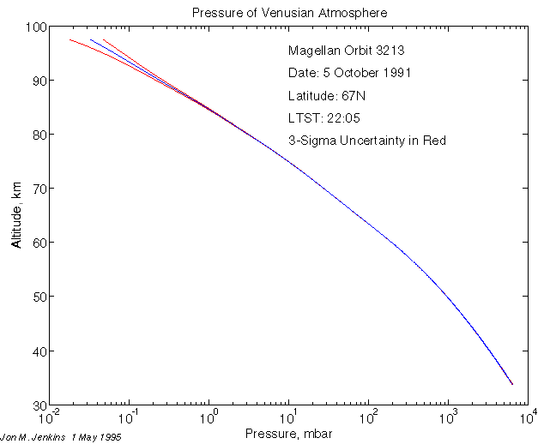
tropopause
Typical Venus thermal structure from radio occultation measurements
The figures above show the thermodynamic structure of the 7 major atmospheres in the solar system. The temperature varies from 50 K to 750K. Interestingly we see that the tropopause of all of these atmospheres occurs near 100 mb despite the wide range of temperatures. This indicates that the transition from radiatively controlled atmosphere to the radiative-convective atmosphere occurs around 100 mb. This indicates further that the atmosphere becomes opaque to infrared wavelengths near pressures of 100 mb such that vertical energy transport must be accomplished by convection at higher pressures. This pressure dependence is independent to first order of the compositions of these atmospheres which differ considerably.
Mars and Titan have interesting “Hydrological” cycles. Mars is apparently like a cold, dry Earth much like Antarctica. While Titan is very cold and slowly rotating, it has a thick N₂ dominated atmosphere with a full methane cycle analogous to Earth hydrological cycle complete with all three phases being present with high latitude lakes and deep moist convection.
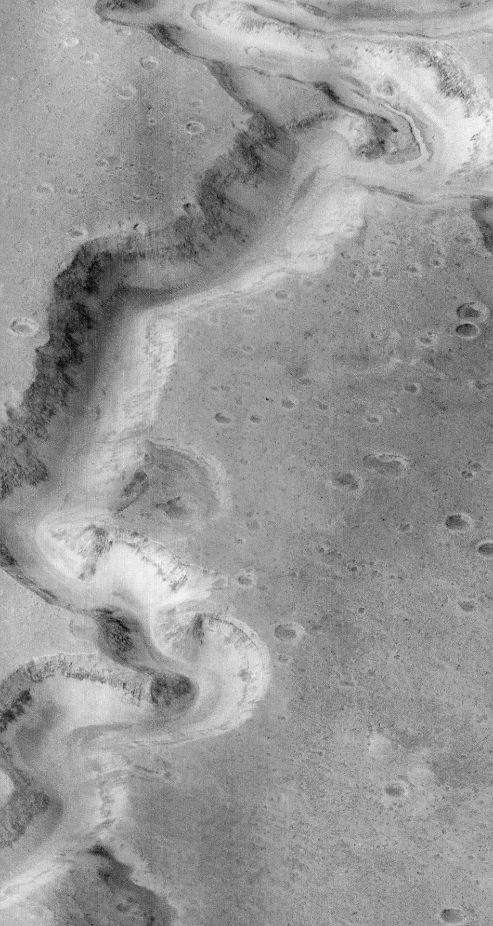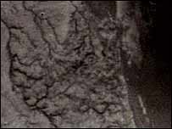

Summary
There is lots of interesting work to do in Atmospheric Science. ATMO 541 and 551 provide the basic tool kit needed to understand how atmospheres work in order to do research in this area. Key areas
- Keep pushing NWP skill particularly for precipitation which is quite poor.
- Atmospheric chemistry has many applications in air quality, stratospheric chemistry and greenhouse gases tied to global warming.
- The issue of climate change is guaranteed to be with us for a long time and it is critical that we reduce uncertainties in predictions so that appropriate mitigating decisions can be made before we end up doing an ugly autopsy on how our climate changed.
- There are many planetary science questions, the most relevant of which to Earth appear to be Mars and Titan.

