ATMO/ECE 489/589 Spring 2009
Homework #3
due Tue., Feb. 24

1. The basic dipole structure of a thunderstorm was deduced in the early 1900s when researchers observed that the electric field polarity switched signs depending on whether the cloud was close to or far from the measuring site.

(a) Write an equation for the vertical electric field at the ground as a function of D.

(b) Determine the field reversal distance, D_{R} (the point at which the field reverses polarity), for the case where H_{P} = 9 km and H_{N} = 6 km.

You may assume that the ground is a perfect conductor, you may ignore the finite conductivity of the atmosphere, may ignore the presence of any screening layers.

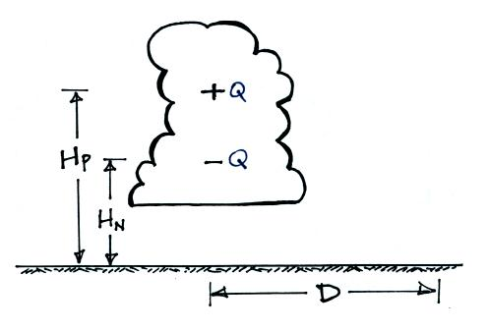

2. A simplified ion balance equation is given below:

dn/dt = q - an² - BnZ

where
n is the concentration of positive or negative small ions ( n₊ = n₋ )
q is the small ion production rate
a is the ion-ion recombination coefficient
B is the ion-particle attachment coefficient
Z is the aerosol particle concentration

(a) Derive an expression for n(t) for the case where ion-aerosol attchment is the dominant loss process and ion-ion recombination can be neglected. Assume n(t) = 0 for t = 0.

(b) Compute the steady-state small ion concentration for the case where
q = 10 (ion pairs)/cm³ sec
B = 2 x 10⁻⁶ cm³ / sec
Z = 1000 cm⁻³

(c) Use the result from (b) to compute the air conductivity assuming that the small ions are singly charged and that the mobilities B_{e}(+) and B_{e}(-) are both 1 (cm/sec)/(volt/cm).

