NATS 101 Name_______________________________
Optional Assignment

1. When the air is moist, water vapor will condense onto COLD WARM objects. When this occurs, the condensation will act to COOL WARM the object.

2. People will often blow on a bowl of hot soup or a cup of hot coffee to cool it. Forced convection is one of the energy transport processes at work. What other energy transport process is causing the soup or coffee to cool?

3. Which of the following has the highest energy and is potentially the most dangerous kind of electromagnetic radiation?
a. UV-A b. UV-B c. UV-C d. IR

4. We are able to see the moon at night because it ABSORBS EMITS REFLECTS TRANSMITS visible light.

5. About 44% of the light emitted by the sun is visible light. Most of the rest, 49% of sunlight, is INFRARED ULTRAVIOLET light.

6. Which two of the following are not found in the infrared (IR) portion of the spectrum?
a. 0.4 to 0.7 μm interval b. the atmospheric window
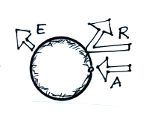
c. peak emission from the sun d. peak emission from the earth

7. The figure at right shows incoming sunlight that is reflected
by the earth (R), incoming sunlight that is absorbed in the
atmosphere or at the surface of the earth (A), and radiation
emitted by the earth (E). Which of the following conditions
will be true when the earth is in radiative equilibrium?

a. E = A + R b. A = E c. A = E + R d. E = R

8. The formation of frost on a cold morning is an example of _______. A bathroom mirror that fogs up during a hot shower illustrates _______. A piece of dry ice left in a room will slowly disappear because of _______. The bubbling of liquid nitrogen is _______.
a. melting b. freezing c. sublimation
d. condensation e. deposition f. evaporation

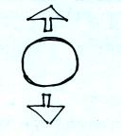
9. The strength of the UPWARD DOWNWARD force
acting on the balloon at right depends on the air
inside the balloon.

10. Which one of the following remains constant when you cool a balloon filled with air?
a. air density b. air temperature c. balloon volume d. air pressure

11. People sometimes float and sometimes sink in water. To determine what will happen to a particular person you would need to know that person's _______.
a. mass b. volume c. weight d. density

12. Which of the following pairs of points on the electromagnetic wave below are exactly one wavelength apart?
a. A & B b. B & D c. A & C d. B & F

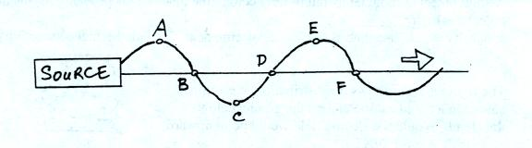

13. Object B has a temperature that is twice as hot as Object A. This means that B will emit
radiation at a rate that is _______ that of A and will have a wavelength of peak emission that is _______ that of A.
a. twice b. more than twice c. half d. less than half

14. Would you expect the surface temperature in Fig. A to INCREASE, remain CONSTANT, or DECREASE? Would you expect the surface temperature in Fig. B to INCREASE, remain CONSTANT, or DECREASE? Would you expect to find that the surface temperature in Fig. A is GREATER than, EQUAL to, or LESS than in Fig. B?
