March 24, 2008

Reminder about homework #5

Development of more powerful and organized thunderstorms
- In ordinary, single cell thunderstorms, the thunderstorm dissipates when its energy supply, the warm humid updraft air, is cut off by the storm’s precipitation and downdrafts. The key to keeping thunderstorms going is to keep the updrafts sustained for longer periods of time or for mature thunderstorms to initiate new updraft cores and thunderstorms.

- One mechanism for organizing thunderstorms is called merging gust fronts. This mechanism provides a way for multicell clusters of thunderstorms to develop and remain active.
  - A simple diagram will be drawn in class.
  - Figure 10.3 of textbook shows a multicell thunderstorm complex.

- Most severe thunderstorms form in a region where there is vertical wind shear. Vertical wind shear is characterized by horizontal winds that change in speed and/or direction with increasing altitude. A simple diagram will be drawn for wind shear. Certain types of wind shear allow thunderstorms to become more organized and long-lived by allowing the updrafts to remain separated from downdrafts. Thus, the updrafts, which supply the energy for the storm, can be sustained for longer periods of time.
  - Draw a diagram showing how wind shear can lead to the development of a “tilted updraft”. Under these conditions a single thunderstorm can remain active for an extended time period as it moves along the surface of the Earth. The longer the updrafts can be sustained, the more potentially strong the thunderstorm can become.
  - Figure 10.10 of textbook shows a picture of a thunderstorm with a tilted updraft.

- If the atmosphere is unstable in a region and there is a large area of forced rising motion, large areas of interacting thunderstorms can form. One example is a squall line, or a line of storms composed of individual thunderstorm cells in different stages of development that all move together as the line moves.
  - This is common with cold fronts, which provide a lifting mechanism along a line. Often the lines form with the cold front, but then move rapidly ahead of the front into the warm air side of the front. The line of thunderstorms can move faster than the cold front because the storms are steered around by the mid-tropospheric (500 mb) winds. The faster winds aloft result in the formation of tilted updrafts along the line. This is very common in the plains and eastern part of the United States.

  - Squall lines can also form in mountainous areas when air is forced to rise along a line of higher elevation. The line of storms can then be moved off the mountain tops by mid-tropospheric (500 mb) winds and form a tilted updraft. This occasionally happens here during the monsoon season.

- Supercell thunderstorms, the most severe type of thunderstorm, generally form in extremely unstable environments, where there is directional wind shear. Typically (at least in the US), surface winds are southerly, while above the surface the wind direction turns to be southwesterly in the middle troposphere and more westerly in the upper troposphere. This wind shear coupled with the extremely unstable atmosphere can produce a single large supercell thunderstorm with a very powerful and counterclockwise rotating updraft. Updraft speeds may reach over 100 mph, which can result in the formation of a dome cloud (see http://www.usatoday.com/weather/wtsm2.htm for a non-technical description of a supercell). The supercell is organized so that the downdrafts and precipitation remain separated from the main updraft core. This allows the storm to remain active for hours.
  - See supercell figures page, which is linked on the lecture summary page
  - Most strong tornadoes are associated with supercell thunderstorms. More information about supercells will be presented with the tornado lectures.

Dangers Associated with Thunderstorms
- Lightning, hail, heavy rain and flooding, tornadoes, and strong winds associated with downbursts are all dangerous and potentially deadly aspects of thunderstorms.

- The US National Weather Service defines a severe thunderstorm as one having at least one of the following: (a) hail with a diameter of 0.75” or larger; (b) surface wind gusts of 50 knots (58 mph) or greater; (c) an associated tornado. We will next briefly describe the mechanisms that produce hail and strong downdraft winds in thunderstorms.

Hail
- In order to understand how hail forms, we must first look at the composition of a cumulonimbus cloud, i.e., the distribution of liquid water and ice.
  - A figure will be drawn in class

- Each hailstone starts as a seed or nucleus around which the hailstone will form. The initial seed is most often a small ice crystal. The developing hailstone tends to fall toward the ground due to gravity, but is also swept upward by strong updrafts within a thunderstorm. Each time the hailstone moves through the middle region of the cumulonimbus cloud and collides with supercooled water droplets, the hailstone grows by accretion, i.e., the supercooled liquid water freezes quickly around the growing hailstone.
  - A figure will be drawn in class
- The stronger the updrafts in a thunderstorm, the potentially larger the hailstones can become, so large hailstones are indicative of thunderstorm with strong updrafts. The largest hailstone ever observed in the United States was about 7” in diameter and weighed 1.75 pounds.

- On average hail is responsible for about 1 Billion dollars of damage in the US each year.
Microbursts
- A microburst is a strong localized downdraft, which is much stronger than an ordinary thunderstorm downdraft. When the downward moving air hits the ground, it spreads out and moves horizontally along the ground. Microburst winds along the ground can be so strong (>150 mph) that the damage they cause is often mistaken for a tornado. The difference is that the damage caused by a microburst will be “straight-line” wind damage, while a tornado produces a more circular pattern of wind damage.

- Microbursts form by the same mechanism as any thunderstorm downdraft: the chilling of air due to evaporation of precipitation. When evaporatively-cooled parcels of air become much colder (and denser) than the surrounding atmospheric air, they rapidly accelerate toward the ground. Therefore, microbursts are more likely to form when relatively dry air (low relative humidity) exists below the thunderstorm as this allows for more rapid evaporation.

- Microbursts are extremely dangerous to aircraft, especially if flying low to the ground, as shown in figure 10.15 of the textbook.

Distribution of thunderstorms
- It is estimated that more than 50,000 thunderstorms occur each day throughout the world. Annually this adds up to more than 18 million thunderstorms per year.

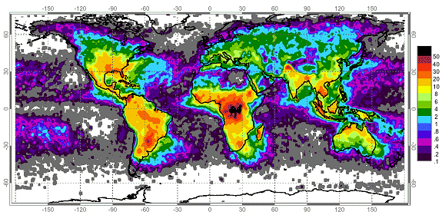

- The figure above shows the distribution of world-wide lightning strikes from satellite-based optical sensors. Units are # of flashes per square kilometer per year. Thunderstorms form from the equator to as far north as Alaska. They occur most commonly in the tropics where convectional heating of moist surface air occurs year round. Many tropical land based locations experience over 100 thunderstorm days per year. Thunderstorm formation over tropical oceans is less frequent because ocean surfaces do not warm as rapidly as land surfaces. Thus, in general, thunderstorms (especially severe thunderstorms) are much more common over land areas than over the oceans. Outside the tropics, thunderstorm formation is more seasonal occurring in those months where heating is most intense.

- The figure below describes the annual average number of thunderstorm days across the United States. According to this map, the greatest incidence of thunderstorms occurs in the southeast This particular spatial distribution suggests that extreme solar heating is not the only requirement for thunderstorm formation. Another important prerequisite is the availability of large quantities of water vapor at the surface. In the United States, the Gulf of Mexico supplies adjacent continental areas with moist maritime tropical air masses. These air masses are relatively unstable quickly forming cumulonimbus clouds when surface heating is intense. The secondary maximums found in Colorado, Arizona, and New Mexico are due to the mountainous terrain. Mountain slopes that face the sun absorb more direct solar radiation and become relatively warmer creating strong updrafts that form into cumulus clouds. These areas are much less humid than the southeastern United States, thus the thunderstorms in these areas are characterized by higher cloud bases and less rainfall. During the summer monsoon season, east winds bring some moisture from the Gulf of Mexico resulting in an increase in thunderstorm frequency. Few thunderstorms occur along the west coast of the United States. This region is dominated by cool maritime polar air masses which suppress convectional uplift over land. That is the atmosphere in these regions is typically stable because surface air usually comes from the relatively cold eastern Pacific Ocean.

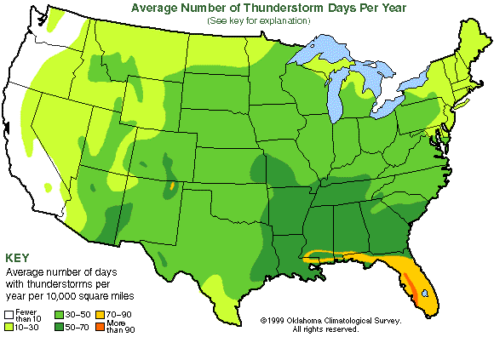
- Although the tropical regions experience the highest number of thunderstorms per year, severe thunderstorms occur most frequently in the humid subtropics. The most severe thunderstorms in the world occur in the United States from the Gulf of Mexico to the great plains of the Mississippi Valley. In this region warm, humid tropical surface air from the Gulf of Mexico interacts with much colder and drier air masses moving down from Canada. This area is unique on Earth. A warm ocean surface lies to the south and a large continental land mass to the north with no mountainous barriers to prevent the clash of warm, humid air masses from the south and very cold, dry air masses from the north.

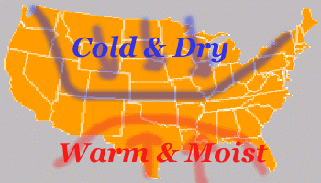

Plan for the rest of the week …

Wednesday - Lightning and Thunder

Friday - Tornadoes

