April 9, 2008

Hurricanes (Continued)
- Predicting storm movement; Providing Public Warnings
  - With modern techniques of forecasting and tracking hurricane paths, it is always possible to issue warnings about the "probable" locations that will be affected by any given hurricane. In fact, this is what the National Hurricane Center does today … they issue a probability forecast for both position and intensity.
    - In lecture, I will briefly describe how this is done.

  - Although hurricanes can be easily tracked using satellite data, predictions of their future movement and intensity are by no means certain. Based on the estimated uncertainty in future hurricane movement, hurricane watches and warnings are issued for a wide swath as shown in the figure below.
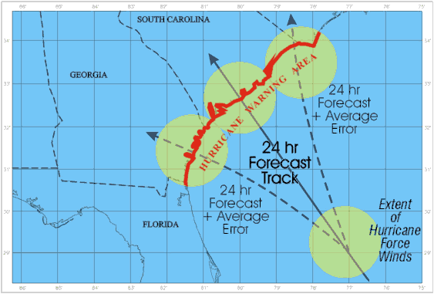

    - The large warning area follows the motto “better safe than sorry”. But it does present a problem. Suppose a large area is evacuated, but the actual hurricane only affects a portion of the warning area. People who evacuated from areas not severely affected by the hurricane may choose to ignore the warning next time … thinking the forecaster have no idea what they are doing.

    - Hurricane Watch: An announcement of specific coastal areas that a hurricane or an incipient hurricane condition (sustained winds > 74 mph) poses a possible threat, generally within 36 hours.

    - Hurricane Warning: Sustained winds of 74 mph or greater associated with a hurricane are expected (have a good probability of happening) in a specified coastal area in 24 hours or less.
- Destruction at Landfall
  - Although we usually categorize hurricanes in terms of their wind speed, coastal flooding due to what is called the storm surge often causes the most damage. Most of the spectacular damage done by hurricanes, e.g., buildings, houses, marinas, piers, etc., completely destroyed or even removed from where they were standing is due to the storm surge.

  - A storm surge is the rise in sea level along the coast as onshore winds pile up the water. It is more like a big dome of water that can be over 100 km in width, rather than big waves. It is similar to tsunamis in that it is a large mass of water, which is forced onshore. As the moving water encounters the normally shallower water areas near the shore, it is forced to rise upward. Storm surges are measured in feet above normal sea level (see Saffir-Simpson scale). Water is very heavy and damaging, and can “wash away” entire houses and bridges.
    - The damage potential associated with a storm surge depends upon:
      - The strength of the wind … stronger winds, higher surge

      - The slope of the Earth’s surface near the shoreline
        - If more gradual, water can move further inland. Thus some areas are more vulnerable than others. Draw simple picture.

      - Timing with respect to normal high and low tides.
        - High tides add to the storm surge

  - In the Northern Hemisphere, the greatest storm surge and the strongest winds occur to the right of the storm center with respect to the direction that the storm is moving as it makes landfall.
    - A diagram explaining this will be drawn in lecture.

  - High winds also cause considerable damage. Hurricane strength winds can damage or destroy vehicles, buildings, bridges, etc. High winds also turn loose debris into flying projectiles, making the outdoor environment even more dangerous. As hurricanes come in many sizes, the area covered by hurricane force winds is a factor in the total amount of damage done. For example, not only was Katrina a very powerful storm, it was also a very large storm.

  - Flooding is also caused by the heavy rains associated with hurricanes, especially when a slow moving or nearly stationary hurricane sits just offshore causing a prolonged period of heavy rains over nearby coastal areas. This can be especially problematic if the nearby coast has sharply rising mountains, enhancing the heavy rains by orographic lifting, with the runoff causing landslides.

  - Considerable damage may also occur from hurricane-spawned tornadoes that may form as the hurricane interacts with land areas. About one-quarter of them produce significant numbers of tornadoes. Tornadoes are most likely to develop in the right front quadrant of the storm, and are more likely to be associated with a spiral rain band rather than the storm's center. They result from the vertical wind shear present in the lower levels of the hurricane's circulation. Most hurricane-spawned tornadoes are of the weak variety (compared to the monsters that can form over the great plains of the United States), but can still produce significant damage.

  - Show highlights of storm chaser video from Biloxi, Mississippi.

  - Perhaps try to show some of the other videos of Katrina and the coastal damage.

- Closer look at Atlantic Hurricane Season and hurricane landfall over the United States
  - We have previously shown that the official Atlantic Hurricane season lasts from June 1st through the end of November, and that on average, there are 10.6 tropical storms, 5.9 hurricanes, and 2.0 major hurricanes (category 3 and higher). The figure below shows that Atlantic hurricane activity peaks in early September and that storms occasionally form outside the official hurricane season in May and December.
    - The biggest reason for the peak in early September is that it is the time of the year when the tropical North Atlantic Ocean is warmest.

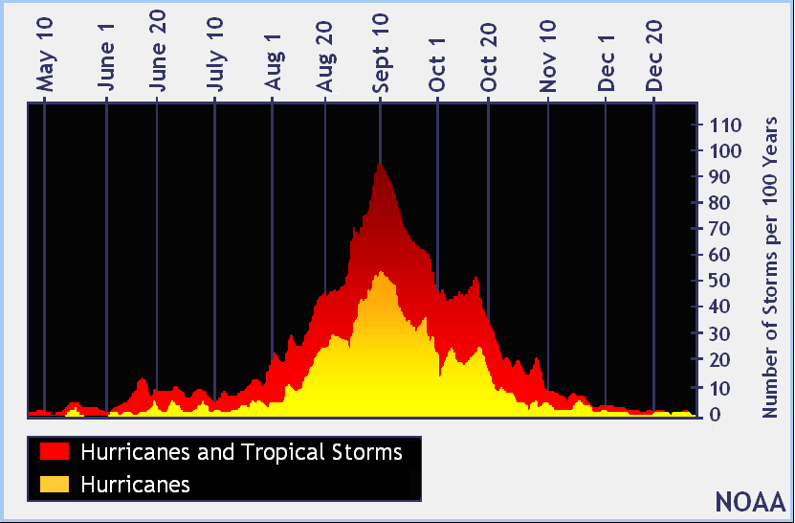

  - There is also quite a bit of variability from year to year in the number of tropical storms and hurricanes that form in the Atlantic each year as indicated in the figure below.
    - An obvious question comes to mind: "Is there a significant temporal (in time) pattern in the number of Atlantic hurricanes?" Many researchers have concluded that there is a multi-decadal cycle, consisting of 25 - 40 year periods of increased hurricane activity followed by 25 - 40 year periods of decreased hurricane activity.
- Without going into the details of the statistics or speculating about the reasons why, there is little doubt that this cycle is real and continues back in time as far as records are available.

- Specifically, the figure shows that hurricane activity in the Atlantic was high from the late 1940s through the mid 1960s, followed by a period of low activity from the mid 1960s to the mid 1990s. Since 1995 we have been in another active period, which will likely continue for about another decade into the future. Thus, based on this information, we should expect hurricane activity in the Atlantic basin to remain high for at least the next 10 years.
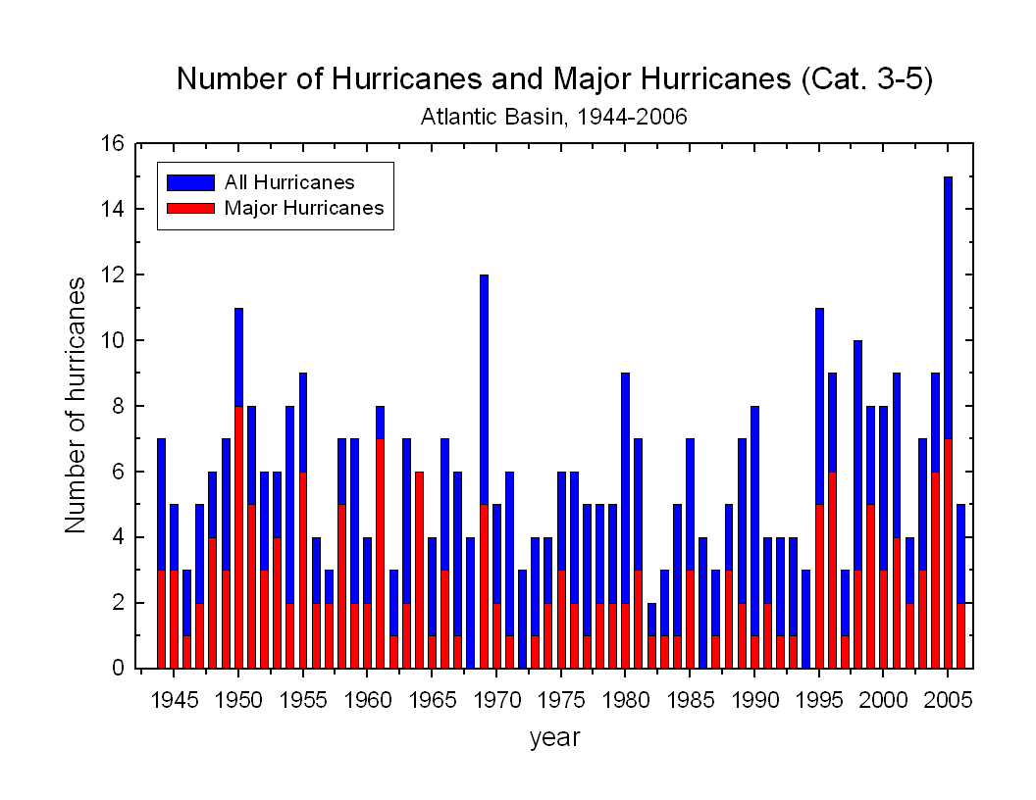
  - While variations in the total number of hurricanes in the Atlantic Ocean is interesting, keep in mind that most people only remember the ones that cause death and destruction on the coast. Many Atlantic hurricanes stay out at sea or are relatively weak when they make landfall. Those few hurricanes that reach category 4 and 5, only remain at that strength for short periods of time, which on average is less than 24 hours. The chance that one of these monsters will hit the U.S. mainland as a category 4 or 5 storm is relatively low. However, these strong landfalling hurricanes are the ones that cause the most deaths and destruction. These are that storms that coastal residents need to be prepared to deal with.
    - Show link to a web page that shows the location of all major landfalling hurricanes to hit the United States since 1899. Note that the average over the period from 1899 through 2005 is less than one per year. However, in 2004 there were 3, followed by 4 more in 2005. There were no major hurricanes to strike the US coastline in 2006 and 2007.
- Cost of US hurricanes
  - Before Katrina happened, I would present statistics about the effects of hurricanes on the United States which clearly showed the following trends:

    - The damage costs due to hurricanes in the US (in terms of dollars) was increasing with time from the early 1900s onward. This trend included factoring in the rate of inflation.
- The increasing trend in property damage results from the fact that much building is occurring along America's coastlines. People want to live on the coast and vacation on the coast. As competition for this property increases, the value of the property increases. High priced homes and resorts are built in hurricane prone areas. This includes re-building in areas damaged by previous hurricanes.

    - Loss of life associated with hurricanes was decreasing from the early 1900s until Katrina hit in 2005.
- The decreasing loss of life results from two factors. In the early part of the century before satellite imagery and sophisticated forecasting methods, people had little warning of an approaching hurricane, and many were killed. In fact the Galveston, TX hurricane of 1900 still ranks as the most deadly in U.S. history with from 8 to 12 thousand deaths. In modern times, people are warned of an approaching storm and either evacuate or make necessary preparations. It seemed that public awareness and preparation had lowered death counts (even though more and more people now live on the coast) until Katrina.

- Why was Katrina so deadly?
  - Katrina forces us to reconsider the long-held belief that hurricanes will not cause many deaths in the United States because we have such a great hurricane monitoring system and no storm will catch anyone by surprise. Sure property damage was high (Katrina has surpassed Andrew as the most expensive hurricane ever), but we have come to expect that. We can deal with property damage, but we should not have to except the number of human deaths and injuries that resulted from Katrina.

  - The question here is: Even with the ample warning provided by the National Hurricane Center, why did so many people die as a result of Katrina? Last count is over 1300 confirmed deaths. This is the most deaths related to a single hurricane since 1928.
    - See figure 11.25 to see how well Katrina’s path was forecasted.

  - Undoubtedly the vulnerability of the New Orleans area to levee failure and flooding was a strong contributing factor and had Katrina hit somewhere else there would have been less loss of life.

  - The one course of action that will always work to save lives is for people to evacuate the area before the storm hits. Unfortunately with Katrina many residents remained even though they were warned in ample time to leave.

    - We can argue about whether this was the government’s fault or whether the responsibility should be placed on the individuals who made personal decisions to not evacuate.

    - And no doubt, federal and local government screwed up in their response to the disaster making it worse than it might have been.

    - But again, the only sure way to save lives is for people to evacuate before the storm hits. Hopefully, Katrina will act as a wake up call for those living in hurricane-prone areas. Don’t take chances or at least understand the risk that you and your family take by not heeding warnings.

    - A Katrina-type disaster was foreseen by many people. In fact a New Orleans newspaper published an article in 2001 about a devastating scenario eerily close to what actually happened, including levee failure, with many residents becoming trapped. Others just warned about how the people living in hurricane-prone areas seemed unaware of the potential damage that can occur when major hurricanes make landfall and would not take appropriate action.
- People living in hurricane prone areas need to understand the devastation that hurricanes can cause, keep informed on hurricane activity in their area, and be prepared to make intelligent decisions. People in New Orleans had the additional responsibility to understand the vulnerability of their city to the possibility of levee breaks whenever a major storm is near.

