ATMO 170A1 Name_______________________________
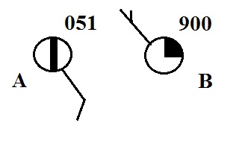
In class Optional Assignment

1. Is the sea level pressure at City A 905.1 mb or 1005.1 mb?
value). Are there more clouds in the sky at CITY A or at CITY B.

2. Before being plotted on a surface weather map the measured station pressure must be corrected for
a. altitude b. latitude c. temperature d. time of day
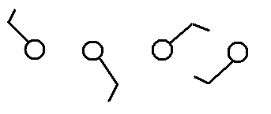
3. Circle the figure at right that shows winds
blowing from the southwest.

4. Which one of the following would not cause rising air motions?
a. low pressure center b. high pressure center c. cold front d. warm front

5. Show at right how the following weather observations would be plotted using the station model notation.
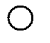
temperature = 75º F cloud cover = 1/8
pressure = 995.4 mb dew point = 57º F
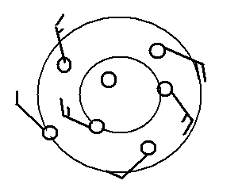
wind direction & speed = east at 20 knots

6. Does the figure at right show winds blowing in a CLOCKWISE or COUNTERCLOCKWISE direction? Are the winds CONVERGING or DIVERGING? Does the figure show a surface center of HIGH or LOW pressure.

7. Are clouds more likely to form when moist air COOLS
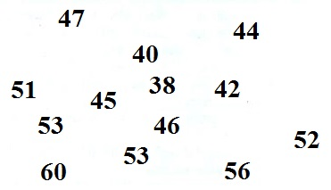
or WARMS, when moist air RISES or SINKS?

8. See if you can sketch in the 40º F and 50º F
isotherms on the figure at right.

9. The large L symbol that you usually see on a surface weather map indicates a region of
a. low altitude b. low air density c. low air pressure d. low temperatures

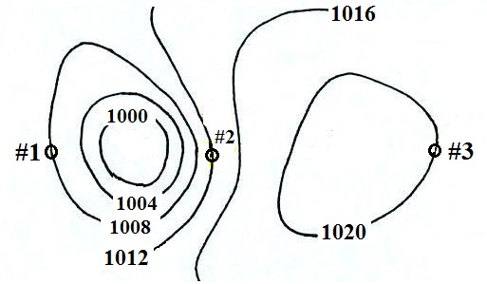
10. Would you find winds blowing
from the south at #1, #2, or #3? Would the warmest temperatures be found at #1, #2, or #3? Would the fastest winds be found at #1, #2, or #3?

