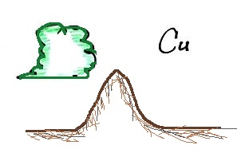
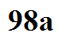
Cumulus (Cu) - separate clouds that resemble
balls of cotton. Low enough (close enough to
the ground) to have grey shading and a clear
3-dimensional appearance.

Can form in stable and unstable situations.
Grow vertically as the atmosphere becomes more unstable.
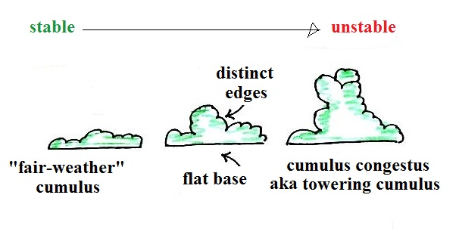

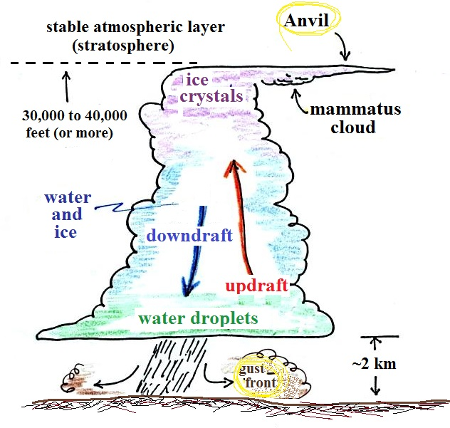
Cumulonimbus (Cb) - Grow from the low to the top of the high altitude category. Strong up and down air motions.

