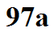
Characteristics of each of the ten cloud types
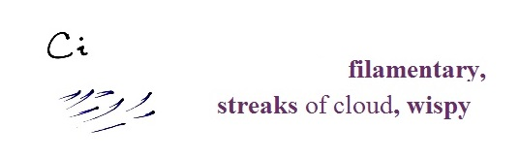
Cirrus (Ci) - thin, white, filamentary appearance.
Form in cold air - not much water vapor, composed
of ice crystals. "Mare's tails"

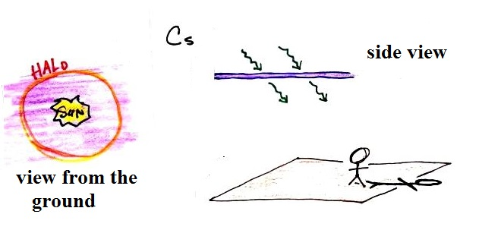
Cirrostratus (Cs) - white layer cloud. Thin enough to be pretty transparent. Can see the sun or moon clearly. Enough direct sunlight shines through that
objects on the ground cast shadows.

Haloes (caused by ice crystals) usually indicate Cs. Cs clouds may arrive 1 or 2 days ahead of an approaching storm.

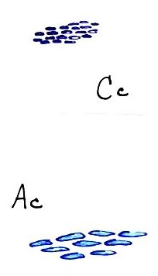
Cirrocumulus (Cc) - very small patches or ripples of
cloud. Uniform white color, not thick enough to have
grey shading. Not as common as the two other cirrus
type clouds.

At sunset, when illuminated by the orange and red
colors of the sun, Cc clouds may resemble the scales
on a fish - hence the name "mackerel sky."

Altocumulus (Ac) - separate cloud elements about
the size of your thumbnail when your hand is held
at arm's length. May have some grey shading.

