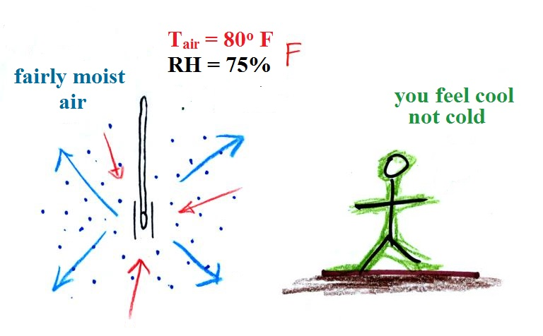


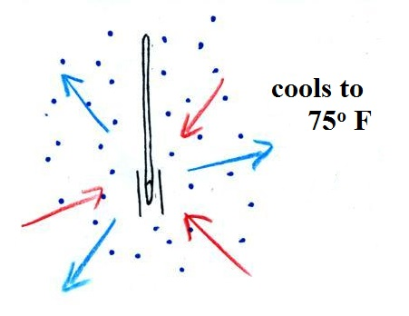
Same air temperature but more moisture in the air (RH=75% and there are 3 arrows of condensation). The wet thermometer will only cool a little bit before the rates of condensation and evaporation balance.

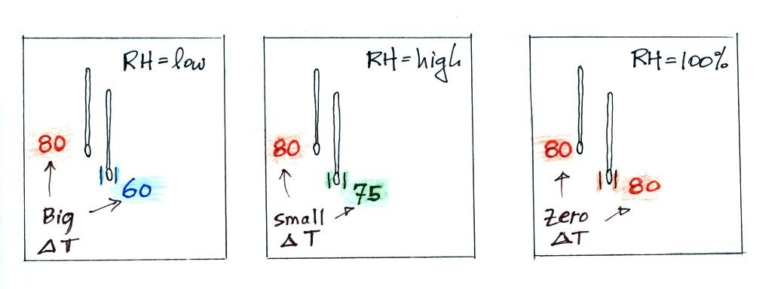
There's only a 5º F difference between the dry and wet thermometers. The small difference means there is more moisture in the air. You can probably imagine what the situation would look like when the RH = 100%, so we'll jump to a summary.

