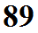
Measuring humidity using a sling (swing) psychrometer
(another example of beating a concept to death)
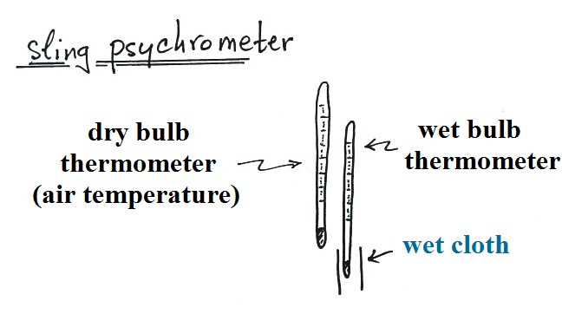

A sling psychrometer consists of 2 thermometers: one is dry and measures the air temperature, the second is wet and measures the "wet bulb" temperature.
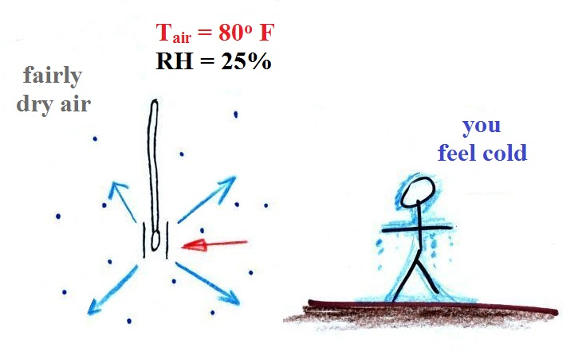

Here's what would happen on a dry day. The rate of evaporation from the wet thermometer depends on the water temperature (initially 4 arrows of evaporation when the water is 80º F). The rate of condensation depends on the amount of moisture in the air (only 1 arrow of condensation because the RH is 25%). More evaporation than condensation means the wet thermometer will cool.
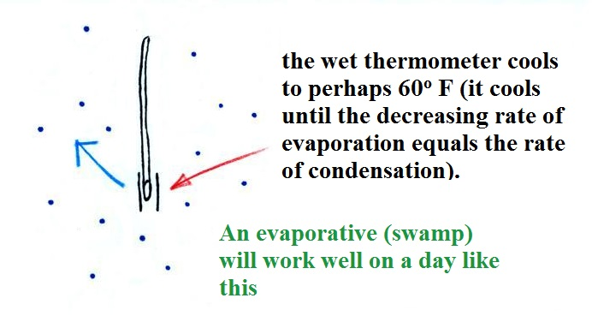

The thermometer has cooled to 60º F at which point the rates of evaporation and condensation are equal. The 20º F difference between the dry and wet bulb thermometers can be used to determine the amount of moisture in the air.

