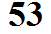
1. A small volume of the 4. The air in this parcel is warmer
atmosphere has been isolated in this than the surroundings. Its density must be
picture. The air density inside and lower than that of the surrounding air in
outside are the same. The air order for the pressures inside and out to be
parcel doesn't rise or sink, it's equal.
neutrally buoyant. Because the parcel is filled with
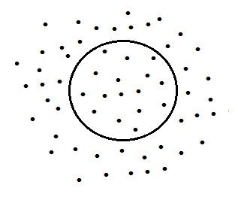
lower density air the parcel's mass and weight have decreased. The upward
pressure difference force has not changed
(the air surrounding the parcel hasn't
changed). The upward force is now
stronger than the downward force and the
parcel rises.
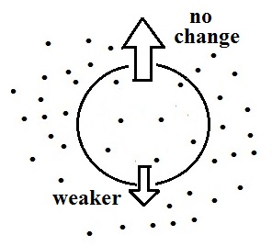

2. The air in the parcel has mass
so there is a downward force caused by
gravity.
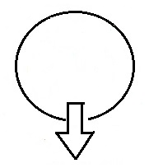

5. A parcel of cold, high density air
will sink because the gravitational force
(the weight) will be stronger than the
upward pressure difference force

3. There must also be an upward
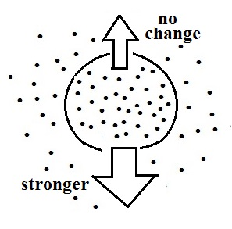
force of equal strength in order for the
parcel to remain in place. This upward
force is supplied by the pressure difference
between the top and bottom of the parcel.

