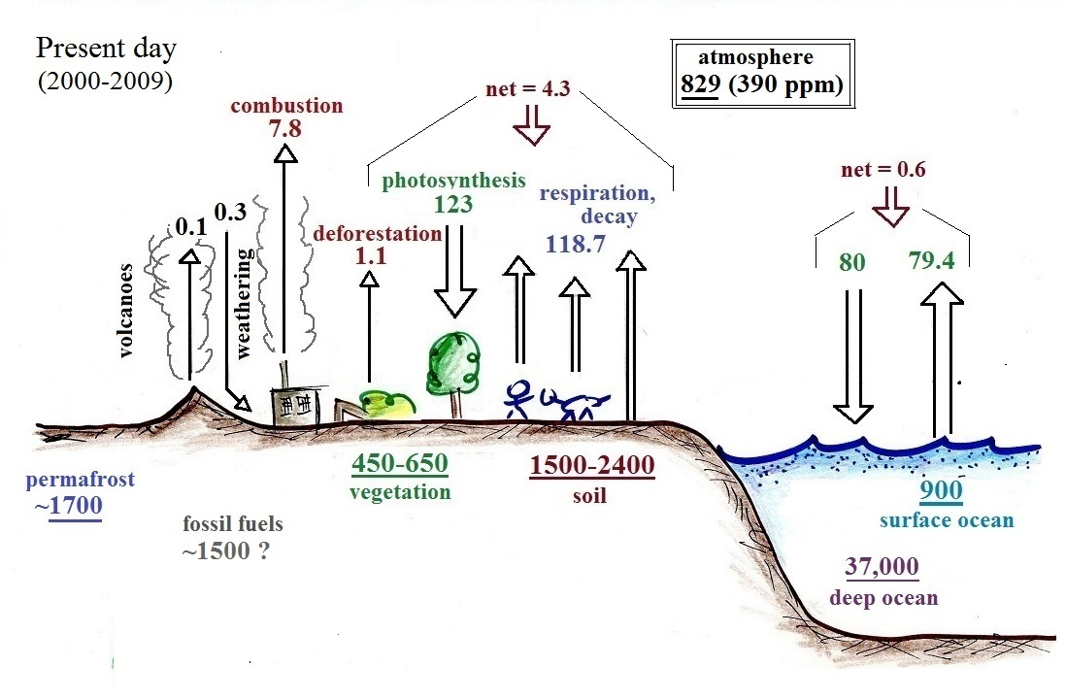

adapted from Climate Change 2013: The Physical Science Basis in the Intergovernmental Panel on Climate Change 5th Assessment Report (available at http://www.ipcc.ch/report/ar5/wg1/)


