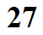
Principle of the Mercury Barometer
(invented by Evangelista Torricelli in 1643)

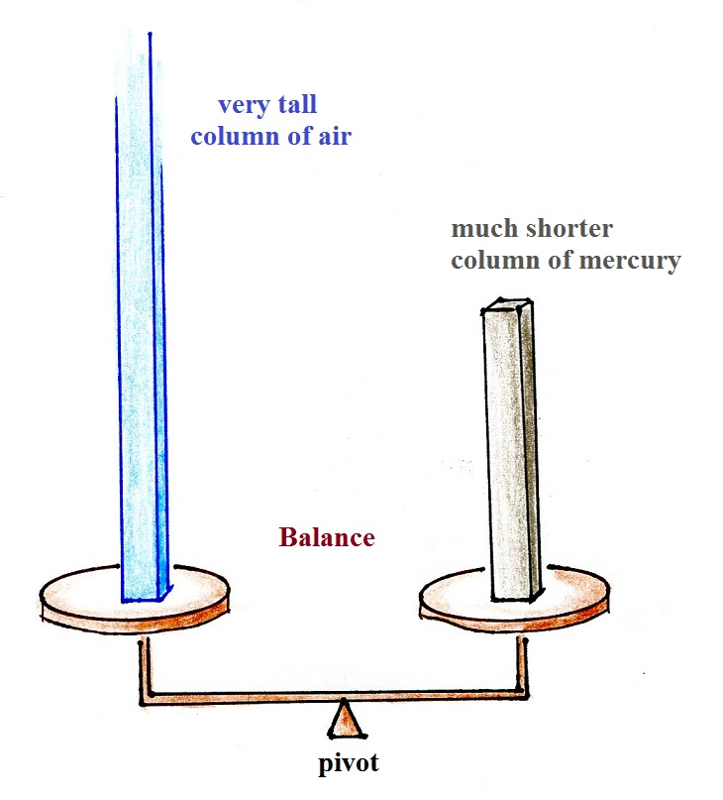

A barometer is essentially a balance.
The weight of the atmosphere is balanced by the weight of a much shorter mercury column.

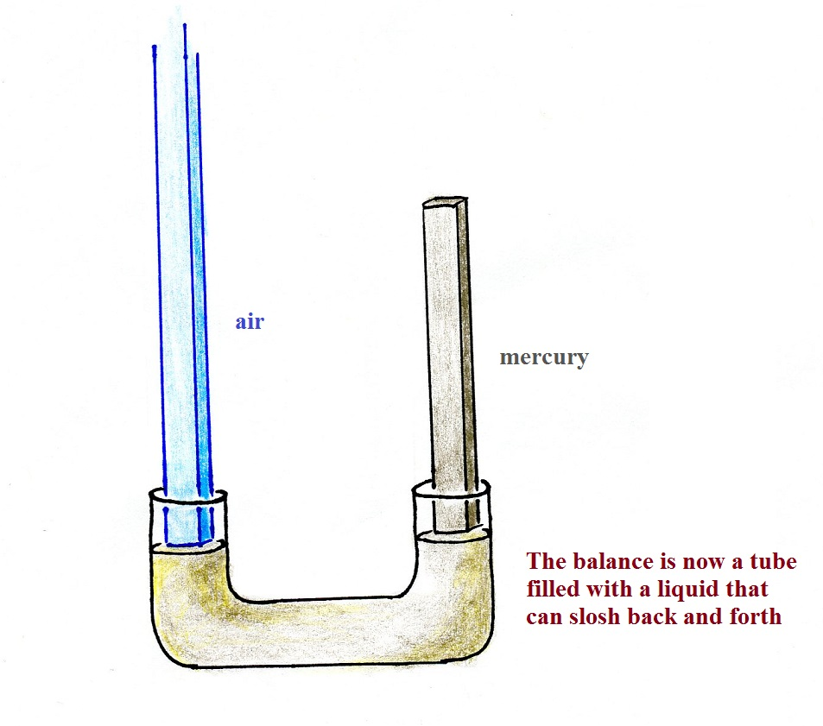

You can't use an ordinary pan balance as shown above to weight the atmosphere (because air is pushing down on both sides). A U-shaped tube filled with some kind of liquid that can slosh back and forth would work. Such an instrument is called a manometer and is often filled with mercury.

