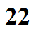
Why? How?
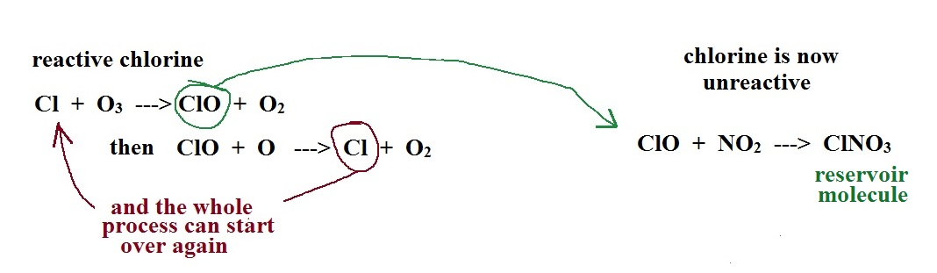
Remember the "interference reactions" that keep some of the free chlorine from reacting with ozone (the chlorine becomes part of an unreactive "reservoir molecule"):

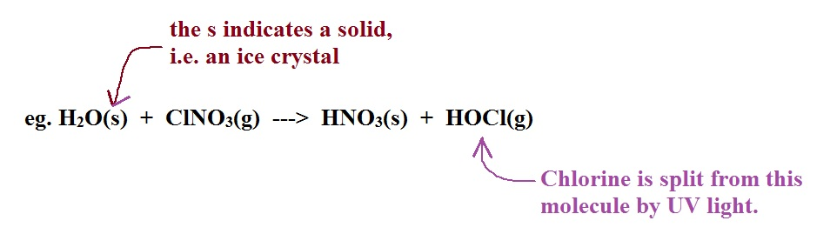
Polar stratospheric clouds (PSCs) form above the south pole in winter when temperatures fall below -80ºC (-110º F). When PSCs form, the reservoir molecules containing chlorine react on the surfaces of the cloud particles and release Cl₂ and HOCl. The concentration of these latter two products build up. They readily dissociate and release reactive Cl when sunlight returns at the end of the southern hemisphere winter.

The cloud particles also react with and store nitrogen compounds that might otherwise react with ClO (i.e. nitrogen compounds that turn ClO into an unreactive reservoir molecule).
A second contributing factor is the formation of an unusual atmospheric circulation pattern in the above the south pole in the winter called the polar vortex. The polar vortex effectively isolates this part of the atmosphere from the rest of the atmosphere for a period of time. Once ozone layer concentrations begin to drop above the south pole, ozone would normally move in from lower latitudes. The polar vortex keeps this from happening until November.

