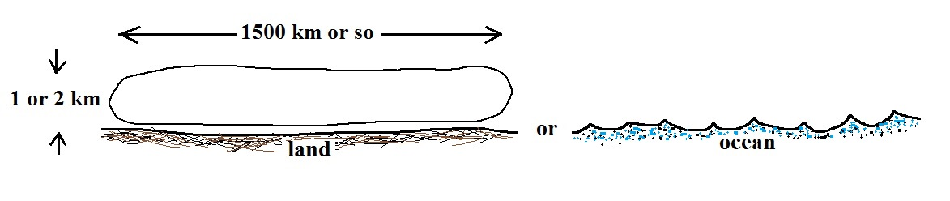
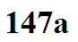
When a large volume of air remains over a flat homogeneous surface for a while, the lowest layers of the air mass will begin to acquire the temperature and moisture characteristics of the underlying surface.
Air masses are classified according to their temperature and moisture properties:
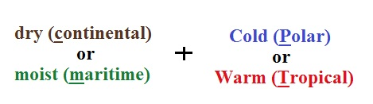

Knowing the characteristics that each major air mass type has provides clues about the kinds of weather they might bring to a region. Unsettled weather conditions are often found along the boundaries of air masses, i.e. along fronts.
