ATMO 170 In-class Optional Assignment Name_____________________________________

1. Based on the information shown at right, does CITY A City A City B
or CITY B have the highest relative humidity. Does the Ta = 90 F Ta = 70 F
air in CITY A or CITY B contain the greatest actual Td = 60 F Td = 50 F
amount of water vapor?

2. To really wring the water vapor out of moist air would it be best to COOL or WARM the air?

3. Here's a solid question to test your understanding of the rain shadow effect.
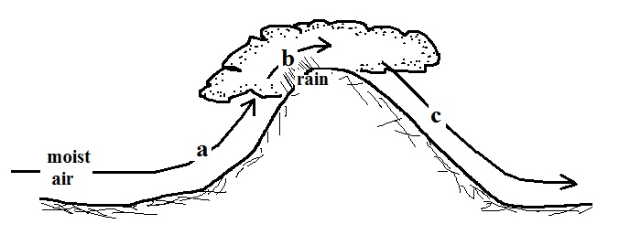

The mixing ratio, r, is increasing and RH is remaining constant along path _______. The RH is increasing & r is remaining constant along path _______. The mixing ratio, r, is decreasing and RH is remaining constant along path _______. The RH is decreasing & r is remaining constant along path _______. (fill in each blank with a, b, or c corresponding to the paths shown in the figure or use d for nowhere; each answer should be used once)

4. Assume that the actual amount of water vapor in the air remains the same during the day. Then _______ and _______ won't change during the day, _______ and _______ will probably be higher in the afternoon than in the morning, and _______ will probably be higher in the morning than in the afternoon. (fill in each blank with one of the choices below, each answer should be used once)
r (mixing ratio) r_{s} (saturation mixing ratio) Ta (air temperature)
RH (relative humidity) Td (dew point temperature)

5. Determine the mixing ratio and the relative humidity T(º F) r_{s} (g/kg) when the air temperature is 75º F and the dew point 75 18
temperature is 55º F. (a table of saturation mixing 70 15
ratio values in included at right) 65 12
60 10
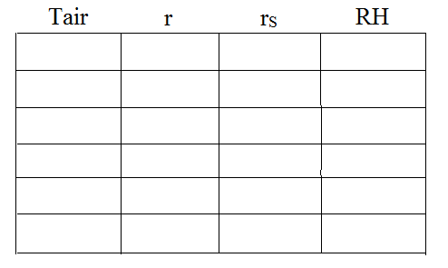
55 9
50 8

use the table at left if you
find it helpful; you aren't required to fill it out

