ATMO 170 Sect. 1 Name__________________________________
Quiz #4 Apr. 24, 2019 (please also put your name on the back)

1. (20 pts) Stationary air will begin to move in the direction of the _______ force. The _______ force can only slow down the wind. The _______ force is always perpendicular to the contours on a weather map. The _______ force is caused by the rotation of the earth. (fill in the blanks)
a. frictional b. buoyant c. pressure gradient d. Coriolis

2. (5 pts) Would the strongest and longest lived thunderstorm be one
with a TILTED or a VERTICAL updraft?

3. (5 pts) Is intracloud lightning MORE or LESS common than cloud-to-ground lightning?
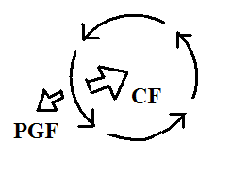
4. (10 pts) Does the figure show winds blowing around a center of HIGH or LOW pressure. Is this a NORTHERN or SOUTHERN hemisphere map?

5. (5 pts) Would an F5 (or EF5) tornado would be a relatively WEAK,
an about AVERAGE, or an unusually STRONG tornado.

6. (5 pts) The net force exerted on an object moving in a circular path at constant speed
a. points inward b. points in the direction of motion c. points outward d. is zero

7. (5 pts) Which of the following processes comes first in a cloud-to-ground lightning discharge?
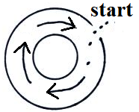
a. dart leader b. upward discharge c. stepped leader d. return stroke

8. (10 pts) The direction of the initial motion in the figure at right means this is a center of HIGH LOW pressure. The bending that occurs after the wind starts to blow indicates that this is a NORTHERN SOUTHERN hemisphere weather map.

9. (5 pts) A narrow, intense, thunderstorm downdraft is called a(n) _______.
a. cyclone b. supercell c. microburst d. squall

10. (5 pts) A sky diver has deployed his/her parachute and is falling straight toward the ground at a safe constant speed. The net force
a. points downward toward the ground b. points upward toward the sky
c. is zero d. is friction

11. (15 pts) The doldrums are a region of calm winds found at _______ in the 3-cell model of the earth's global circulation. The trade winds are found at _______ and the horse latitudes are a belt of high pressure found at _______ . (fill in the blanks)
a. 0º latitude b. 15º latitude c. 30º latitude d. 45º latitude

12. (15 pts) Tornado winds always spin around a center of LOW HIGH pressure. Are the winds in most tornadoes MORE or LESS than 100 MPH? Do the strongest tornadoes occur in the SPRING SUMMER WINTER or FALL.

Name______________________________________

13. (10 pts) Which two of the following would be the best indication that a thunderstorm has a rotating updraft?
a. gust front b. anvil cloud c. wall cloud d. hook echo e. lightning f. microburst

14. (10 pts) A metal car is a SAFE DANGEROUS place to seek shelter during a lightning storm. It is SAFE DANGEROUS to use a cell phone during a lightning storm.

15. (5 pts) There is no _______ force at the equator.
a. Coriolis b. pressure gradient c. frictional d. gravitational

16. (5 pts) Which of the following creates the electricity in thunderstorms needed for lightning?
a. ultraviolet light b. collisions between precipitation particles c. wind shear
d. condensation and evaporation e. St. Elmo's fire f. expanding air

17. (10 pts) Rising air motions are produced by surface centers of HIGH LOW pressure in the northern hemisphere and centers of HIGH LOW pressure in the southern hemisphere.

18. (5 pts) An ordinary air mass thunderstorm will begin to dissipate when
a. lightning activity begins b. all the cloud particles turn to ice
c. the downdraft cuts off the updraft d. the thunderstorm top reaches the stratosphere

19. (5 pts) The 1st law of motion that we have been using in this class was formulated by
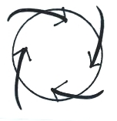
a. Archimedes b. Coriolis c. Foucault d. Galileo e. Newton

20. (15 pts) The figure at right shows SURFACE UPPER LEVEL winds blowing around
a center of HIGH LOW pressure in the NORTHERN SOUTHERN hemisphere.

21. (5 pts) Which one of the following is produced by a thunderstorm downdraft?
a. mesocyclone b. wall cloud c. gust front d. hook echo

Extra Credit (you can earn up to 10 pts)
1. (5 pts) _______ is generally considered to be the inventor of the lightning rod
a. Thomas Jefferson b. Benjamin Franklin c. John Adams d. Thomas Edison

2. (5 pts) The term cylone refers to
a. counterclockwise spinning winds b. winds spinning around low pressure
c. clockwise spinning winds d. winds spinning around high pressure
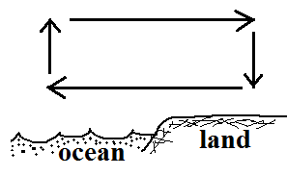
3. (6 pts) The warmest part of the thermal circulation shown at right
would be found over the OCEAN LAND. Would cloud formation
be more likely over the OCEAN or the LAND.

